



**Module Code & Module Title**

**CS6P05NI Final Year Project**

**Assessment Weightage & Type**

**40% FYP Final Report**

**Semester**

**2021 Autumn**

**Project Title: Rent Management Web app, Tarif**

**Student Name: Suyogya Luitel**

**London Met ID: 19031784**

**College ID: np01cp4a190035**

**Internal Supervisor: Mohit Sharma**

**External Supervisor: Ankit Tandukar**

**Assignment Due Date:**

**Assignment Submission Date:**

**Word Count (Where Required):**

*I confirm that I understand my coursework needs to be submitted online via Google Classroom under the relevant module page before the deadline in order for my assignment to be accepted and marked. I am fully aware that late submissions will be treated as non-submission and a mark of zero will be awarded.*

**Abstract**

This report demonstrates the early phases of the development of the Rent Management Web app based on React and Django. Even as the world has entered the stage of electronic data storage, people in the rental domain still either keep a record of rent data on paper or do not store it at all. Keeping in mind the importance of data analysis to make educated decisions, this project aims to digitally store the rental data of the users and make it easier to find houses to rent.

**Table of Contents**

1. Introduction 1

1.1. Introduction to the Topic 1

1.2. Current Scenario 1

1.2.1. World 1

1.2.2. Nepal 3

1.3. Problem Scenario 4

1.4. Project as solution 4

1.5. Aim and Objectives: 5

1.5.1. Aim 5

1.5.2. Objectives 5

1.6. Report Structure 6

1.6.1. Background 6

1.6.2. Development 6

1.6.3. Testing 6

1.6.4. Conclusion 6

2. Background 7

2.1. Client description and requirements 7

2.1.1. Description 7

2.1.2. Requirements 7

2.2. Understanding the project 10

2.2.1. Web app as a medium 10

2.2.2. Project elaboration 10

2.2.3. Project deliverables 10

2.2.4. Technical terms and definition 12

2.3. Similar systems 13

2.3.1. System 1: Onsite Property Manager 13

2.3.2. System 2: Vacationlabs 15

2.3.3. System 3: Buildium 16

2.3.4. System 4: Neopropertynepal 18

2.3.5. System 5: Property Care Guru 20

2.4. Similar Systems Comparison 23

2.4.1. Comparison Table 23

2.4.2. Comparison Result 23

3. Development 24

3.1. Considered Methodologies 24

3.1.1. Iterative Waterfall 24

3.1.2. Prototyping 25

3.1.3. Feature Driven Development 26

3.2. Adopted Methodology (FDD) 28

3.3. Phases of Adopted Methodology 29

3.3.1. Initiation 29

3.3.2. Overall Model 29

3.3.3. Feature List 29

3.3.4. Plan by Feature 30

3.3.5. Design by Feature 30

3.3.6. Build by Feature 31

3.4. Survey Results 31

3.4.1. Presurvey Results: 31

3.4.2. Postsurvey Results 36

3.5. Requirement Analysis 39

3.5.2. Gantt Chart 41

3.6. Designs 43

3.6.1. Work Breakdown Structure 43

3.6.2. Use Case Diagram 44

3.6.3. Wireframes 45

3.6.4. UI Designs 61

3.6.5. Use Cases 70

3.6.6. Domain Object Model 1

3.7. Implementation 1

3.7.1. Important Screenshots 1

3.8. System Architecture 8

4. Testing 10

4.1. Test Plan 10

4.1.1. Unit Testing 10

4.1.2. Integration Testing 10

4.1.3. User Acceptance Testing 11

4.2. Unit Testing 12

4.2.1. Testing Register Feature 12

4.2.2. Testing Login Feature 19

4.2.3. Testing Data Visualization / Dashboard Feature 21

4.2.4. Testing to Add House 24

4.2.5. 27

5. References 29

6. Appendix 32

6.1. Appendix A (Development) 32

6.1.1. Gant Chart 32

6.1.2. Work Breakdown Structure 33

6.2. Appendix B (Development Till Date) 34

6.2.1. Code Snippets 34

6.2.2. Viewable Development 39

**Table of Figures**

Figure 1: North American Market size and projection (Fortune Business Insights, 2021) 2

Figure 2: Similar System 1 13

Figure 3: Similar system 1.1 14

Figure 4: Similar system 1.2 14

Figure 5: Similar system 2.2 16

Figure 6: Similar System 2.3 16

Figure 7: System 3 17

Figure 8: System 3.1 17

Figure 9: System 3.2 18

Figure 10: System 4 19

Figure 11: System 4.1 19

Figure 12: System 4.2 20

Figure 13: System 5 21

Figure 14: System 5.1 21

Figure 15: System 5.2 22

Figure 16: Iterative waterfall model (Ruparelia, 2010) 24

Figure 17: Prototyping Model (Martin, 2021) 25

Figure 18: FDD project Lifecycle (Abler, 2021) 27

Figure 19: Presurvey result 1 31

Figure 20: Presurvey Result 2 32

Figure 21: Presurvey Result 3 32

Figure 22: Presurvey Result 4 33

Figure 23: Presurvey Result 5 33

Figure 24: Presurvey Result 6 34

Figure 25: Presurvey Result 7 34

Figure 26: Presurvey Result 8 35

Figure 27: Postsurvey Results 1 36

Figure 28: Postsurvey Results 2 36

Figure 29: Postsurvey Results 3 37

Figure 30: Postsurvey Results 4 37

Figure 31: Postsurvey Results 5 38

Figure 32: Postsurvey Results 6 38

Figure 33: Revised Gantt Chart 41

Figure 34: Gantt Chart Contents 42

Figure 35: Work Breakdown Structure 43

Figure 36: Use Case Diagram 44

Figure 37: Householder Profile Tab 45

Figure 38: Householder Map view 46

Figure 39: Tenant Login 47

Figure 40: Tenant House view 48

Figure 41: Tenant Dashboard view 49

Figure 42: Tenant Bills view 50

Figure 43: Register User view 51

Figure 44: Login Landlord view 52

Figure 45: Login Portal View 53

Figure 46: Tenant Profile view 54

Figure 47: Tenant map view 55

Figure 48: Householder Houses view 56

Figure 49: Householder Dashboard view 57

Figure 50: Householder Bills view 58

Figure 51: Sign-in page UI 61

Figure 52: Sign up page UI 62

Figure 53: Home Page UI 63

Figure 54: Houses page UI 64

Figure 55: Bills page UI 65

Figure 56: Analysis page UI 66

Figure 57: Profile page UI 67

Figure 58: Map page UI 68

Figure 59: Use Case Diagram 70

Figure 60: Register Sequence Diagram 78

Figure 61: View Reviews Sequence Diagram 78

Figure 62: Update Bills Sequence Diagram 79

Figure 63: Push Bills Sequence Diagram 79

Figure 64: Data analysis Sequence Diagram 80

Figure 65: Login Sequence Diagram 80

Figure 66: Logout Sequence Diagram 81

Figure 67: Add House Sequence Diagram 81

Figure 68: Edit Profile Sequence Diagram 82

Figure 69: Edit House Details Sequence Diagram 82

Figure 70: View House Details Sequence Diagram 83

Figure 71: Review Houses Sequence Diagram 83

Figure 72: Pay Bills Sequence Diagram 84

Figure 73: View Bills Sequence Diagram 84

Figure 74: Domain Object Model 1

Figure 75: Code Screenshot 1 1

Figure 76: Code Screenshot 2 2

Figure 77: Code Screenshot 3 3

Figure 78: Code Screenshot 4 4

Figure 79: Code Screenshot 5 5

Figure 80: Code Screenshot 6 6

Figure 81: Code Screenshot 7 7

Figure 82: System Architecture 8

Figure 83: Register form 12

Figure 84: Register form with test data 13

Figure 85: User data in backend 14

Figure 86: Code causing the issue 15

Figure 87: Code resolving the issue 16

Figure 88: Register form filled 17

Figure 89: Registered User in the backend 18

Figure 90: Login form 19

Figure 91: Login form with test data 20

Figure 92: Auth Token being stored in local storage after login 20

Figure 93: Dashboard display not rendering 21

Figure 94: Code causing issue 22

Figure 95: Code after fix 22

Figure 96: Dashboard with loaded data 23

Figure 97: House Addition Form 24

Figure 98: House Addition Form after clicking the map 25

Figure 99: Code causing issue 26

Figure 100: Code after fix 26

Figure 101: Dashboard with loaded data 27

Figure 102: Updated Gantt Chart 32

Figure 103: Gantt chart Tasks for Clarity 32

Figure 104: Work Breakdown Structure 33

Figure 105: App.js Code 34

Figure 106: App.css Code 35

Figure 107: Button Component Code 36

Figure 108: Login form Code 36

Figure 109: Button style Code 37

Figure 110: Login Page Code 38

Figure 111: Sign-in page 39

**Table of Tables**

Table 1: System Comparison Table 23

Table 2: Initiation of Project 29

Table 3: Developing Overall Model of Project 29

Table 4: Developing Overall Model of Project 30

Table 5: Developing Overall Model of Project 30

Table 6: Developing Overall Model of Project 30

Table 7: Developing Overall Model of Project 31

Table 8: High level description of Register 71

Table 9: High level description of View Reviews 71

Table 10: High level description of Add Bills 72

Table 11: High level description of Register House 72

Table 12: High level description of Update Bill 73

Table 13: High level description of Data analysis 73

Table 14: High level description of Login 74

Table 15: High level description of Logout 74

Table 16: High level description of Edit Profile 75

Table 17: High level description of Edit House Details 75

Table 18: High level description of View House Details 76

Table 19: High level description of Pay Bills 76

Table 20: High level description of Review House Details 76

Table 21: High level description of Review House Details 77

Table 22: Unit Test 1 12

Table 22: Unit Test 2 17

Table 22: Unit Test 2 19

Table 22: Unit Test 3 21

Table 22: Unit Test 3 23

Table 22: Unit Test 4 24

Table 22: Unit Test 4 27

# 

# Introduction

## Introduction to the Topic

Web apps have revolutionized the way we use the internet. While initially, web browsers could only render simple HTML contents, nowadays browsers are powerful enough to run heavy web apps and even heavy 3D RPG games, thanks to the JavaScript engines built into browsers. People use the internet very frequently, making it the perfect platform for reaching a huge mass of people. The beauty of a web app is that it runs on any platform so long as you have an internet connection and a browser, be it IOS, Windows, Android, Linux, or any other OS. Using a web app, both the tenants and householders can find one another more easily and communicate. The ratings help both the tenants and householders in screening the available options.

## Current Scenario

### World

According to a report on property management market by Fortune Business Insights, the global property management market size was USD 13.88 billion in 2020 (Fortune Business Insights, 2021). While the COVID-19 affected the whole world in a catastrophic way, property management software/services witnessed a positive demand shock across all regions. Based on their analysis, the global market exhibited a significant growth of 8.7% in 2020 as compared to year-on-year growth during 2017-2019 and the market is expected to grow from USD 15.10 billion in 2021 to USD 28.21 billion in 2028 at a CAGR (Compound Annual Growth Rate) of 9.3% in the 2021-2028 period (Fortune Business Insights, 2021). The steady rise in CAGR as attributable to this market’s demand and growth, returning to pre-pandemic levels once the pandemic is over.

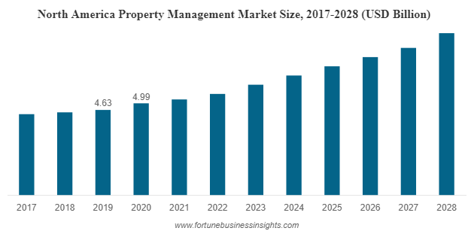

Figure 1: North American Market size and projection (Fortune Business Insights, 2021)

### Nepal

In case of Nepal, the pandemic made people more aware and enthusiastic about cashless payment options in. While managing rents looks trivial at a first glance, it can get out of hand very quickly if multiple properties are to be put on rent. Besides, traditionally in Nepal, people either do not keep a record of the rents they push or pay; or record it on paper. Keeping a record of rents is extremely useful as it can provide statistical benefits. Comparing the rents paid for different houses can give one an idea of what the market is offering them which can be used in decision making while searching for rents. On the flip side, keeping tabs of bills pushed or rent collected can be valuable to householders to gauge what people are willing to pay and what their property’s worth should be to tenants. By keeping a record of rents paid/collected, the users can make educated decisions about what properties are worth and what amount they should be paying.

## P**roblem Scenario**

The problems that the web app intends to solve are as follows:

1. Finding a rent or finding a tenant is difficult given the limited means of reaching out to one another in Nepal.
2. People are opting to spend money via cashless means due to the pandemic. However, house rents are paid mostly via cash when the householder visits the tenant door to door.
3. Pushing consistent bills to tenants takes quite a bit of time as householders mostly need to do all the calculations themselves, write it all down on a piece of paper, sign it, and manually send it to tenants.
4. While pushing a bill or paying a bill, most of the parties involved in house rents, do not keep track of the transactions being made. That is ignorance of data which could serve as a valuable asset in decision making.
5. Often there is no reliable way for screening available options of householders and tenants. Thus, after a contract is signed, either party could end up stuck with a bad or unwanted company.

## Project as solution

The project solves the aforementioned issues by the following means:

1. The app displays a map-based view which helps users locate houses ready to be rented. Similarly, since the houses are now viewable on a map, the householders can find tenants more frequently.
2. The app provides a cashless means to pay rent if the user desires to do so.
3. The app supports the development of a bill template which the householders can then use to push consistent bills to all tenants.
4. The app keeps track of all rent-related transactions and visualizes the data in form of a graph so that the user can make educated decisions.

The app supports ratings and reviews which help in screening both tenants and householders.

## Aim and Objectives:

### Aim

The major aim of the project is to make finding and managing rents easier. The project helps tenants find reliable rent and help householders find reliable tenants. To help tenants and householders make educated guesses based on their previous data. To provide tenants and householders a reliable way to pay and push bills respectively via e-payment.

### Objectives

The objectives of this web app are:

* To learn about web development and its required paradigms
* To learn about database designing in a real-world scenario
* To learn how restful APIs work
* To better understand third-party APIs in development such as map APIs.
* To better understand frontend technologies like react, and JS in general.
* To better understand backend technologies such as Django and Django REST framework.

## Report Structure

### Background

The background section of the report clarifies the project requirements, project description, and end-users. The section also covers a comparison of the project with other similar projects to establish how the project is different from some of the existing solutions.

### Development

The development section of the report elaborates how the project is to be developed. The section also covers the considered and selected methodologies while also describing the several phases of the selected methodology. The development process is also visually represented with the help of the Work Breakdown Structure and Gantt Chart.

### Testing

This section consists of the process related to unit testing, integration testing, and customer evaluation testing.

### Conclusion

This section consists of information related to the supposition of the report, a review of wider implications, and future improvements of the project.

# Background

## Client description and requirements

Client name: Saral Karki

### Description

The client is Saral Karki, an individual, who resides in a rental house and wants a web app to enhance their rent experience. Having experienced rental issues first-hand, the client knows the common issues faced in the house rental domain.

Upon presenting this project to Saral, he found the project helpful in resolving the issues he has seen in the house rental domain. He agreed to be the client for this project as he sees practicability in the project and is thus willing to provide his insight on the rental domain.

### Requirements

According to the meeting with the client, the following requirements were declared as mandatory:

1. **The householder and Tenant registration with citizenship**

The user registers as a householder or a tenant. While registering, the user must upload a scanned copy of their citizenship which is also stored for security purposes. While it is not a common practice in Nepal for householders to take a copy of the tenant’s citizenship, it is a good practice to have it available. Having citizenship attached to an account also significantly reduces the chances of fraud or run-away cases.

1. **Houses must be visible on a map**

The web app must contain a map displaying the houses available for rent which is visible to users after they sign in. This makes it easier for tenants to find houses for rent in their desired location.

1. **Push bills as a householder**

The web app must enable householders to make house bills and push the bills via email. This makes it easier to calculate the rent amount as well as removes the hassle of physically visiting the tenant or handing out bills.

1. **Pay bills as Tenant**

The pushed bills must have an e-payment option so that tenants can pay the bills virtually. This removes the hassle of physically meeting the householder just for paying the rent amount.

1. **Reviews**

The initial proposed idea was that both householders and tenants must be able to leave a rating on one another after their term has ended. This ensures that there is a way for screening the tenants/householders even before the interview takes place.

However, upon a later call from the client, it was stated that having reviews on people can cause demoralization if the ratings go low. It would eventually cause the user to stop using the rental app if their rating plummeted. Thus, the feature was modified to allow tenants to review houses.

1. **Register houses as a householder**

A householder must be able to have multiple houses registered since a user may have multiple houses.

1. **Keep track of payment amounts and dates**

The web app must also ensure that it stores bill details and bill dates paid by each user.

1. **Visualize user data for educated decision making.**

The web app must visualize the given user data in form of a graph to enable educated decision making.

The client also mentioned a communication portal for tenants and householders as an optional feature if possible.

## Understanding the project

### Web app as a medium

Web apps have revolutionized the way we use the internet. While initially, web browsers could only render simple HTML contents, nowadays browsers are powerful enough to run heavy web apps and even heavy 3D RPG games, thanks to the JavaScript engines built into browsers. People use the internet very frequently, making it the perfect platform for reaching a huge mass of people. The beauty of a web app is that it runs on any platform so long as you have an internet connection and a browser, be it IOS, Windows, Android, Linux, or any other OS.

### Project elaboration

The project is a web app built using React and Django frameworks. React is the frontend framework used for making the project viewable in the browser and to collect input from the users. Django is the backend framework for storing user information. The project uses restful APIs to transfer data between the backend and the frontend. The web app registers users as a householder or a tenant. Upon sign in, they are given access to further features such as finding available houses, registering available houses, e-payment for bills, and a communication portal. Once both the householder and the tenant have selected one another, the house is marked rented, and this term can be ended by the householder. After the term has ended, the house is marked again as available.

### Project deliverables

The expected outcomes and deliverables of the web app are:

* The householder and Tenant registration with citizenship
* Houses must be visible on a map
* Push bills as a householder
* Pay bills as Tenant
* Reviews
* Register houses as a householder
* Keep track of payment amounts and dates
* Visualize user data for educated decision making.

### Technical terms and definition

#### IDE

Visual Studio Code is a lightweight but powerful source code editor which runs on your desktop and is available for Windows, macOS and Linux (Visual Studio, 2022). It comes with built-in support for JavaScript, TypeScript and Node.js and has a rich ecosystem of extensions for other languages (such as C++, C#, Java, Python, PHP, Go) and runtimes (such as .NET and Unity).

#### Database

##### SQLite

SQLite is an in-process library that implements a self-contained, serverless, zero-configuration, transactional SQL database engine. The code for SQLite is in the public domain and is thus free for use for any purpose, commercial or private. SQLite is the most widely deployed database in the world with more applications than we can count, including several high-profile projects. (SqLite, 2022)

#### Frontend Framework

##### React

React is a JavaScript library for building user interfaces. React has been designed from the start for gradual adoption, and can be used as little or as much as the user needs. Whether to get a taste of React, add some interactivity to a simple HTML page, or start a complex React-powered app, React provides a platform to the user. (React, 2022)

#### Backend Framework

##### Django

Django is a python framework developed in a fast-paced newsroom environment, designed to make common web development tasks fast and easy. (Django, 2022)

## Similar systems

### System 1: Onsite Property Manager

URL: <http://www.onsitepropertymanager.com/>

This system manages property rental with automated postings, rent roll format, and Tenant portals. However, it does not have the feature to help tenants find householders or rent. It is also not free to use and has paid plans starting at $6.95.

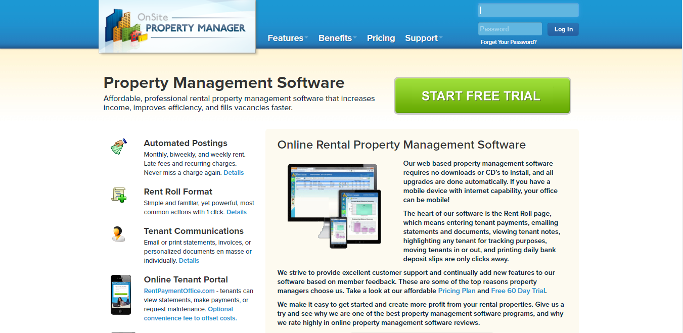

Figure 2: Similar System 1

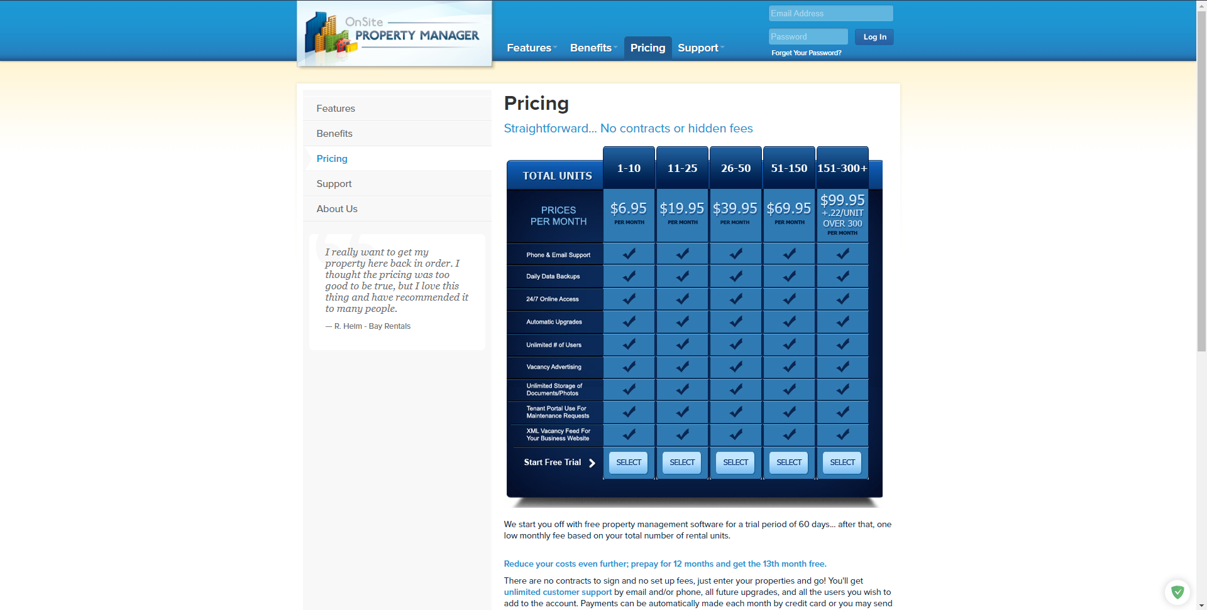

Figure 3: Similar system 1.1

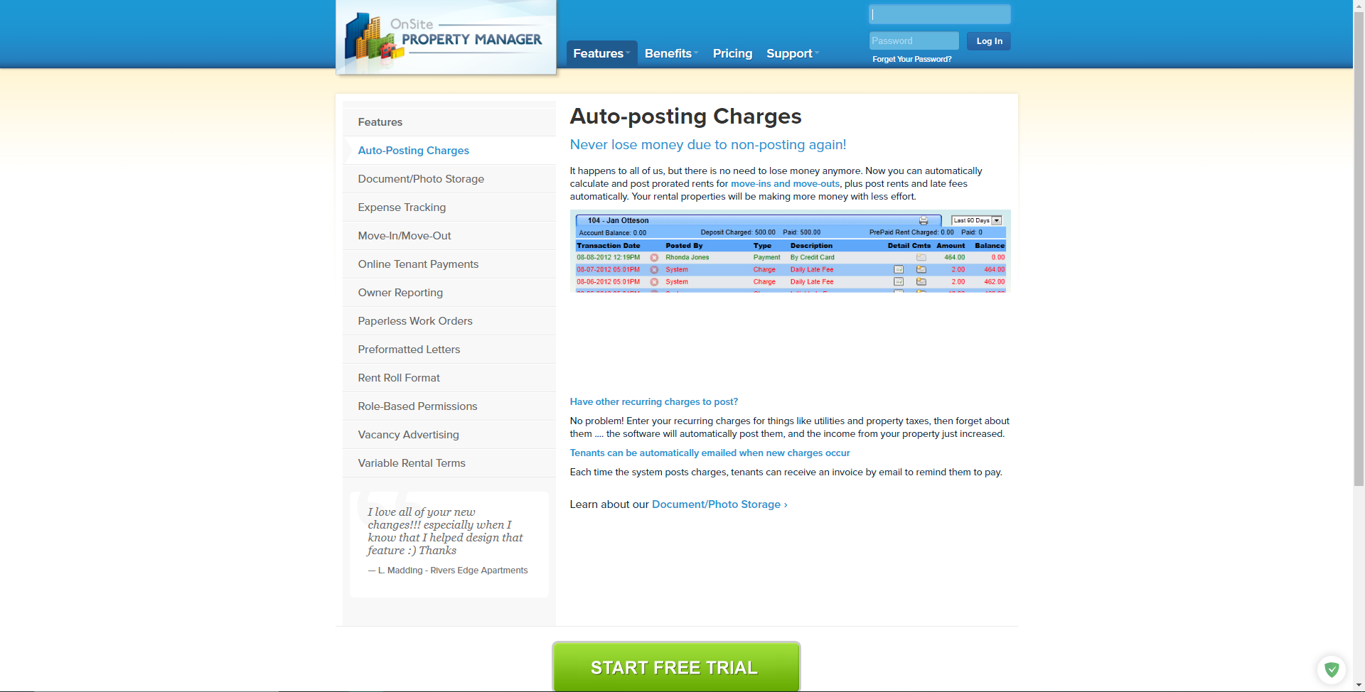

Figure 4: Similar system 1.2

### System 2: Vacationlabs

URL: <https://www.vacationlabs.com/rental-management-system/>

This system handles vacation-related rentals such as hotels, tours, etc. While residing in the property rental domain, this system arranges temporary rents for tour and travels. It does not solve the issue of tenants and householders.

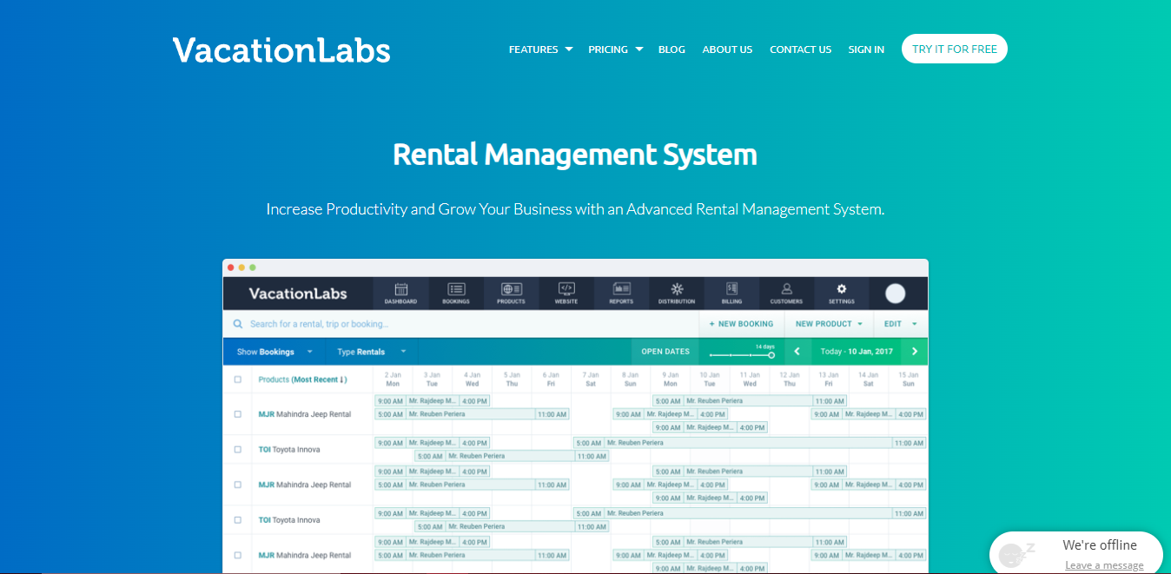

Figure: System 2

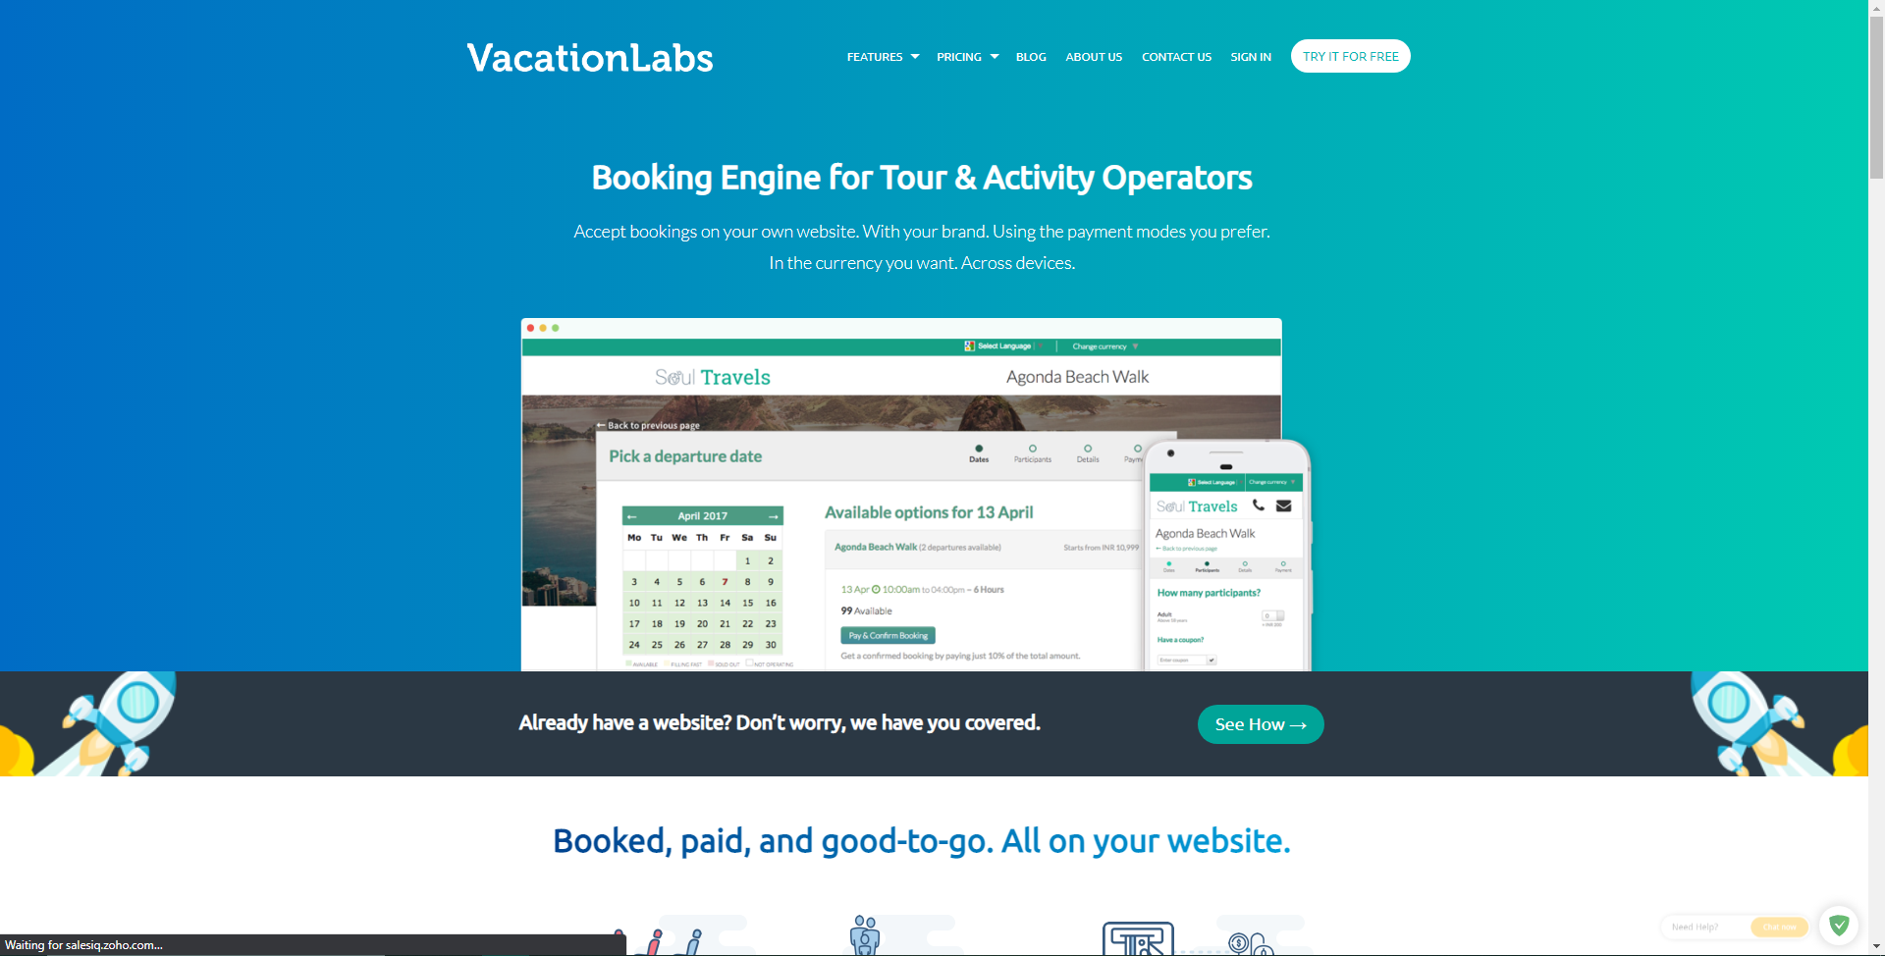

Figure 5: Similar system 2.2

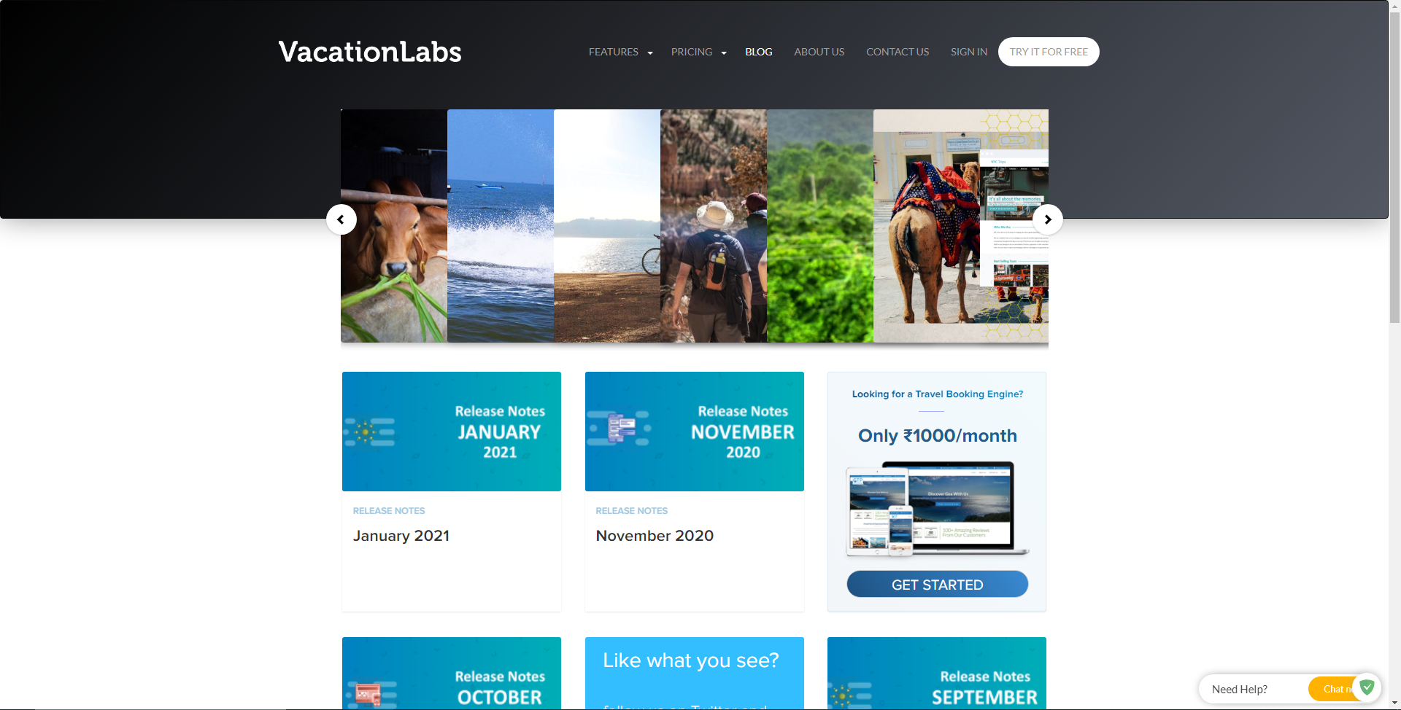

Figure 6: Similar System 2.3

### System 3: Buildium

URL: <https://learn.buildium.com/>

This system is a pay-to-use system that helps in ePay, Tenant Screening, Renters Insurance, and data visualization reports. While the system is great, it is not used in the case of Nepal since it is a pay-to-use system with a rather high price plan starting at $50 per month.

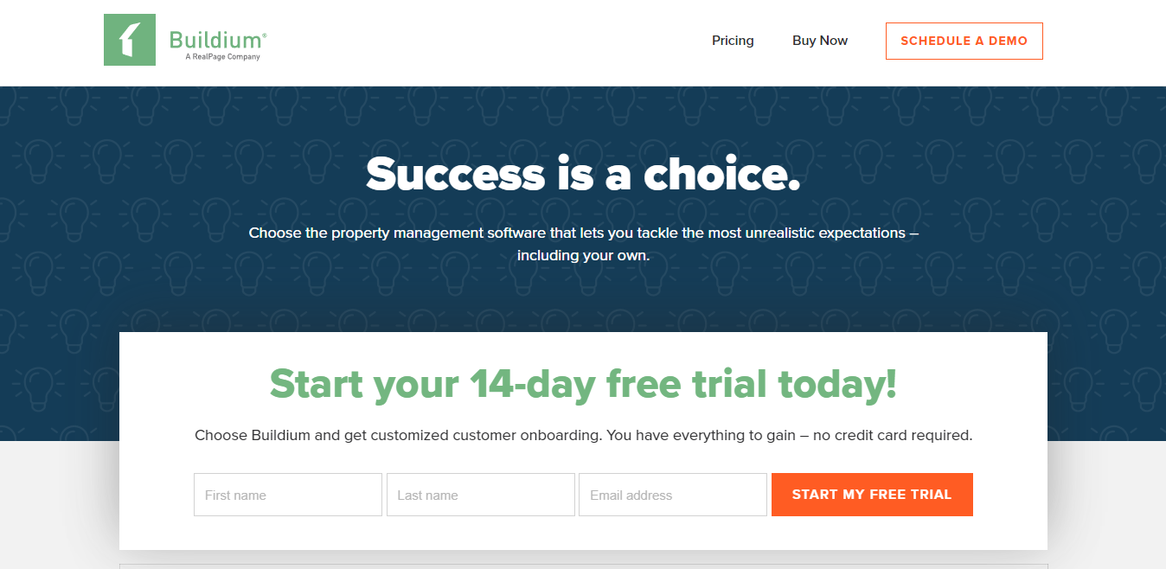

Figure 7: System 3

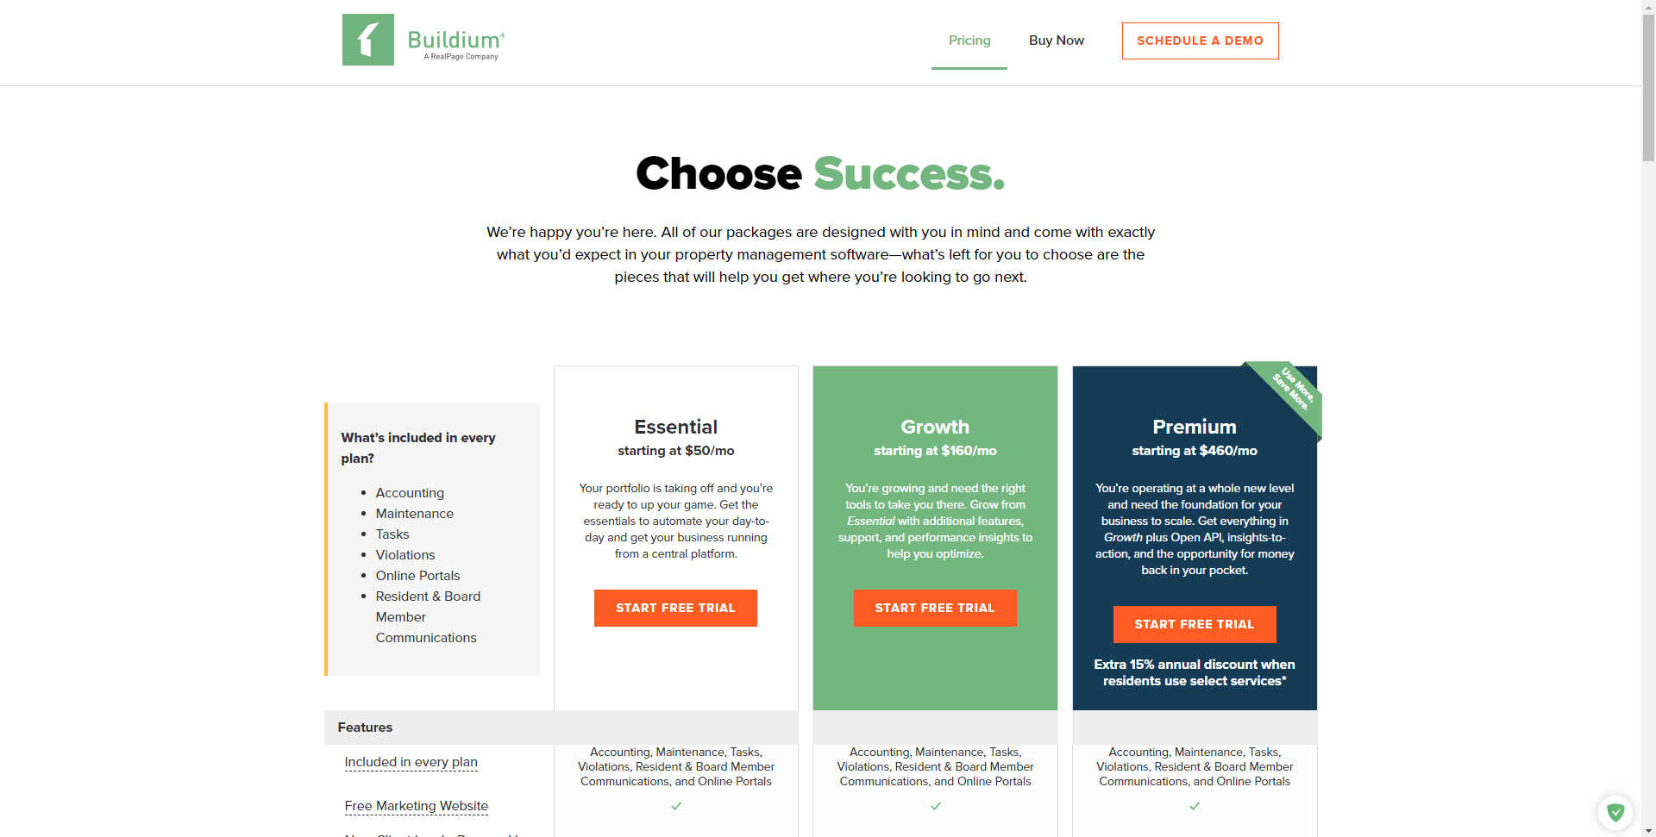

Figure 8: System 3.1

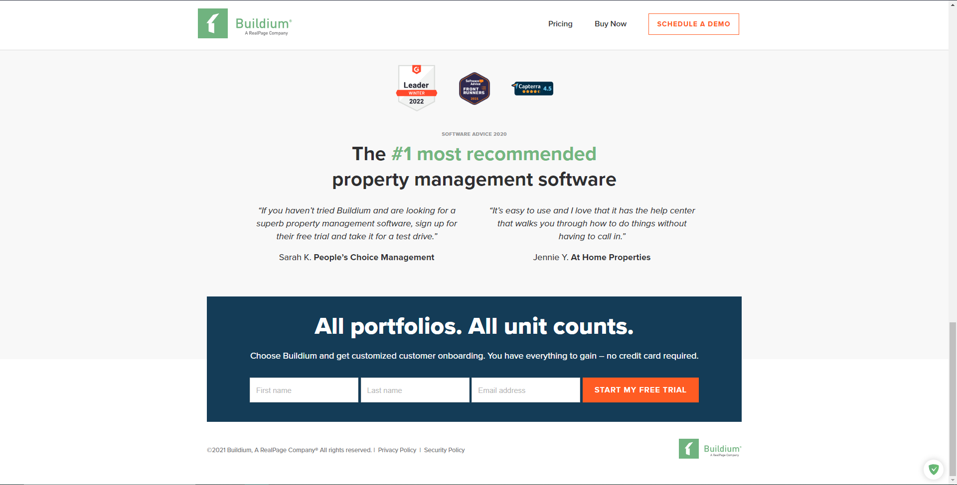

Figure 9: System 3.2

### System 4: Neopropertynepal

URL: <https://www.neopropertynepal.com/>

This system is based in Nepal and helps users with property sales and rental. It includes houses, offices, land, hotel, apartments, etc. While the app is great, it cannot be used for tenant or householder filtering since it shows advertisement-based property and has no system for rating.

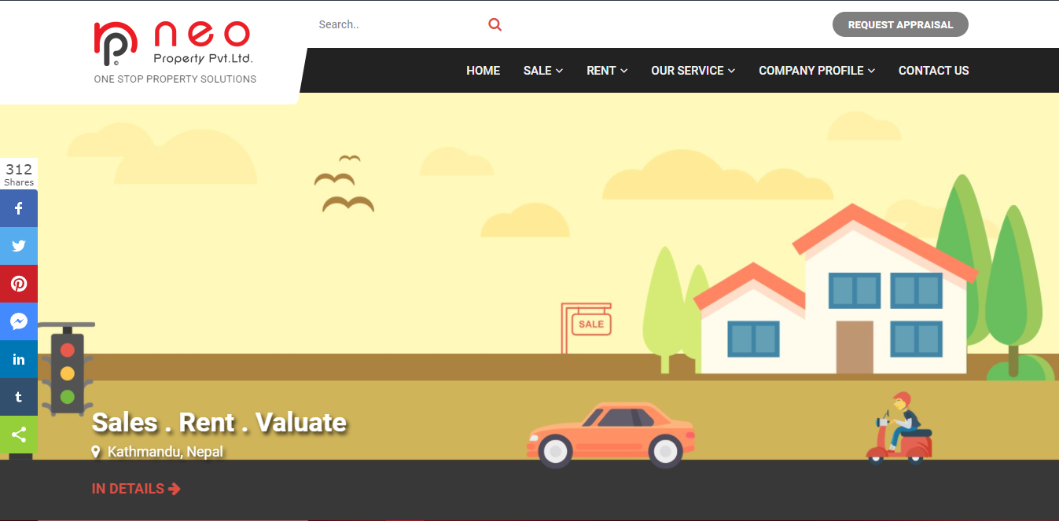

Figure 10: System 4

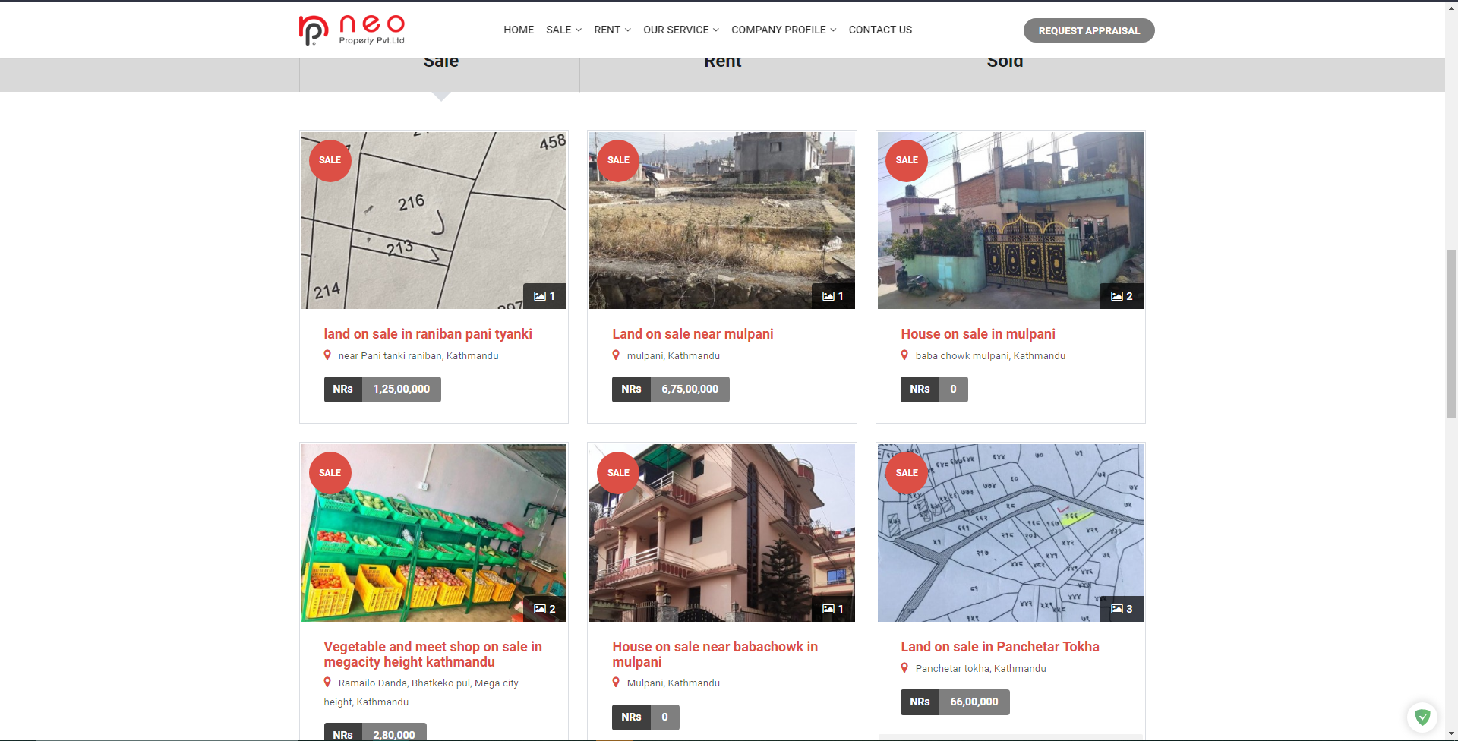

Figure 11: System 4.1

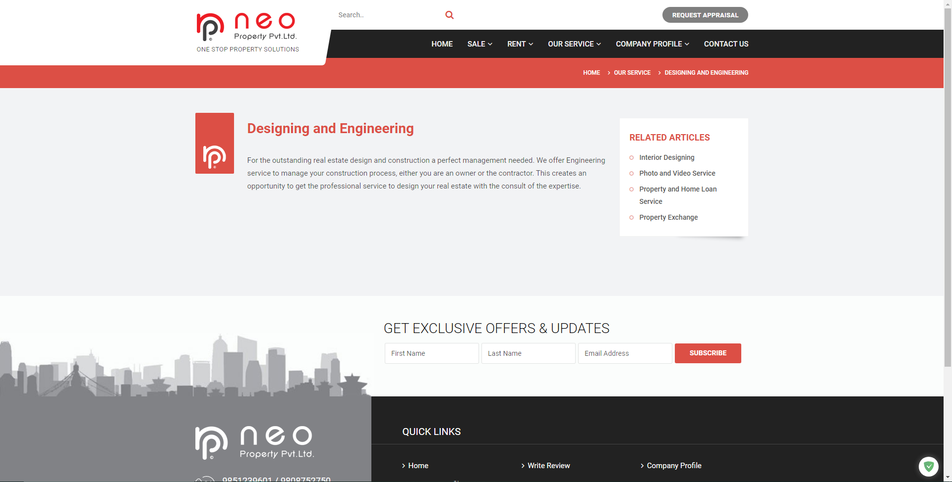

Figure 12: System 4.2

### System 5: Property Care Guru

URL: <http://propertycareguru.com/>

This system is also based in Nepal and helps users find vacant properties. The app has a lot of property filtering options but similar to the previous system, has no feature for rating and reviewing.



Figure 13: System 5



Figure 14: System 5.1

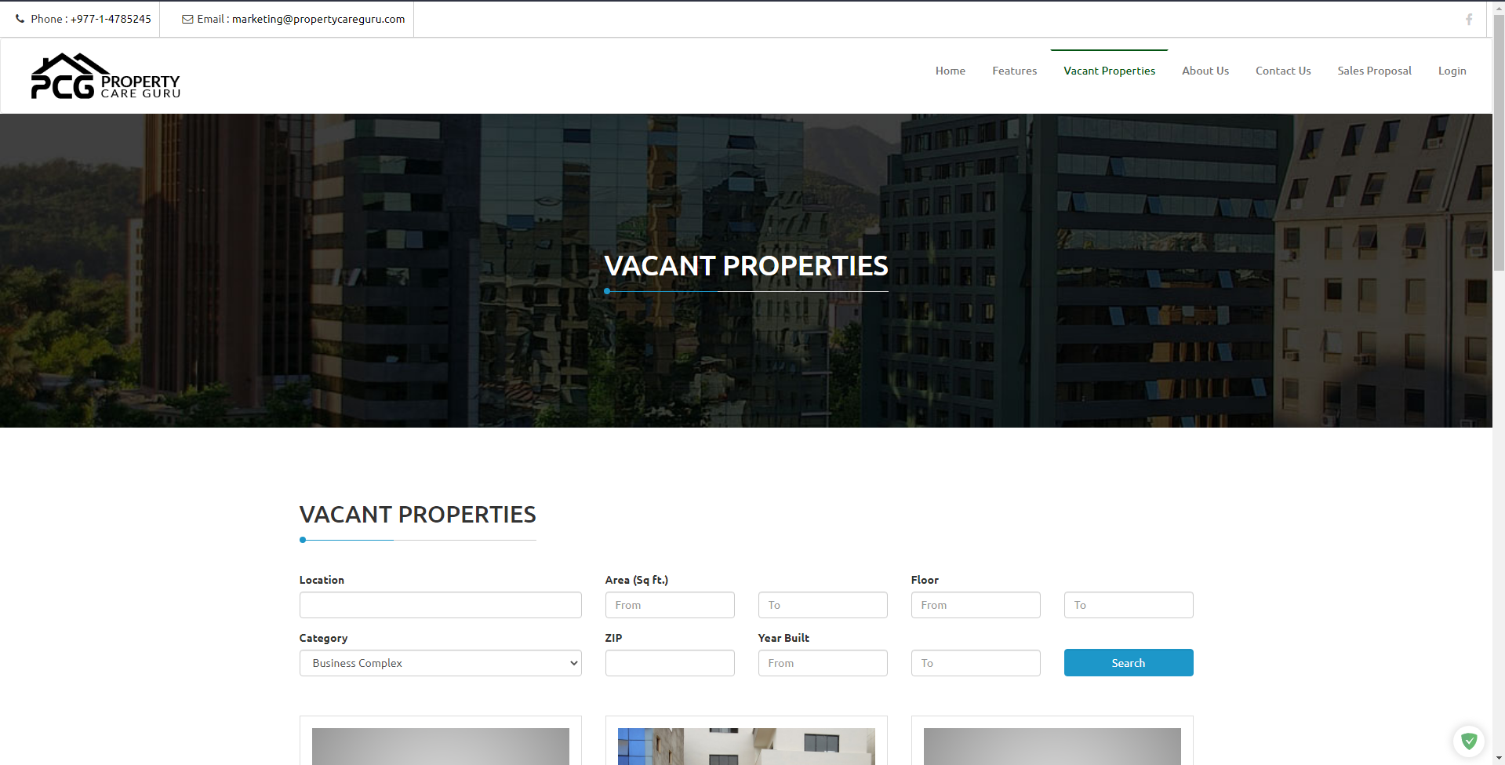

Figure 15: System 5.2

## Similar Systems Comparison

### Comparison Table

|  |  |  |  |  |  |  |
| --- | --- | --- | --- | --- | --- | --- |
| Features | System 1 | System 2 | System 3 | System 4 | System 5 | My Project |
| Availability in Nepal | û | û | û | ü | ü | ü |
| Free to use | û | û | û | ü | ü | ü |
| Rating and Review | û | ü | ü | û | û | ü |
| Map | û | û | û | û | û | ü |
| Push bills | ü | û | ü | û | ü | ü |
| E-payment | ü | û | ü | û | ü | ü |
| Data Analysis | û | ü | û | û | û | ü |

Table 1: System Comparison Table

### Comparison Result

Rent or property management systems are rising in demand each day, especially after the COVID-19 breakout. It has caused an uprise in the number of property management systems available in the market. The comparison done above shows that while there are multiple systems in the rent management domain, none have all the set of features present in my system. The system adheres to the requirements provided by the client. The system is free to use, and available in Nepal. The user can register with a copy of their citizenship, and immediately reap the benefits of the webapp like finding rentable houses via map.

# Development

## Considered Methodologies

### Iterative Waterfall

The waterfall methodology is a linear project management approach, where stakeholder and customer requirements are gathered at the beginning of the project, and then a sequential project plan is created to accommodate those requirements (Project Manager, 2021). The methodology phases do not overlap one another and each phase is carried out sequentially. While being cheap, the project failure chances for long-term projects are maximized in this methodology since it cannot handle client requirement variation very well. Any changes in pre-existing project architecture can result in changes being made to every unit that has already been completed. (Prepinsta, 2020)

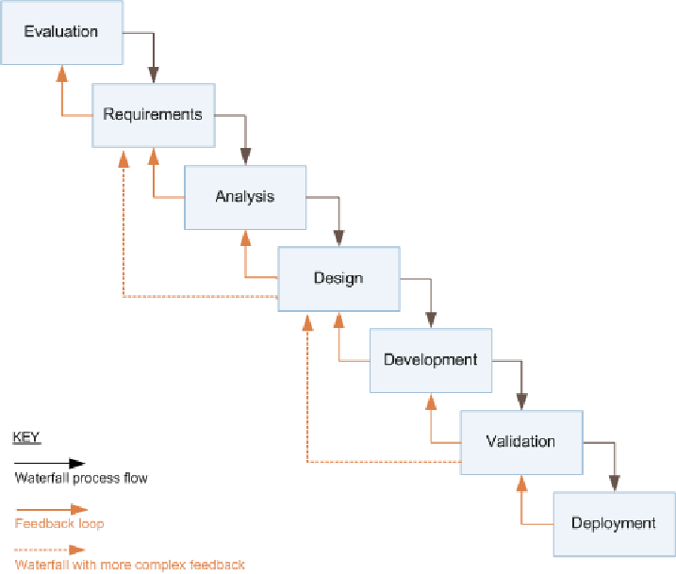

Figure 16: Iterative waterfall model (Ruparelia, 2010)

### Prototyping

A prototype is an early sample, model, or release of a product built to test a concept or process or to act as a thing to be replicated or learned from (Lumitex, 2017). This implies that a prototype is an instrument to evaluate an idea. In prototype methodology, a prototype of the project is made and it is then refined over and over till the app meets client satisfaction. The methodology makes addressing client requirement variation simpler. It is well suited for long-term projects where client requirement is not clear or is prone to frequent changes. (Lewis, 2019)

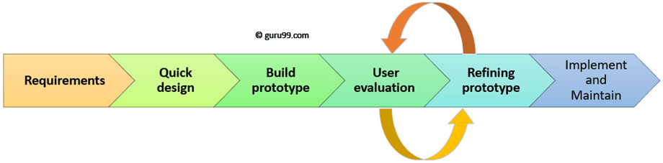

Figure 17: Prototyping Model (Martin, 2021)

### Feature Driven Development

An Agile methodology for developing software, Feature-Driven Development (FDD) is customer-centric, iterative, and incremental, with the goal of delivering tangible software results often and efficiently (PlanView, 2021). As the name suggests, this methodology focuses more on features. In FDD, a feature is expected to be delivered every 2-10 days. The methodology is followed using the below steps:

* Develop overall model
* Build feature list
* Plan by feature
* Design by feature
* Build by feature

Instead of traditional project milestones, FDD uses features to organize its activities. The first three steps are completed initially and the rest of the steps are repeated for every feature. If the client decides to add any more features or changes the requirements, the entirety of the five steps is carried out again in an incremental fashion. (PlanView, 2021)

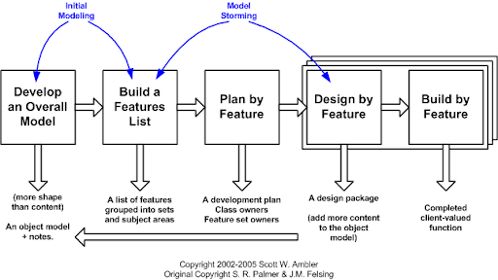

Figure 18: FDD project Lifecycle (Abler, 2021)

## Adopted Methodology (FDD)

Despite being a methodology for large projects, I adopted Feature Driven Development due to the following reasons:

* The methodology requires fewer meetings and is documentation-oriented.
* It uses a user-centric approach with the client in mind.
* It is very scalable and can address the growth of the project.
* It breaks feature sets into smaller chunks and regular iterative releases, which makes it easier to track and fix coding errors, reduces risk, and allows you to make a quick turnaround to meet your client’s needs (Lucid Content Team, 2021).

Further Content: [Appendix A](#_Appendix_A_(Development))

## Phases of Adopted Methodology

### Initiation

In this phase information regarding features that are to be included in the application is identified. The requirements were gathered from the client primarily, while also taking references from other property management websites.

|  |  |
| --- | --- |
| **Task** | **Estimated Duration (days)** |
| Requirement Gathering | 3 |
| Client meeting (Requirement Discussion) | 1 |
| Risk analysis | 3 |
| Client meeting (Terms agreement) | 2 |
| Research on Project and Technologies | 7 |

Table 2: Initiation of Project

### Overall Model

In this phase, a high-level model representing the scope of the project was drawn. Then, a detailed domain model was developed which represents the business logic of the system.

|  |  |
| --- | --- |
| **Task** | **Estimated Duration (days)** |
| Identifying Objects | 1 |
| High Level Overview (Use Case Diagram) | 1 |
| Domain Object Model | 4 |

Table 3: Developing Overall Model of Project

### Feature List

Features are small pieces of client-valued modules of the system. They are usually expressed in the form of “<action<result><object>”, for example: ‘Validate user credentials’, or ‘Render map data’, etc. These are usually completed within two weeks of development time.

In this phase, the features are identified and added to a list. If a feature seems to take more than two weeks to complete, it is broken down into smaller features and added to the list.

|  |  |
| --- | --- |
| **Task** | **Estimated Duration (days)** |
| Identifying Features | 1 |
| Breaking Down Features | 2 |
| Developing Feature List | 3 |

Table 4: Developing Overall Model of Project

### Plan by Feature

After building the feature list, a plan is created which typically dictates the order and ownership of features. This phase includes such planning.

|  |  |
| --- | --- |
| **Task** | **Estimated Duration (days)** |
| Identifying Feature Owners | 0 |
| Planning Feature Sequence | 15 |

Table 5: Developing Overall Model of Project

### Design by Feature

In this phase, the overall model is re-evaluated (also known as conceptual design) and sequence diagrams are drawn for each feature (also known as technical designs).

|  |  |
| --- | --- |
| **Task** | **Estimated Duration (days)** |
| Conceptual Design Review | 12 |
| Sequence Diagrams for Features | 14 |
| Technical Design Review | 7 |

Table 6: Developing Overall Model of Project

### Build by Feature

In this phase, a feature is built, code review is conducted and unit testing for the feature is done. If the unit testing succeeded, it is later added to the main build as well. It is an iterative process.

|  |  |
| --- | --- |
| **Task** | **Estimated Duration per Feature (days)** |
| Identifying Feature Execution plan | 1 |
| Develop Feature | 3-14 |
| Unit testing / Debugging | 4 |

Table 7: Developing Overall Model of Project

## Survey Results

### Presurvey Results:

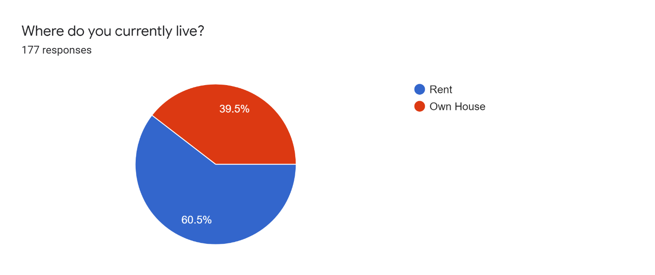

Figure 19: Presurvey result 1

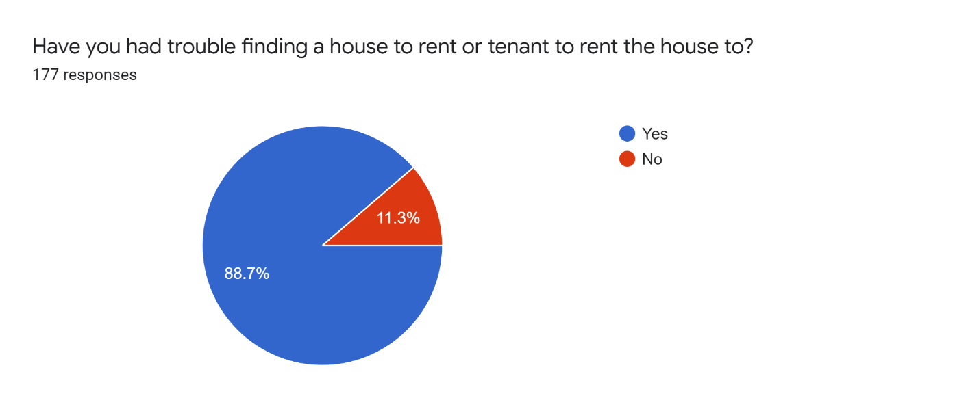

Figure 20: Presurvey Result 2

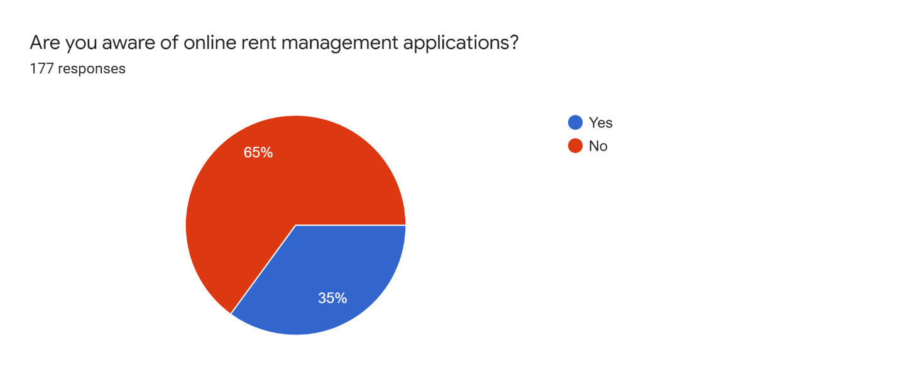

Figure 21: Presurvey Result 3

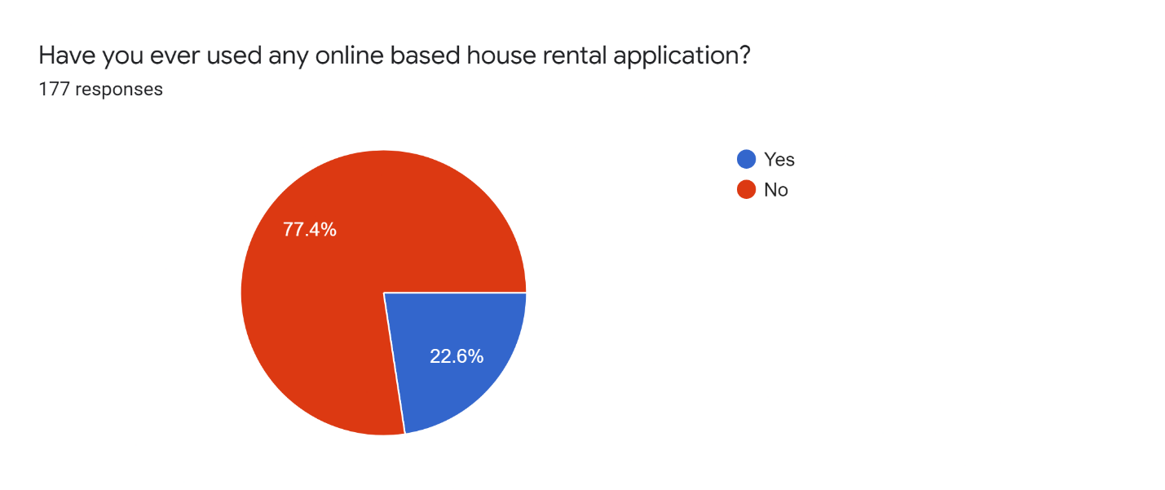

Figure 22: Presurvey Result 4

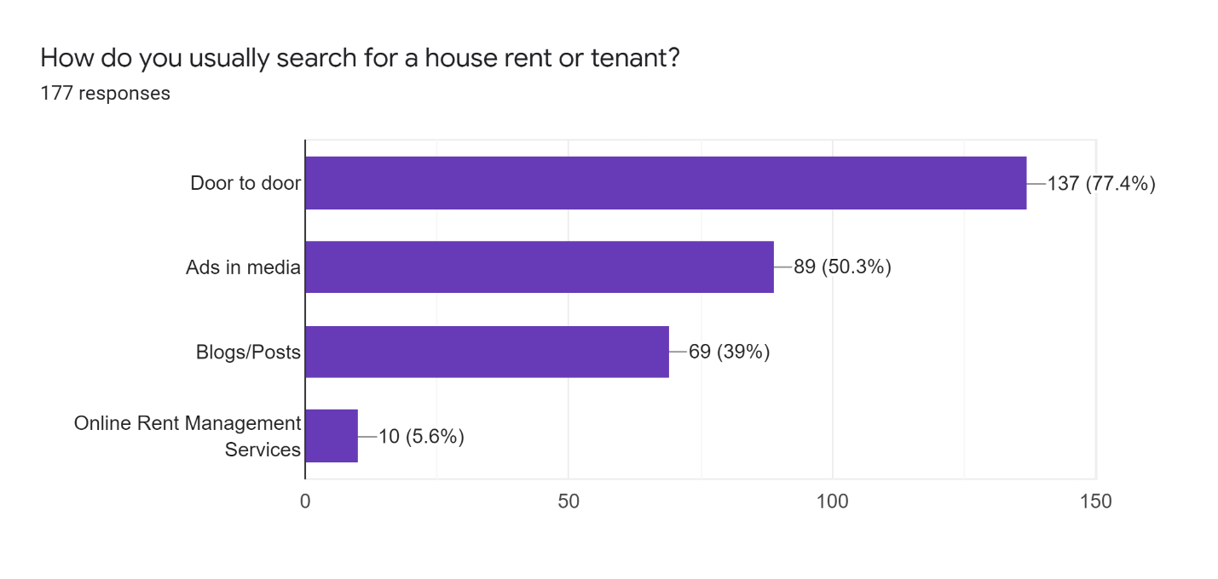

Figure 23: Presurvey Result 5

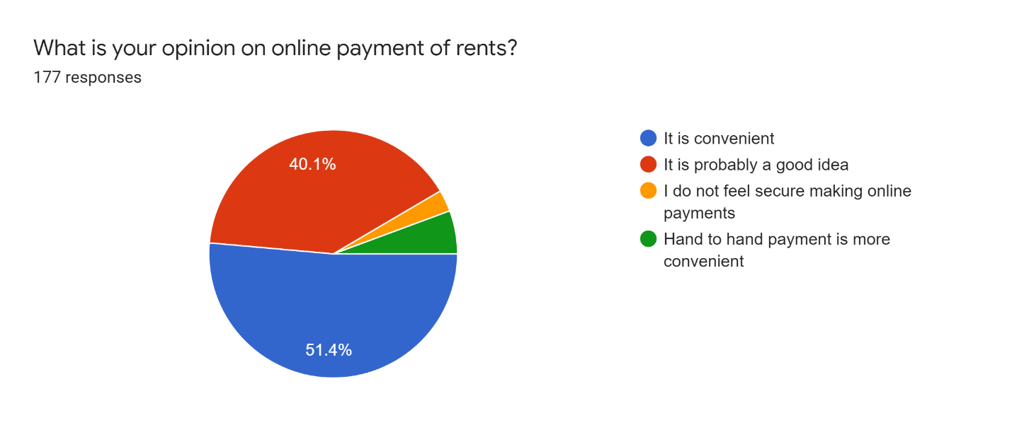

Figure 24: Presurvey Result 6

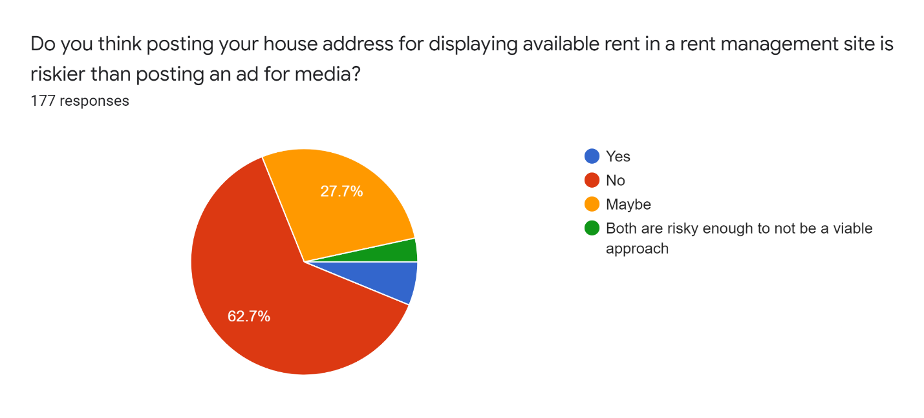

Figure 25: Presurvey Result 7

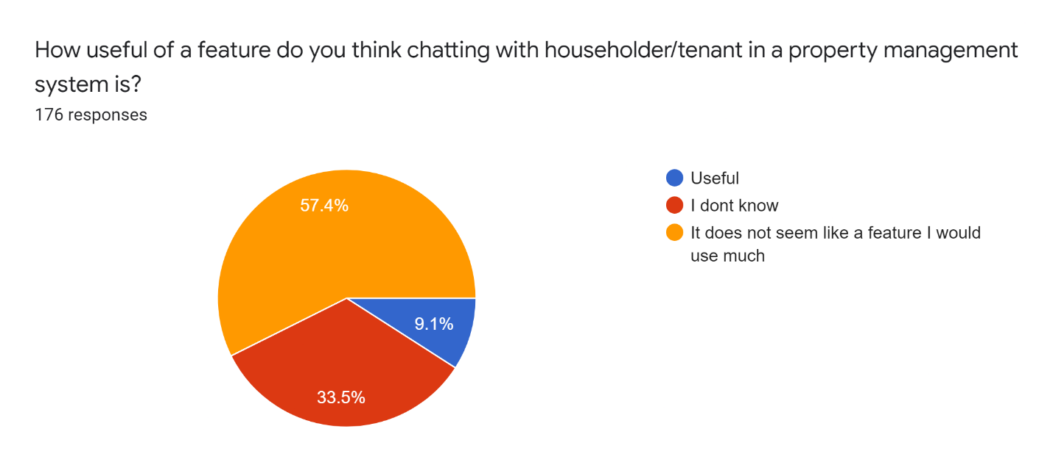

Figure 26: Presurvey Result 8

### Postsurvey Results

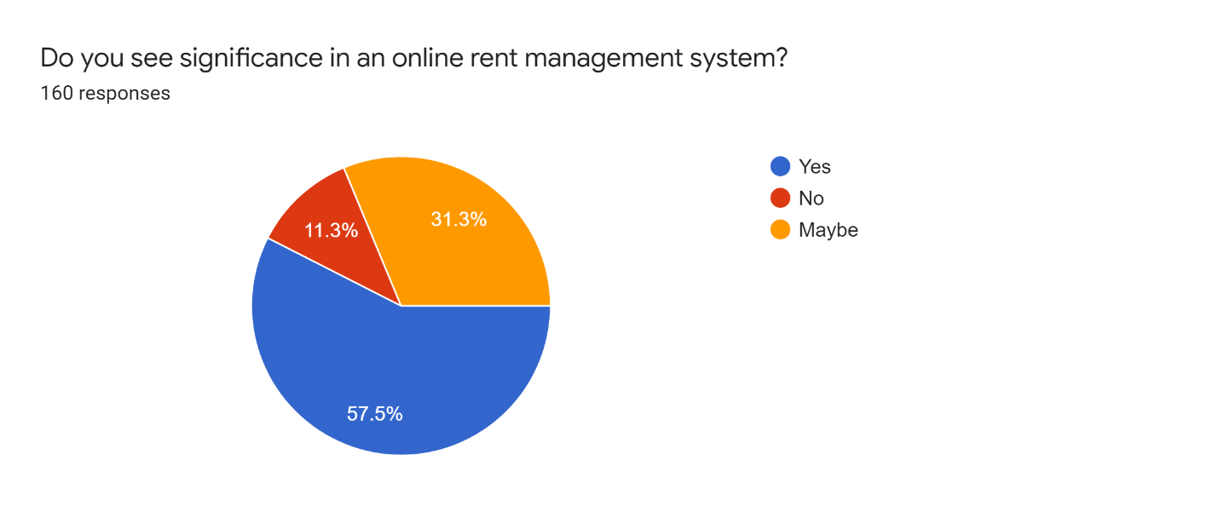

Figure 27: Postsurvey Results 1

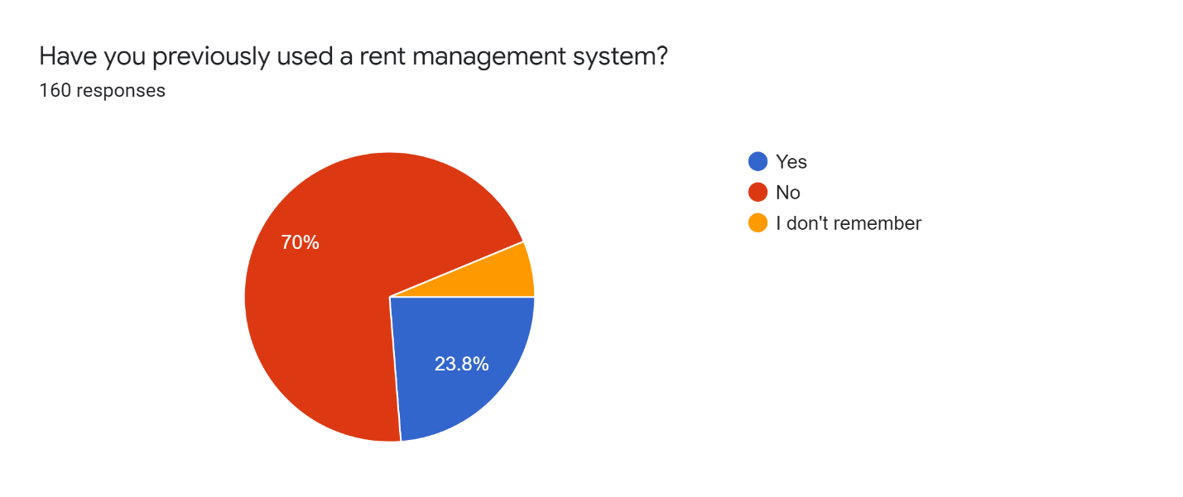

Figure 28: Postsurvey Results 2

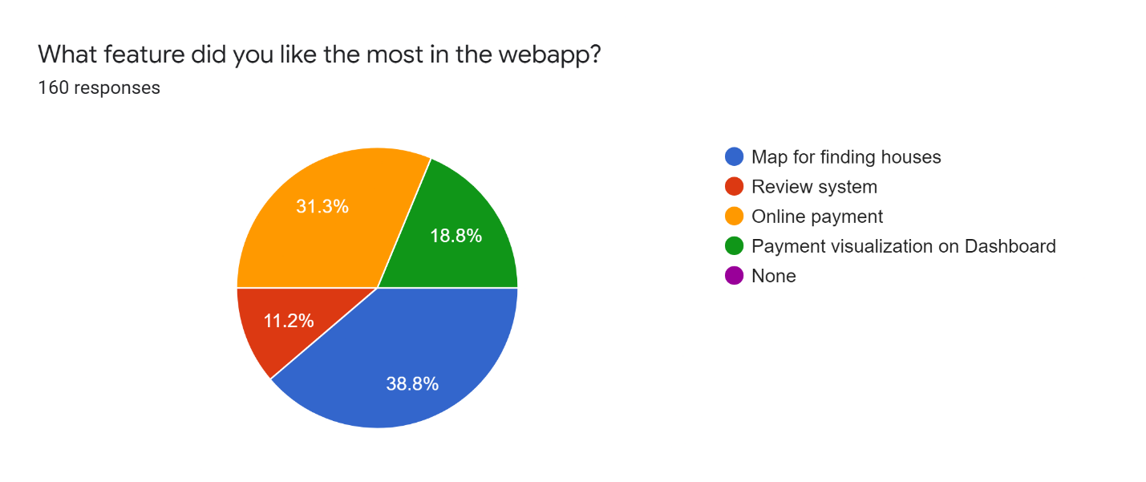

Figure 29: Postsurvey Results 3

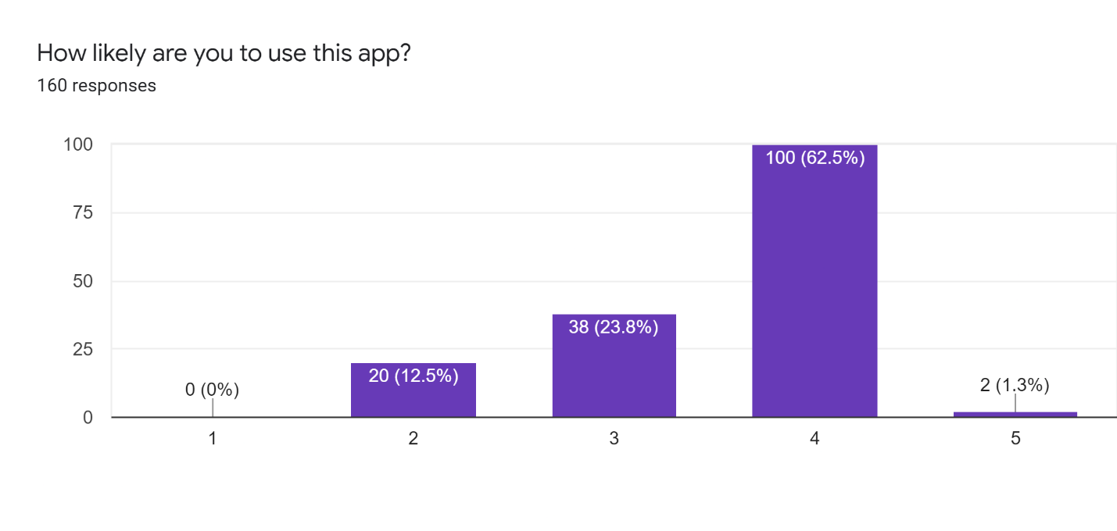

Figure 30: Postsurvey Results 4

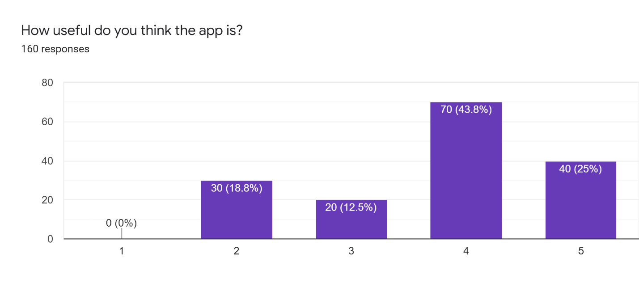

Figure 31: Postsurvey Results 5

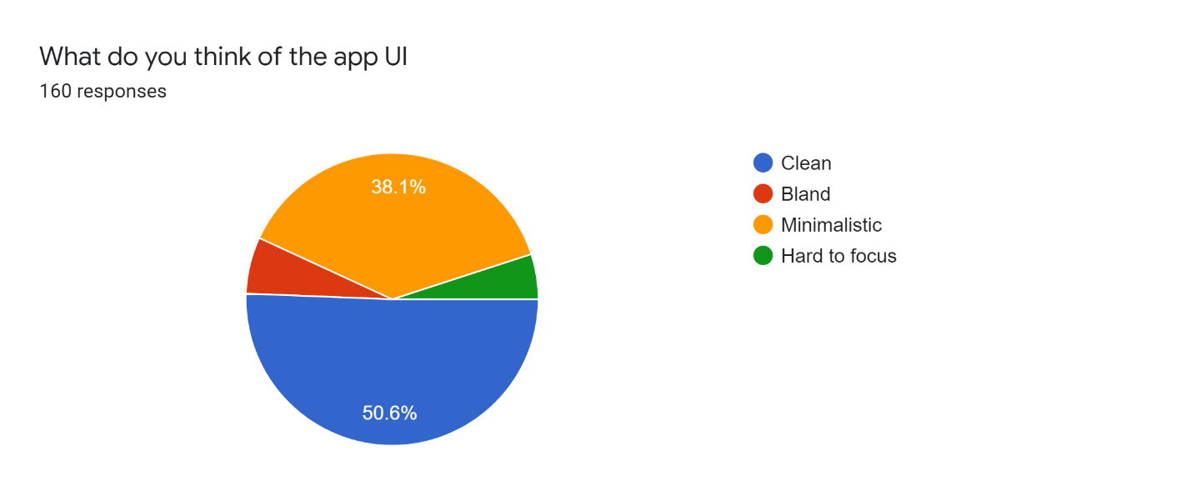

Figure 32: Postsurvey Results 6

## Requirement Analysis

The project is a webapp for managing house rental. Hence, it does not require any specific hardware to run it. Any device with a working internet connection and a web browser can run access the webapp.

Some requirements for accessing this web application are:

* Smartphone, laptop, or smart television
* Stable internet connection
* Web browser: Google Chrome, Firefox

Some requirements for running the webapp are:

* A server environment capable of running NodeJs for hosting the React server.
* A server environment capable of running WSGI or ASGI for hosting the Django backend server.

#### Generalized list of requirements

##### Functional

* User can register as a householder or a tenant
* User can login to access the system
* User registered as householder can add houses
* User registered as householder can add bills
* User can look at available houses in the map
* User registered as tenant can pay bills online
* User cannot access the page without registration
* User registered as tenant can review houses

##### Non-Functional

* User can get information about the houses
* User can view a house reviews and ratings
* User can view visualized payment history
* User has a way of navigating through the webapp

### Gantt Chart

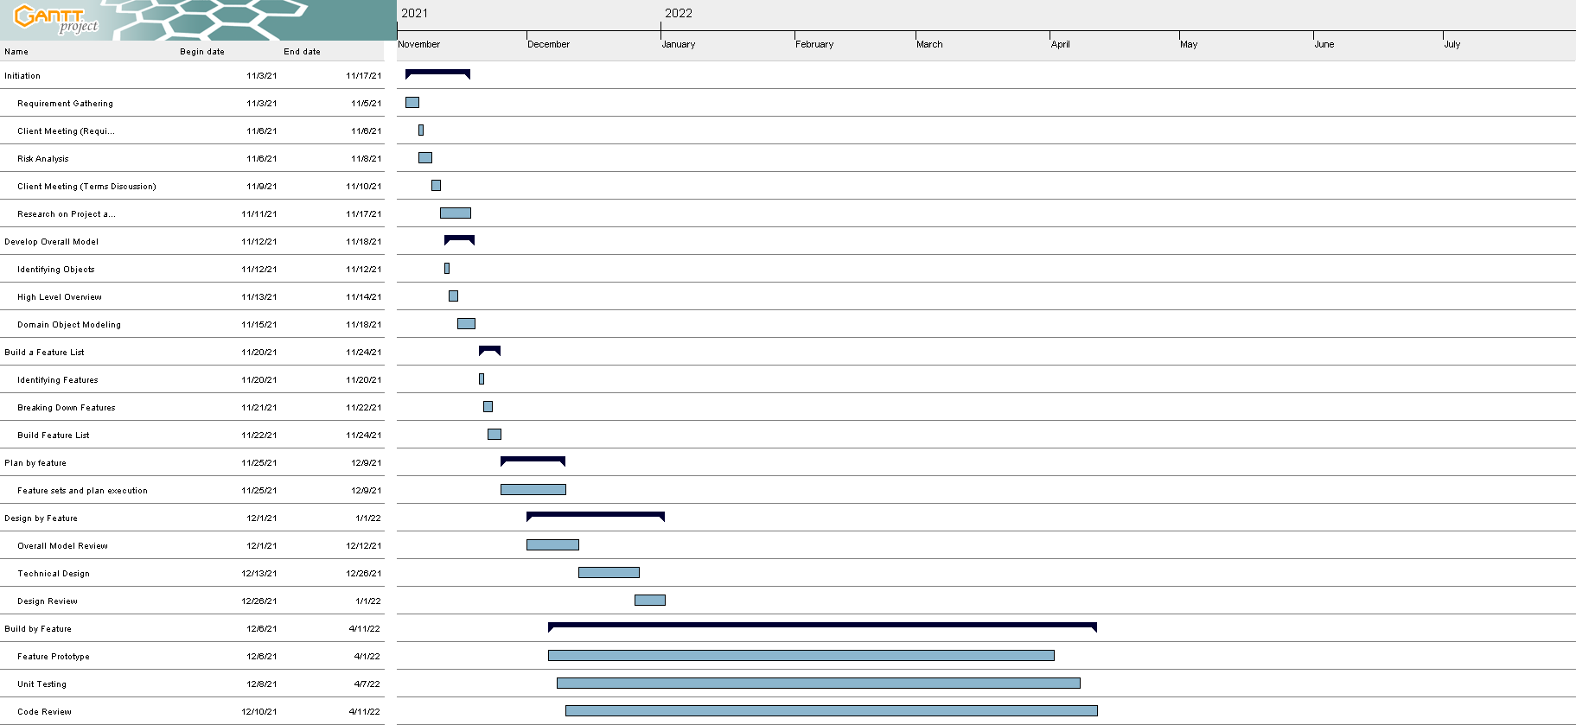

Figure 33: Revised Gantt Chart

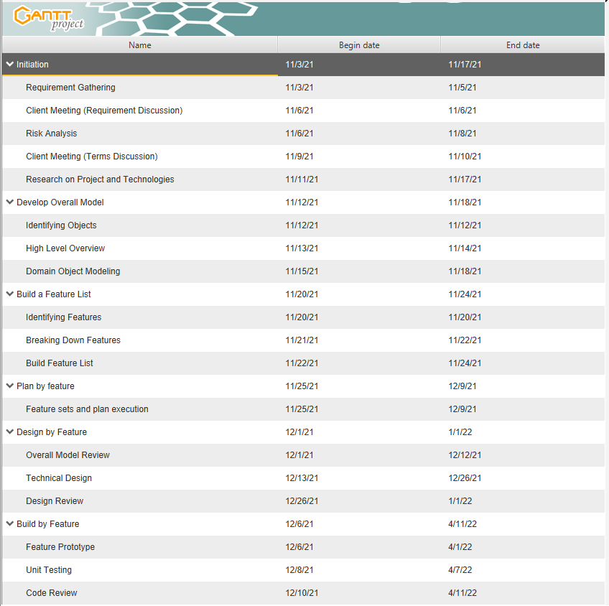

Figure 34: Gantt Chart Contents

## Designs

### Work Breakdown Structure

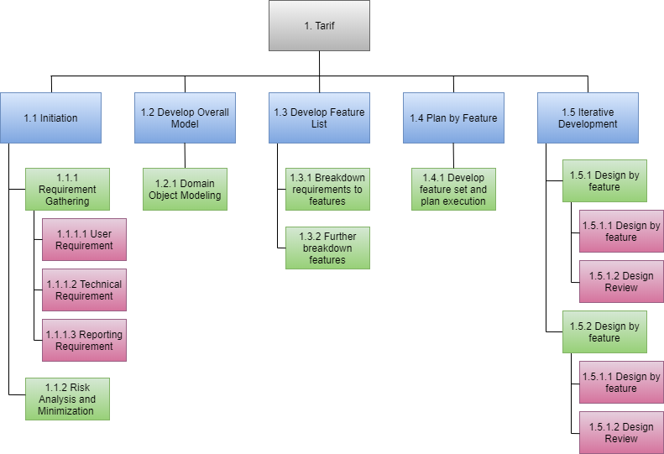

Figure 35: Work Breakdown Structure

### Use Case Diagram

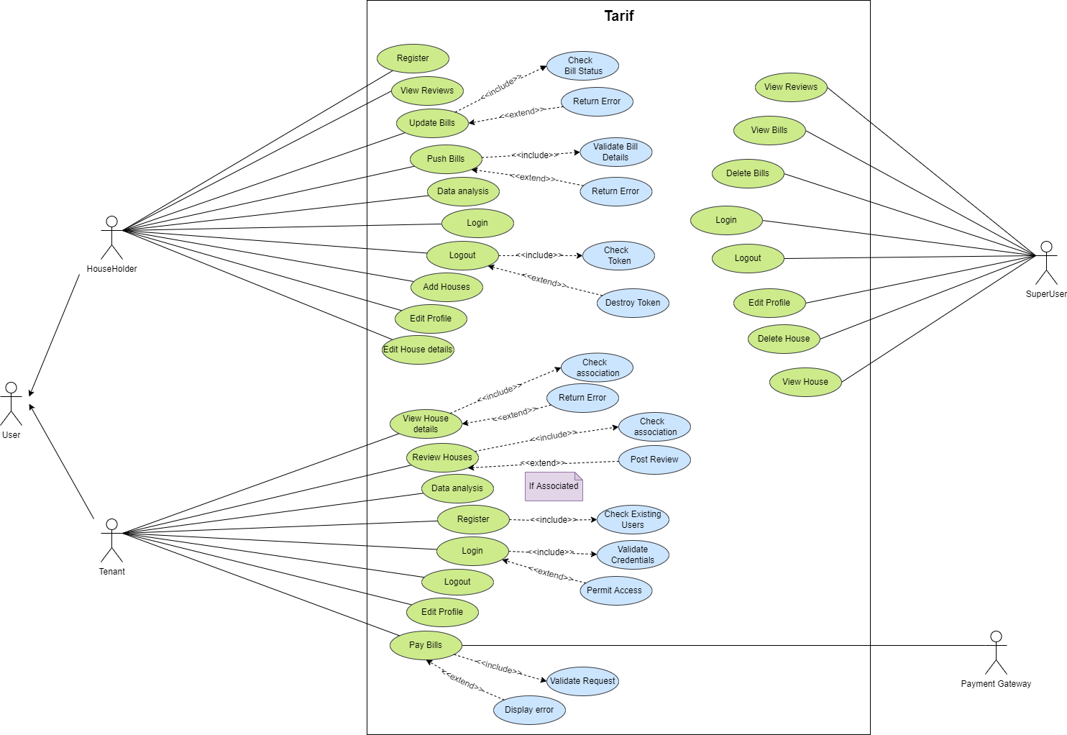

Figure 36: Use Case Diagram

### Wireframes

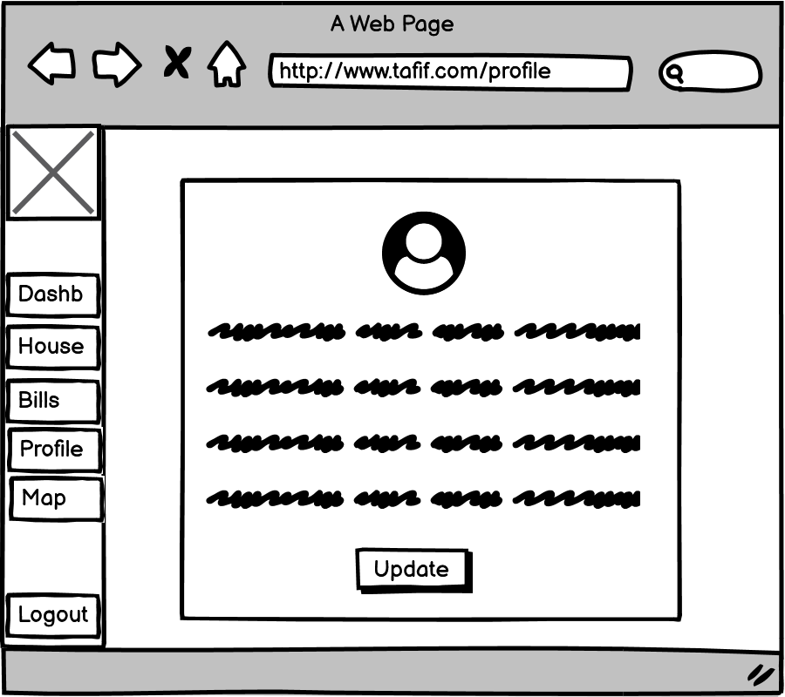

Figure 37: Householder Profile Tab

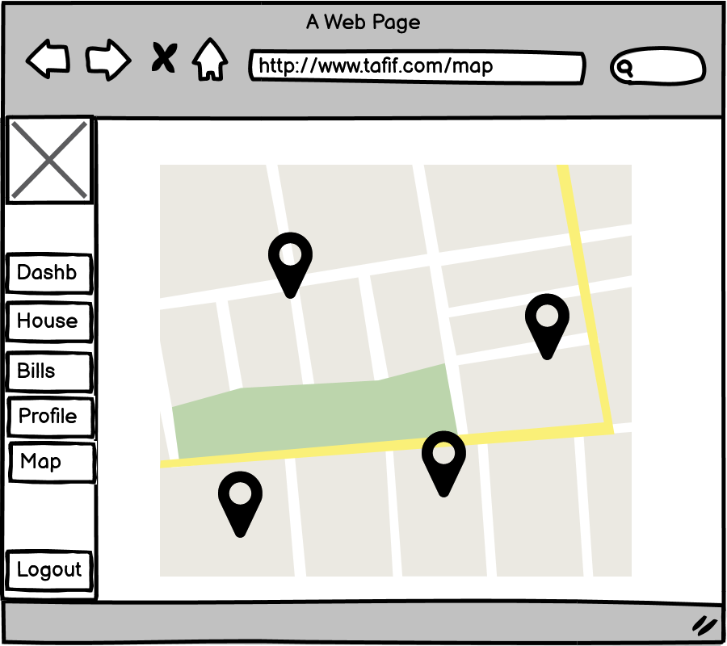

Figure 38: Householder Map view

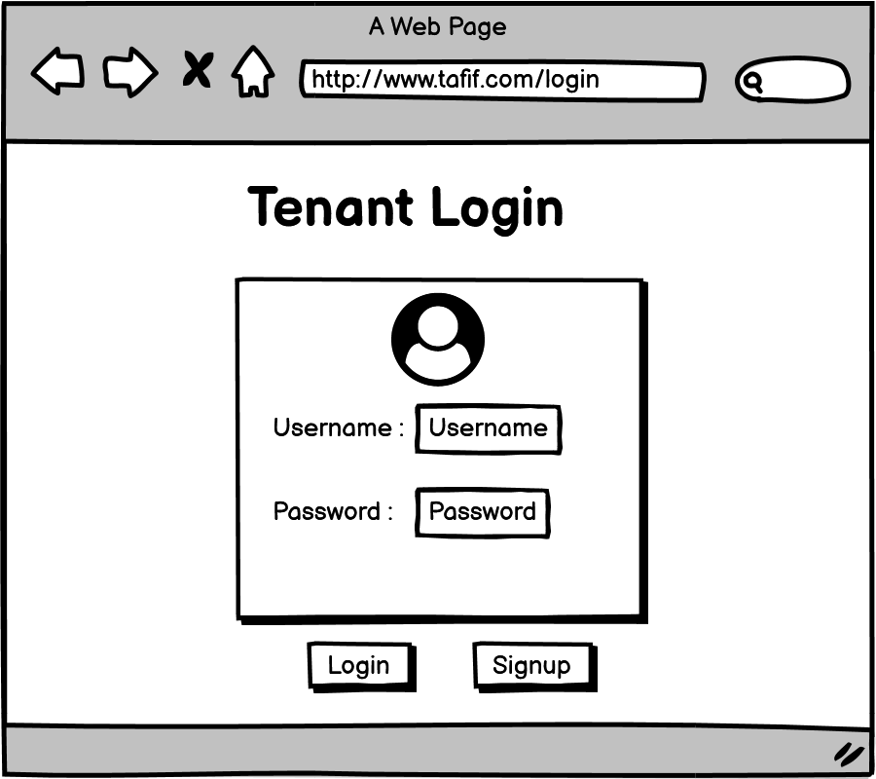

Figure 39: Tenant Login

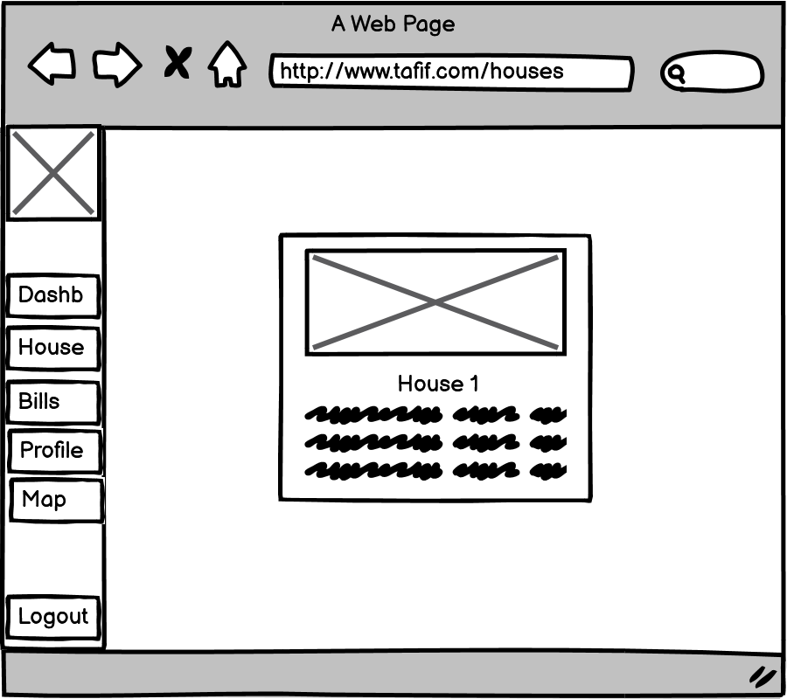

Figure 40: Tenant House view

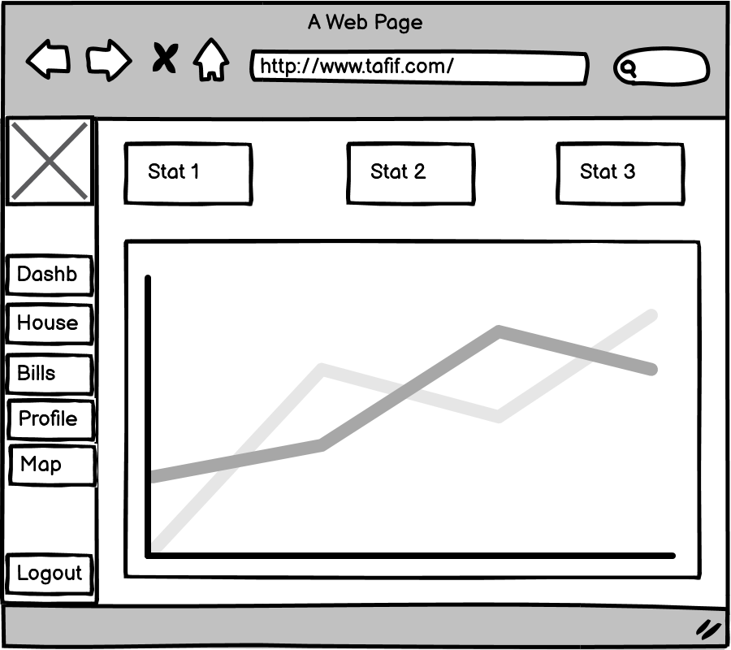

Figure 41: Tenant Dashboard view

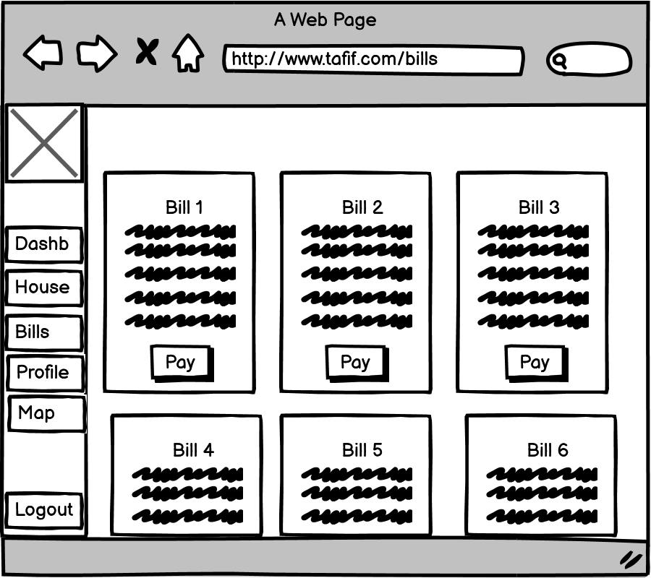

Figure 42: Tenant Bills view

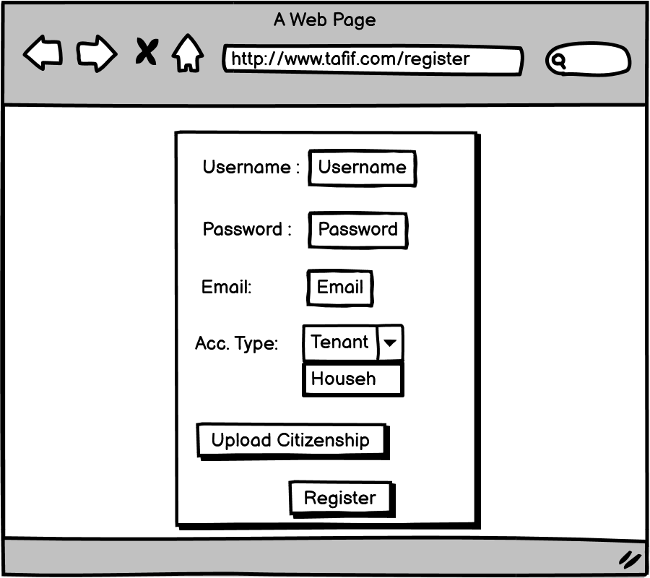

Figure 43: Register User view

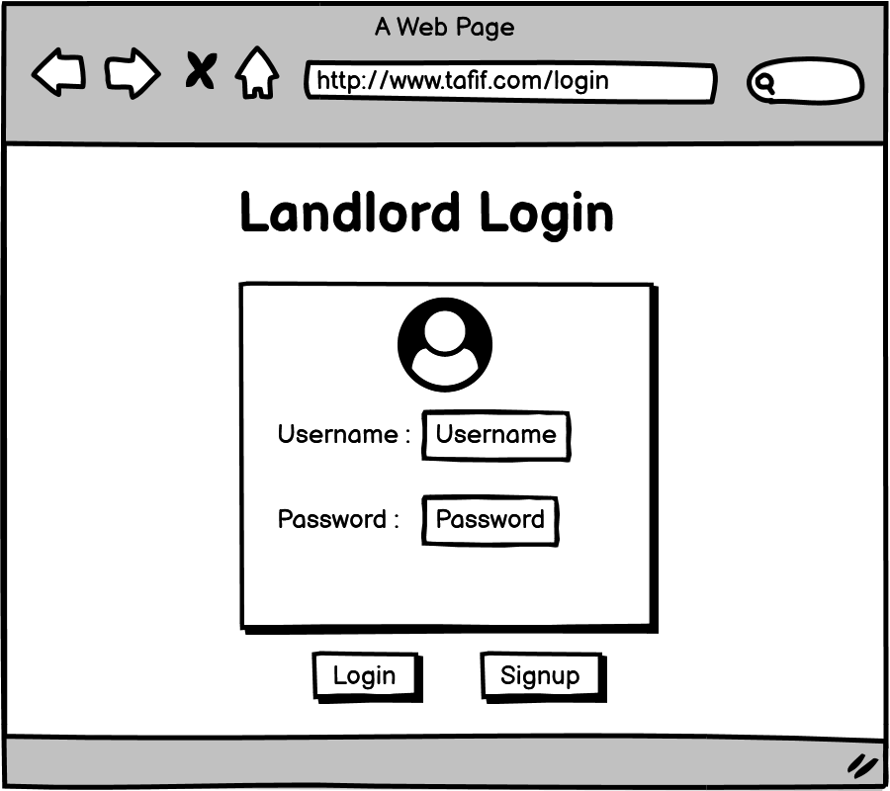

Figure 44: Login Landlord view

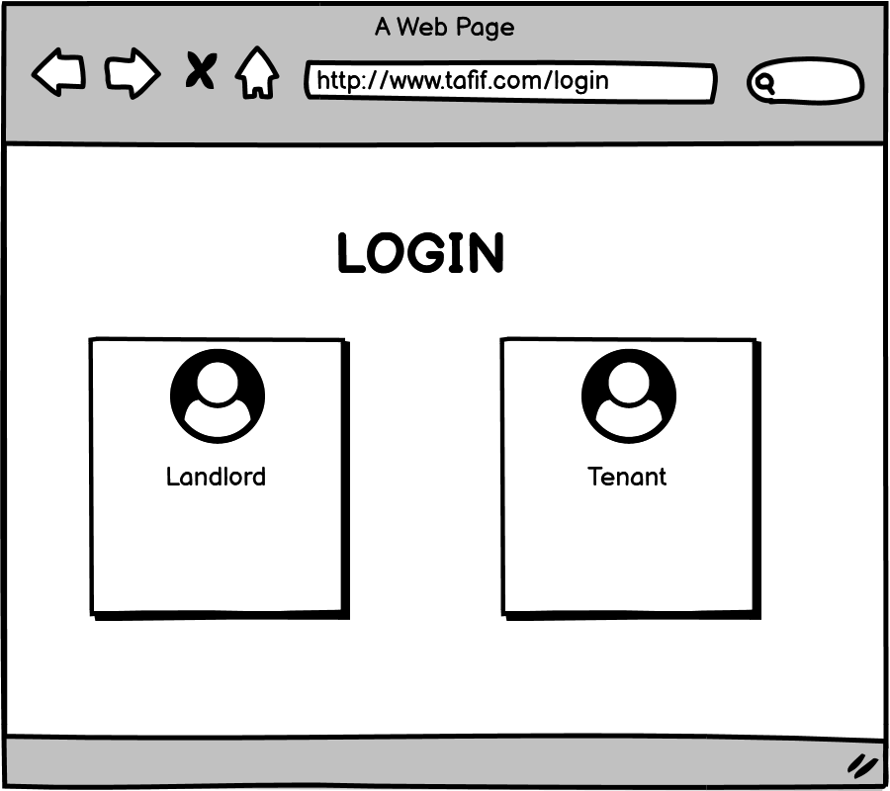

Figure 45: Login Portal View



Figure 46: Tenant Profile view



Figure 47: Tenant map view

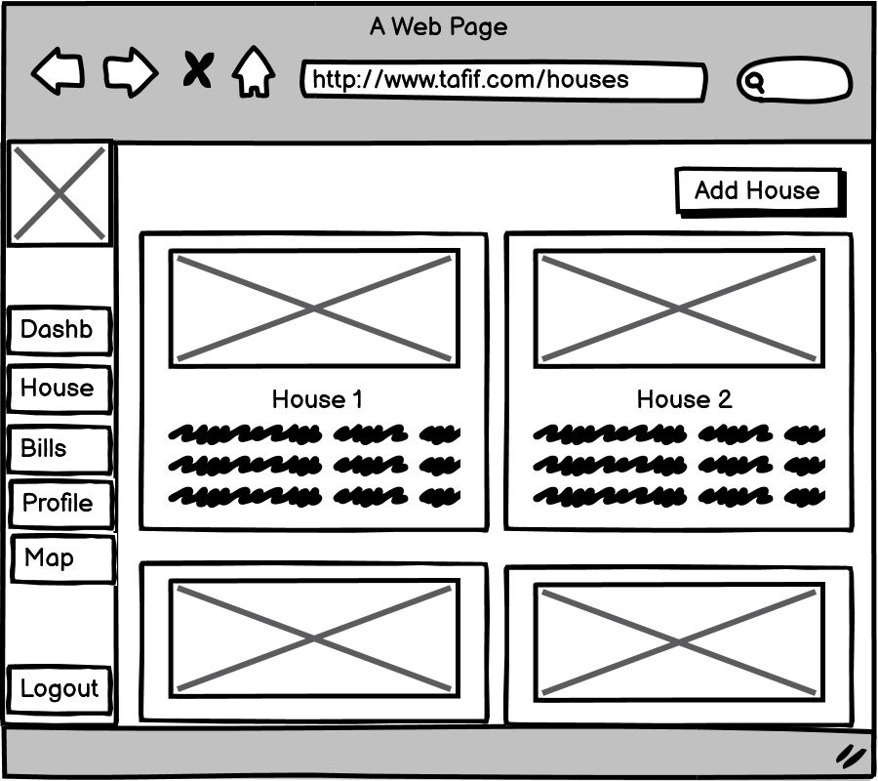

Figure 48: Householder Houses view

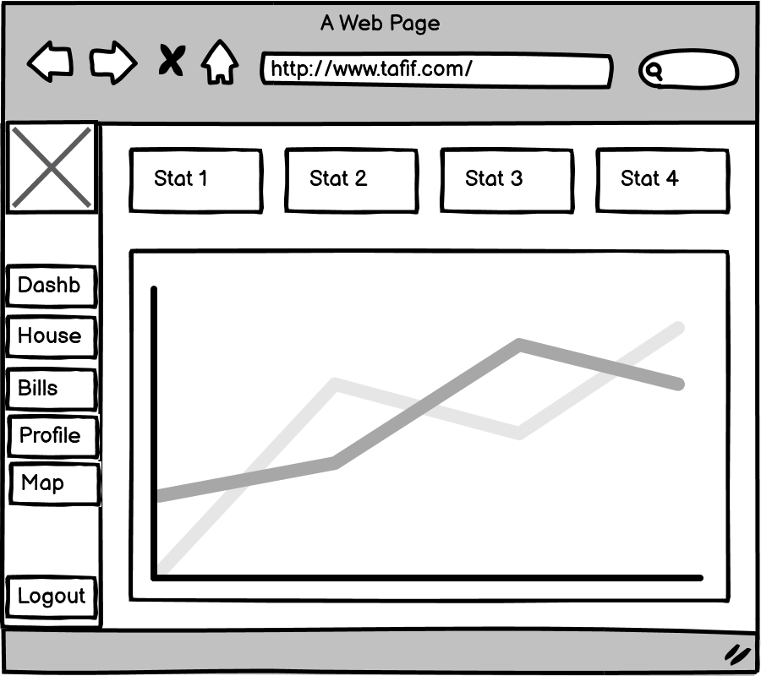

Figure 49: Householder Dashboard view

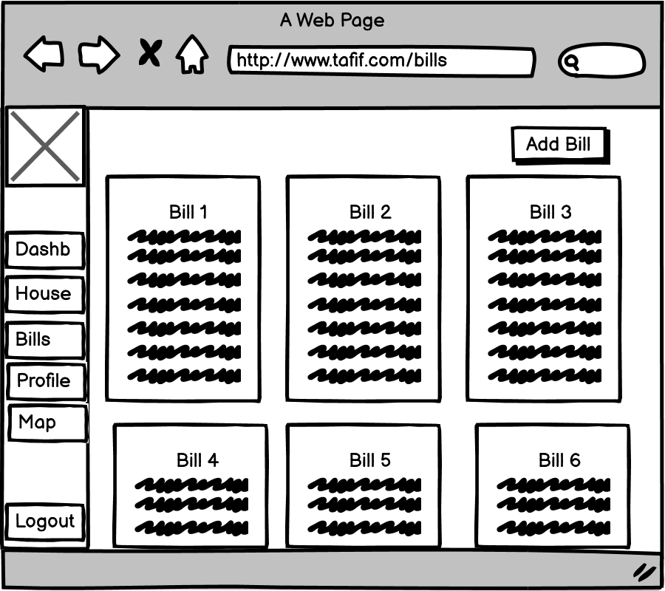

Figure 50: Householder Bills view

### UI Designs

##### Preliminary UI Designs

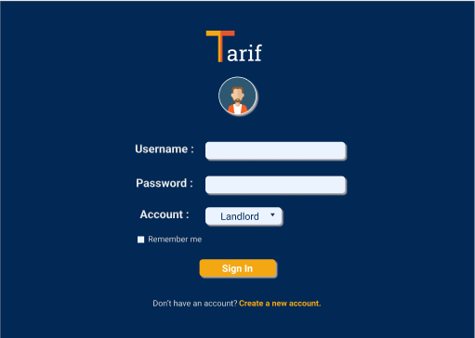

Figure 51: Sign-in page UI

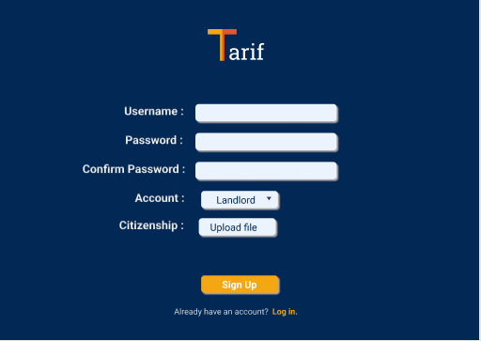

Figure 52: Sign up page UI

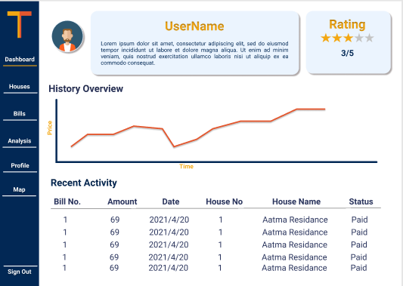

Figure 53: Home Page UI

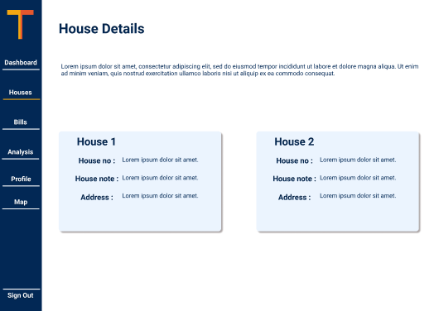

Figure 54: Houses page UI

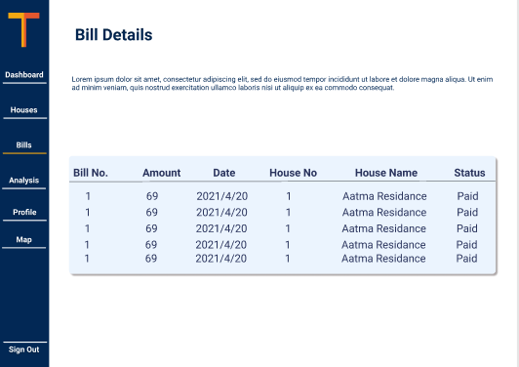

Figure 55: Bills page UI

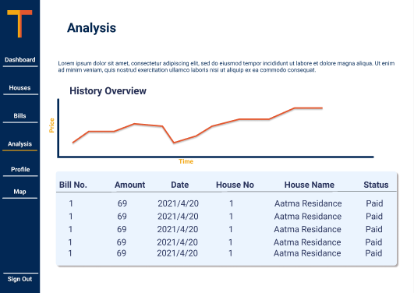

Figure 56: Analysis page UI

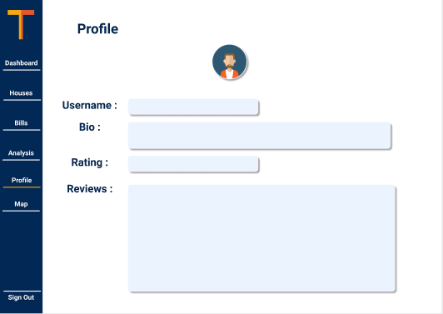

Figure 57: Profile page UI

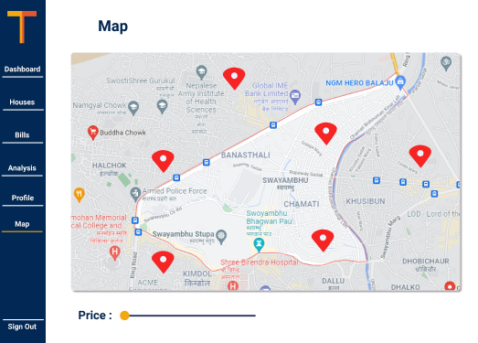

Figure 58: Map page UI

##### Final UI Designs

### Use Cases

#### Use Case Diagram

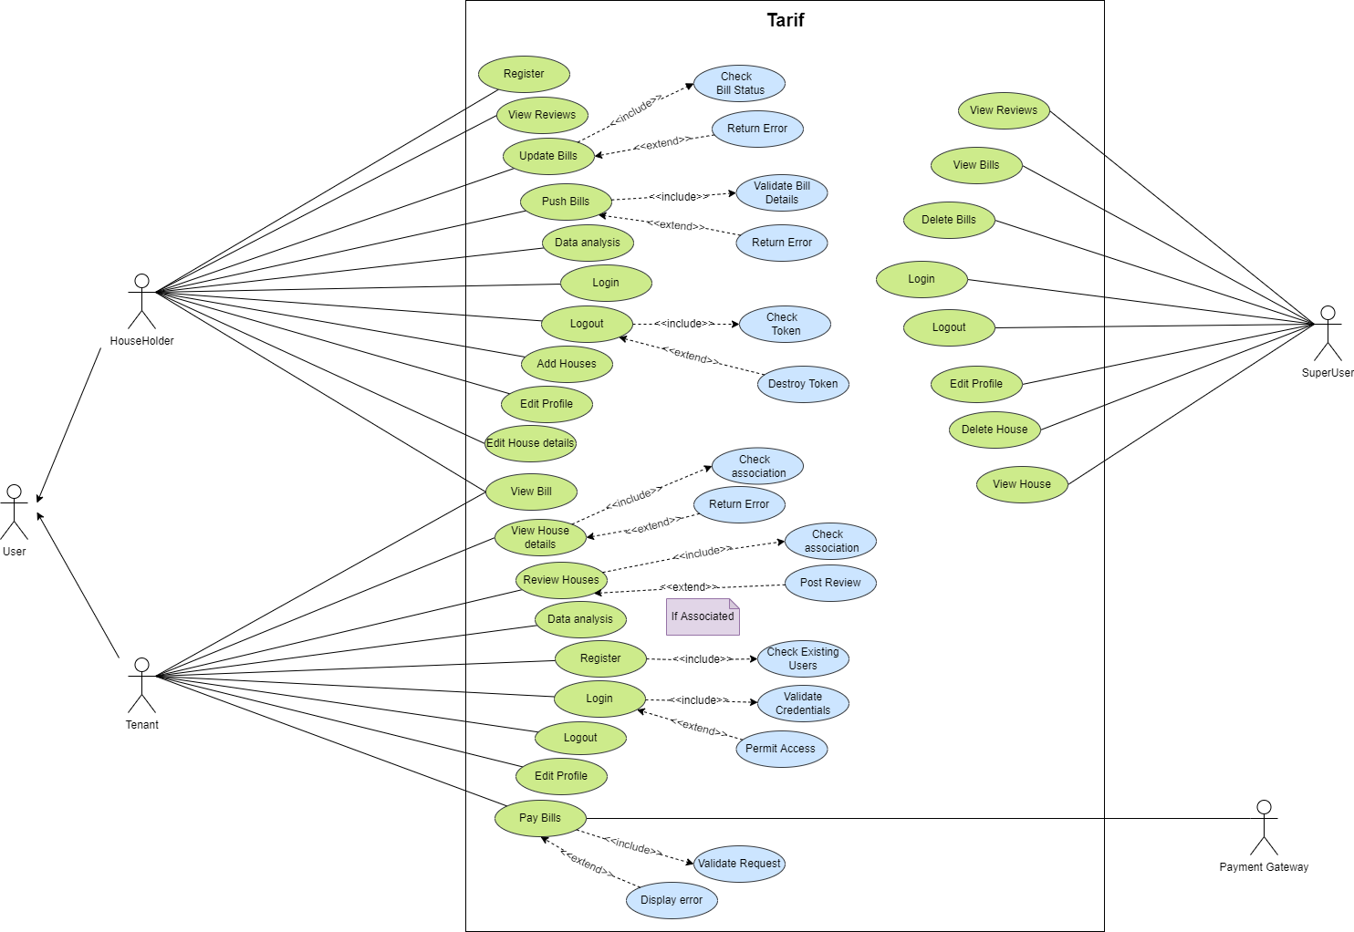

Figure 59: Use Case Diagram

#### High-Level Description

**Use Case 1**

|  |  |
| --- | --- |
| **Use Case** | **Register** |
| Actor | User |
| Description | The user enters their details in the system. The system checks if the user is already registered. If not, the registration executes successfully, otherwise, the system gives an appropriate error message to the user. |

Table 8: High level description of Register

**Use Case 2**

|  |  |
| --- | --- |
| **Use Case** | **View Reviews** |
| Actor | User |
| Description | The user registered as a householder can view reviews of the houses added by the user. |

Table 9: High level description of View Reviews

**Use Case 3**

|  |  |
| --- | --- |
| **Use Case** | **Add Bill** |
| Actor | Householder |
| Description | The householder enters the bill details and presses the add bill button. The system then calculates the bill and adds the bill in the database. |

Table 10: High level description of Add Bills

**Use Case 4**

|  |  |
| --- | --- |
| **Use Case** | **Register House** |
| Actor | Householder |
| Description | The householder fills in the details of their house and registers it in the system. Registered houses can then be displayed as available for rent by the system. |

Table 11: High level description of Register House

**Use Case 5**

|  |  |
| --- | --- |
| **Use Case** | **Update Bill** |
| Actor | Householder |
| Description | The householder selects the bill status as paid to update the bill. No other details of the bill can be updated. Once the bill is marked as paid, its status can also not be updated any further. |

Table 12: High level description of Update Bill

**Use Case 6**

|  |  |
| --- | --- |
| **Use Case** | **Data analysis** |
| Actor | Householder, Tenant |
| Description | The householder or tenant are displayed their details collected by the system in the form of a line chart. |

Table 13: High level description of Data analysis

**Use Case 7**

|  |  |
| --- | --- |
| **Use Case** | **Login** |
| Actor | Householder, Tenant, Superuser |
| Description | The householder or tenant or superuser fills in their credentials and presses the login button. The user is then displayed their corresponding app UI if the provided credentials were valid. Superuser login is carried out by a separate UI directly linked to the backend server. |

Table 14: High level description of Login

**Use Case 8**

|  |  |
| --- | --- |
| **Use Case** | **Logout** |
| Actor | Householder, Tenant, Superuser |
| Description | The householder or tenant or superuser clicks logout button. Logged out into the login UI. Superuser logout is carried out by a separate UI directly linked to the backend server. |

Table 15: High level description of Logout

**Use Case 9**

|  |  |
| --- | --- |
| **Use Case** | **Edit Profile** |
| Actor | Householder, Tenant |
| Description | The householder or tenant presses the edit button. The new data is then updated. |

Table 16: High level description of Edit Profile

**Use Case 10**

|  |  |
| --- | --- |
| **Use Case** | **Edit House Details** |
| Actor | Householder |
| Description | The householder presses the edit button and gets redirected to a page where fields in the house page then become editable and the householder updates new data in the fields. |

Table 17: High level description of Edit House Details

**Use Case 11**

|  |  |
| --- | --- |
| **Use Case** | **View House Details** |
| Actor | Householder, Tenant |
| Description | The householder can view their own house details and tenant can view all house details. |

Table 18: High level description of View House Details

**Use Case 12**

|  |  |
| --- | --- |
| **Use Case** | **Pay Bills** |
| Actor | Payment gateway, Tenant |
| Description | The tenant presses the pay button. A confirmation message pops up and the payment gateway is activated. |

Table 19: High level description of Pay Bills

**Use Case 13**

|  |  |
| --- | --- |
| **Use Case** | **Review House Details** |
| Actor | Tenant |
| Description | The tenant can review houses and tenant can view all house reviews. |

Table 20: High level description of Review House Details

**Use Case 14**

|  |  |
| --- | --- |
| **Use Case** | **View Bills** |
| Actor | Tenant, Householder |
| Description | The tenant or the householder can view the bills they received or sent respectively. |

Table 21: High level description of Review House Details

#### Sequence Diagrams

**Use Case 1: Register**

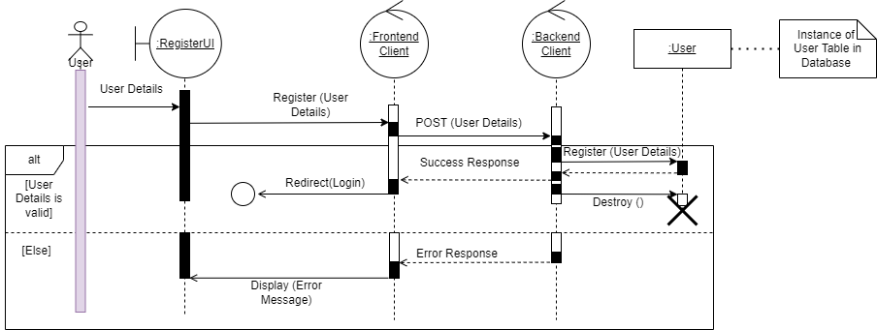

Figure 60: Register Sequence Diagram

**Use Case 2: View Reviews**

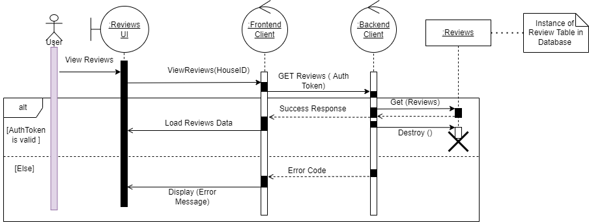

Figure 61: View Reviews Sequence Diagram

**Use Case 3: Update Bills**

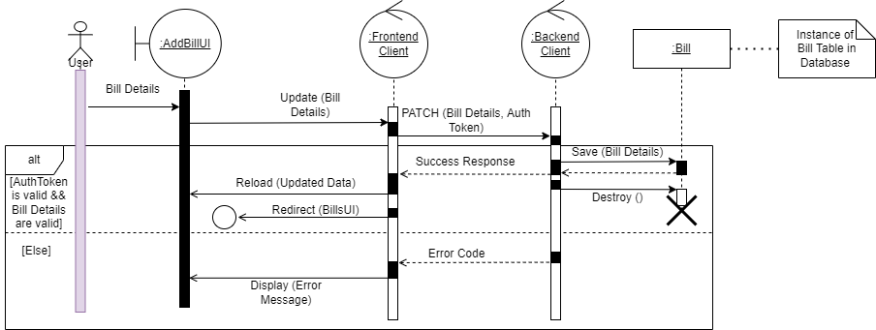

Figure 62: Update Bills Sequence Diagram

**Use Case 4: Push Bills**

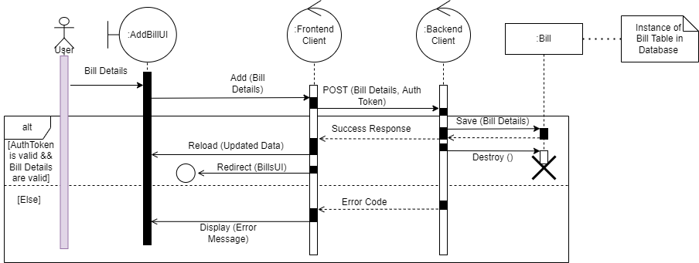

Figure 63: Push Bills Sequence Diagram

**Use Case 5: Data Analysis**

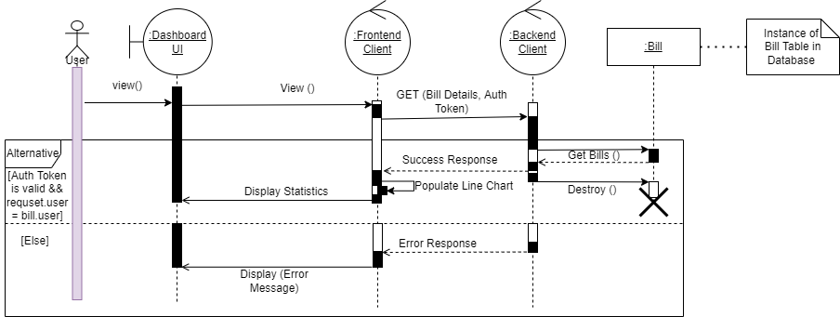

Figure 64: Data analysis Sequence Diagram

**Use Case 6: Login**

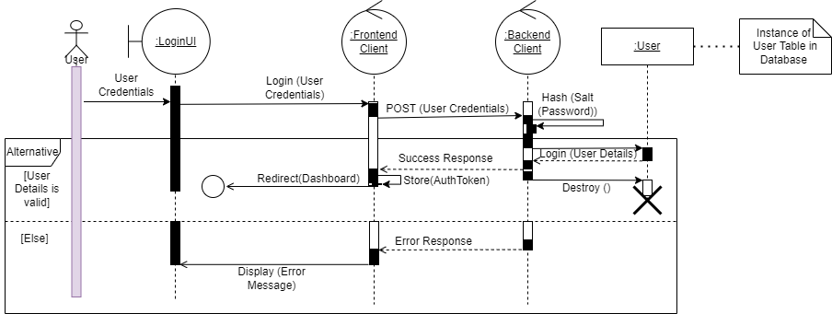

Figure 65: Login Sequence Diagram

**Use Case 7: Logout**

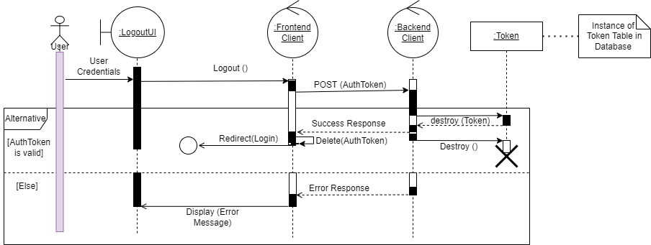

Figure 66: Logout Sequence Diagram

**Use Case 8: Add House**

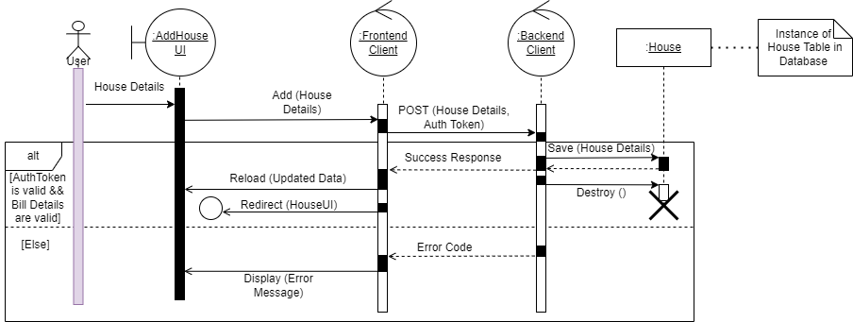

Figure 67: Add House Sequence Diagram

**Use Case 9: Edit Profile**

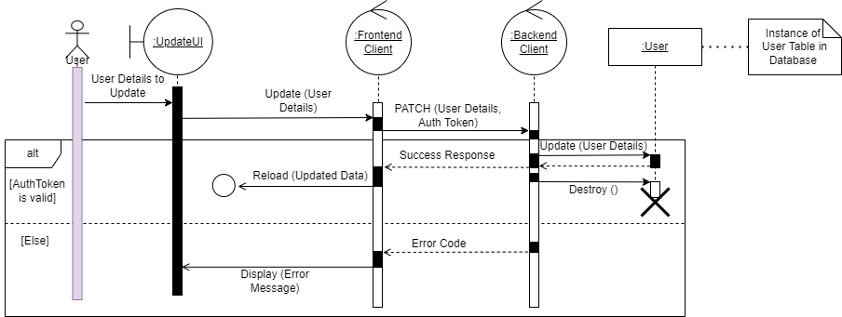

Figure 68: Edit Profile Sequence Diagram

**Use Case 10: Edit House Details**

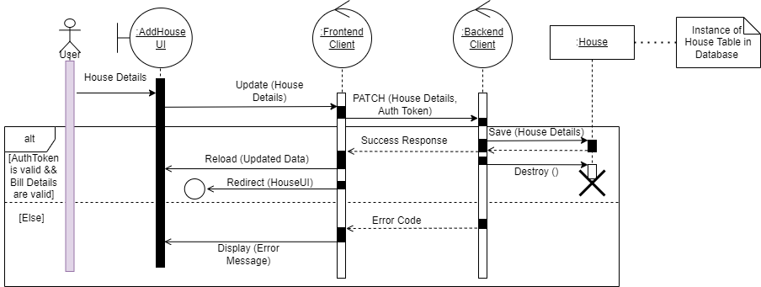

Figure 69: Edit House Details Sequence Diagram

**Use Case 11: View House Details**

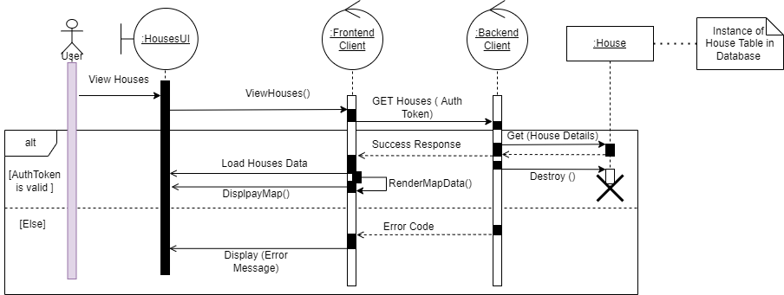

Figure 70: View House Details Sequence Diagram

**Use Case 12: Review Houses**

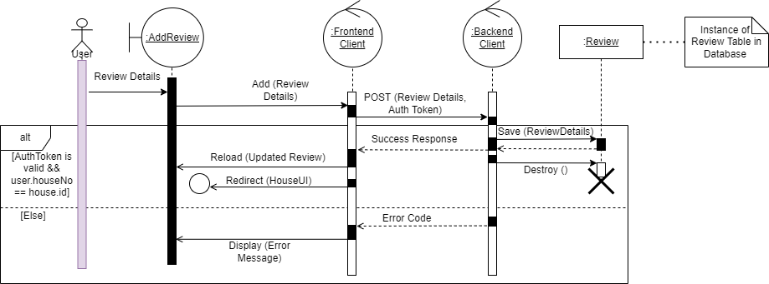

Figure 71: Review Houses Sequence Diagram

**Use Case 13: Pay Bills**

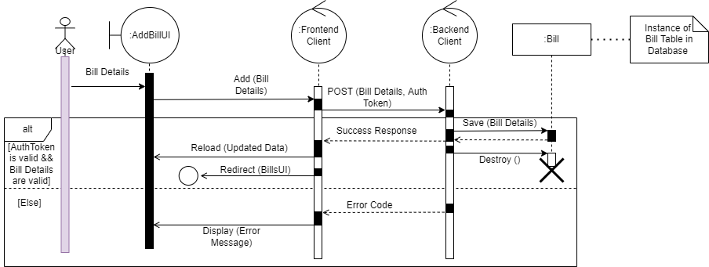

Figure 72: Pay Bills Sequence Diagram

**Use Case 14: View Bills**

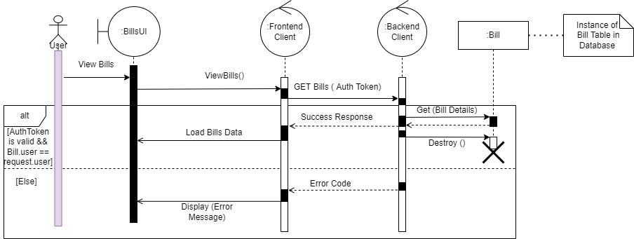

Figure 73: View Bills Sequence Diagram

### Domain Object Model

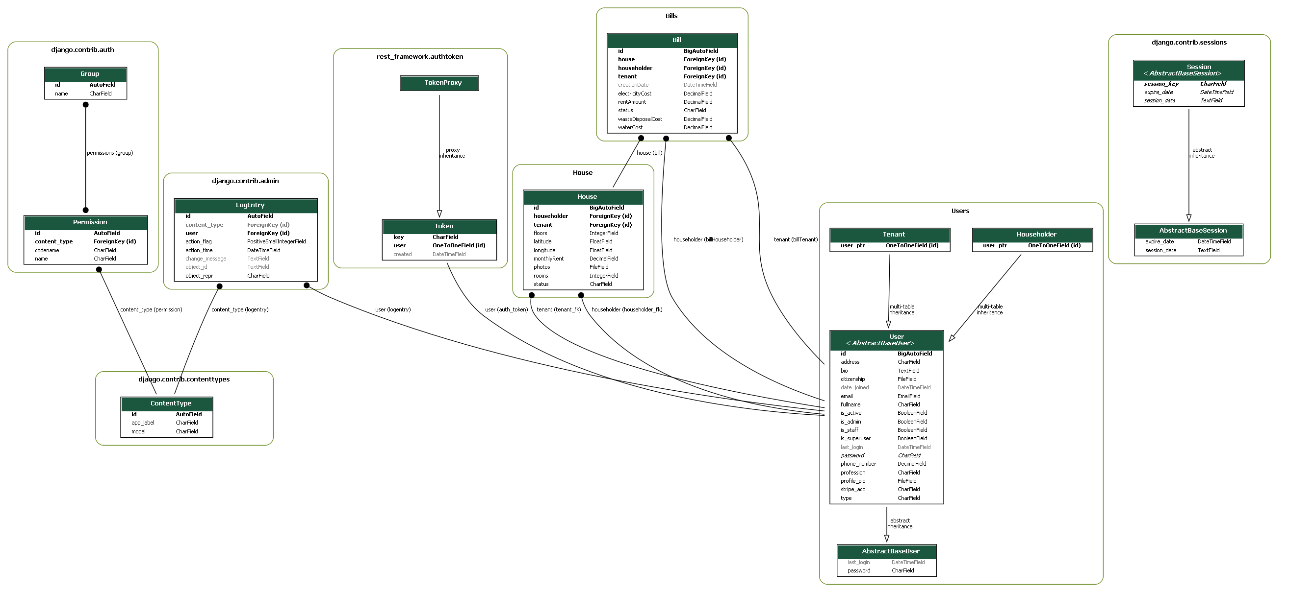

Figure 74: Domain Object Model

## Implementation

### Important Screenshots

Code to return user id, auth token, and user type on login

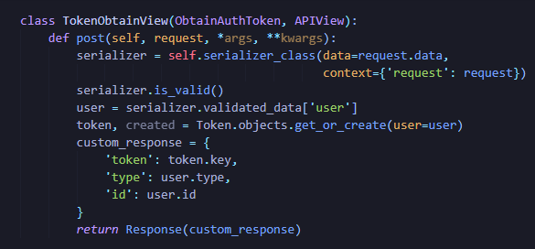

Figure 75: Code Screenshot 1

Code defining custom user model in Django

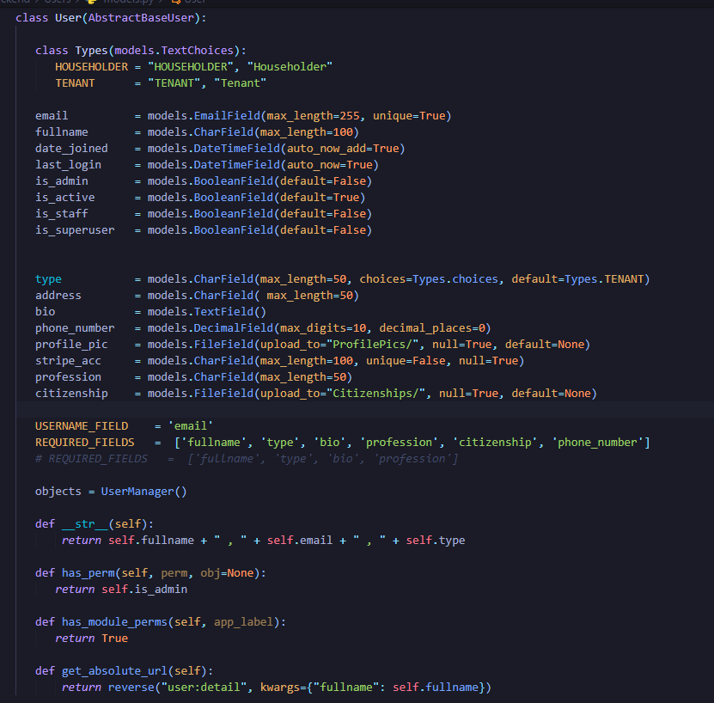

Figure 76: Code Screenshot 2

GET, POST and PATCH APIs

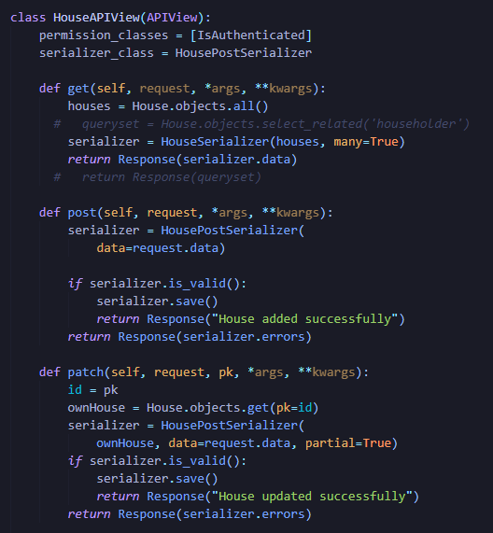

Figure 77: Code Screenshot 3

React Private Routing

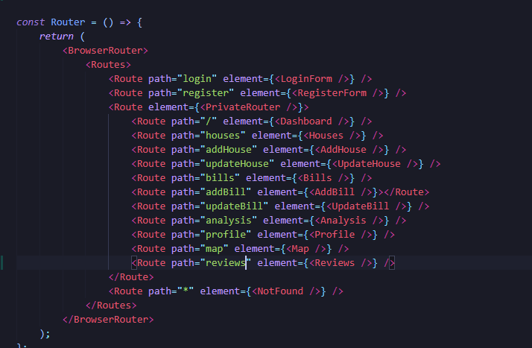

Figure 78: Code Screenshot 4

API to return map coordinates

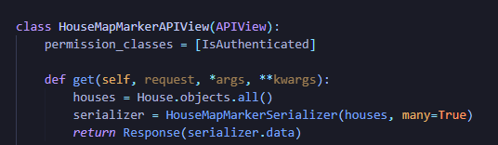

Figure 79: Code Screenshot 5

Redux persist store

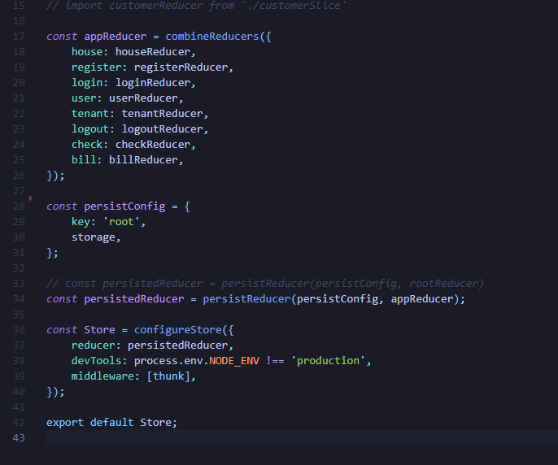

Figure 80: Code Screenshot 6

Register slice code to dispatch the register action

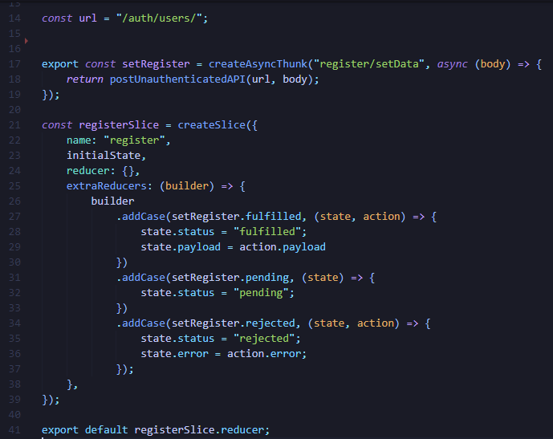

Figure 81: Code Screenshot 7

## System Architecture

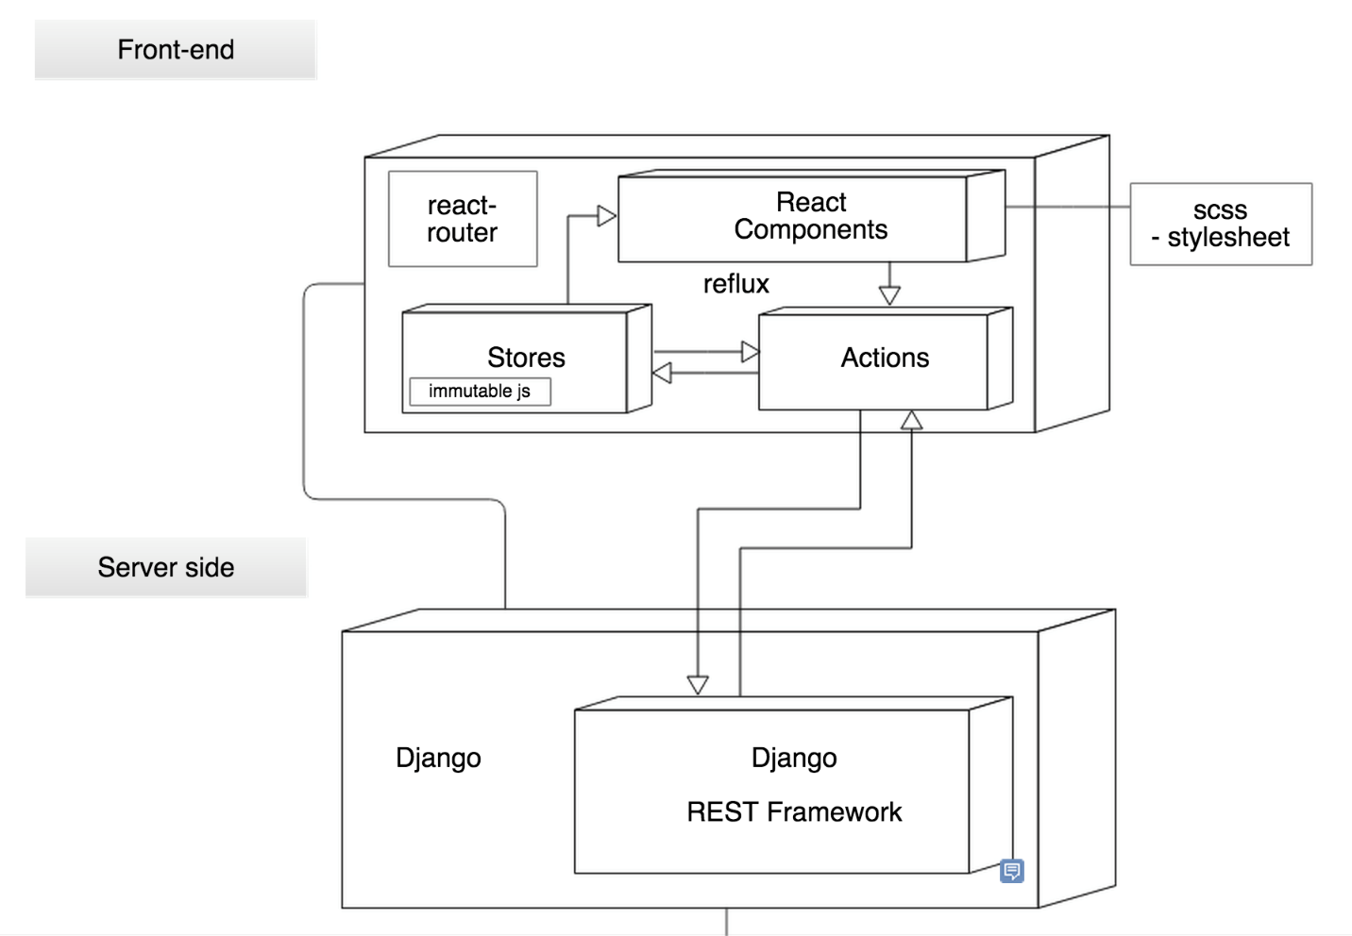

Figure 82: System Architecture

The server side or backend framework used for the project is Django. Django REST Framework is a toolkit built on top of Django to provide a flexible way of building Web APIs. Django uses the MVC (Model View Controller) format, known in the Django community as MVT (Model View Template) for developing webapps. Django Rest Framework provides built in templates for web browsable APIs thus allowing users to write only models and views. MVT can be elaborated with the following components:

* **Models (M):** Manages data and business logic.
* **View (V):** Routes commands to the model and template parts.
* **Template (T):** Handles layout and display.

The client side or the frontend library used for the project is React. React is a UI library built by Facebook which leverages JSX. JSX is a combination of JS and HTML to create highly customizable and flexible UI components. The project utilizes react along with react ecosystem libraries such as Redux, React Router, Axios, etc. to generate the UI of the system.

# Testing

## Test Plan

No software is truly bug free. However, the goal of testing is to ensure that the software is usable and has a low number of common bugs that users may frequently come across, or to make the software safe and stable for consumer use. To accomplish this goal, the software must be thoroughly tested. Testing is a vital lifecycle of a software development.

There are more than a dozen test types in the real world. However, for the project testing, the following types of tests were performed as directed by the adopted development methodology:

### Unit Testing

Unit testing, a testing technique using which individual modules are tested to determine if there are any issues by the developer himself. It is concerned with functional correctness of the standalone modules. (Tutorials Point, 2022)

Unit testing is performed in order to identify and debug errors during development. It is the first step of testing to make a module stable. For the purposes of this project, each feature is identified as a unit or a module.

### Integration Testing

Integration testing is a technique in which program modules are combined and tested as a single unit. (QA Test Lab, 2018)

Big Bang Integration Testing is an approach in which all software components (modules) are combined at once and turned into a complicated system. This unity of different modules is then tested as an entity. According to this checking method, the integration process will not be executed until all components are completed. (QA Test Lab, 2018)

This method executes the necessary tests while saving the tester’s time and is favourable in small projects.

### User Acceptance Testing

User Acceptance Testing (UAT), also known as beta or end-user testing, is defined as testing the software by the user or client to determine whether it can be accepted or not. (Software Testing Help, 2022)

This testing is performed after all other tests are complete and after completion of this test, usually the software is released in a production build.

## Unit Testing

### Testing Register Feature

|  |  |
| --- | --- |
| Objective | To check if register feature registers the user |
| Action | Click the Register button after filling all fields |
| Expected Outcome | The user is registered with provided details |
| Actual Outcome | The user was registered with all details except the citizenship file. |
| Conclusion | Test unsuccessful |

Table 22: Unit Test 1

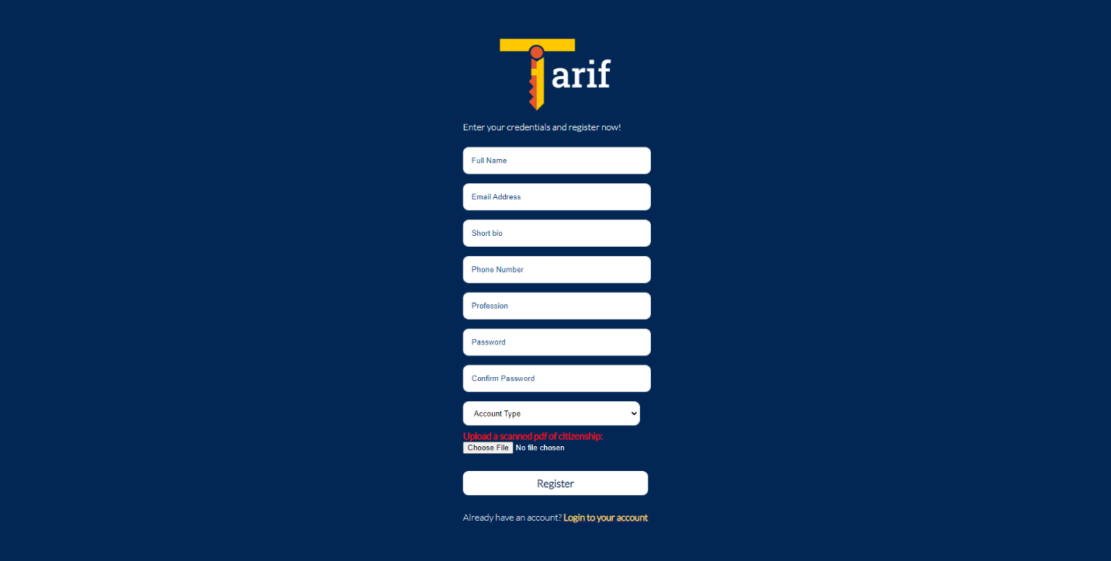

Figure 83: Register form

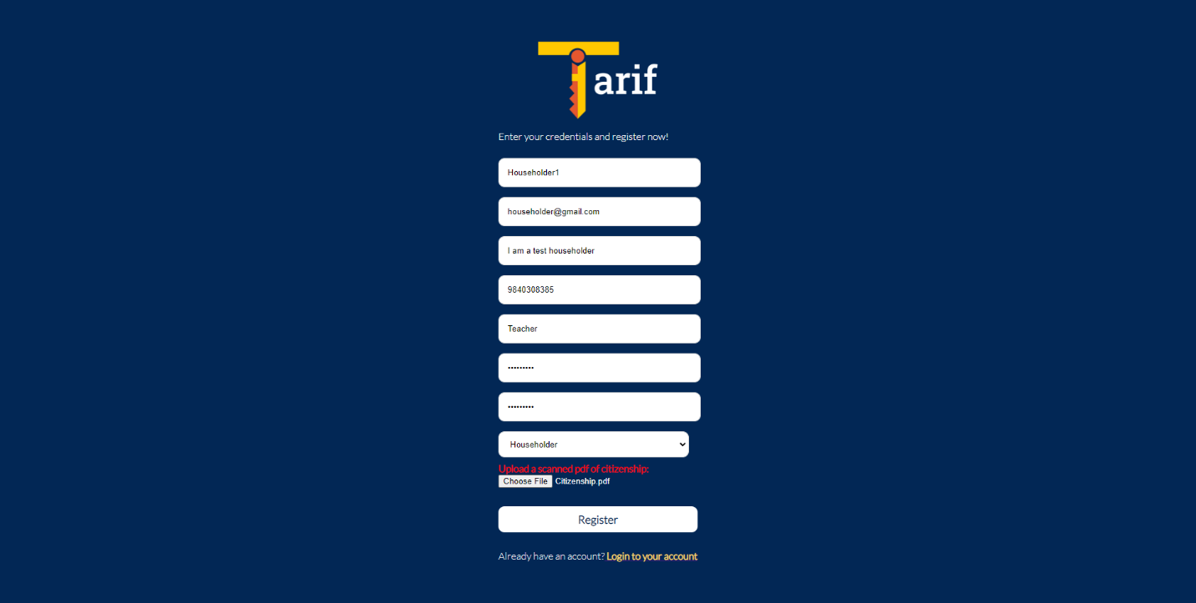

Figure 84: Register form with test data

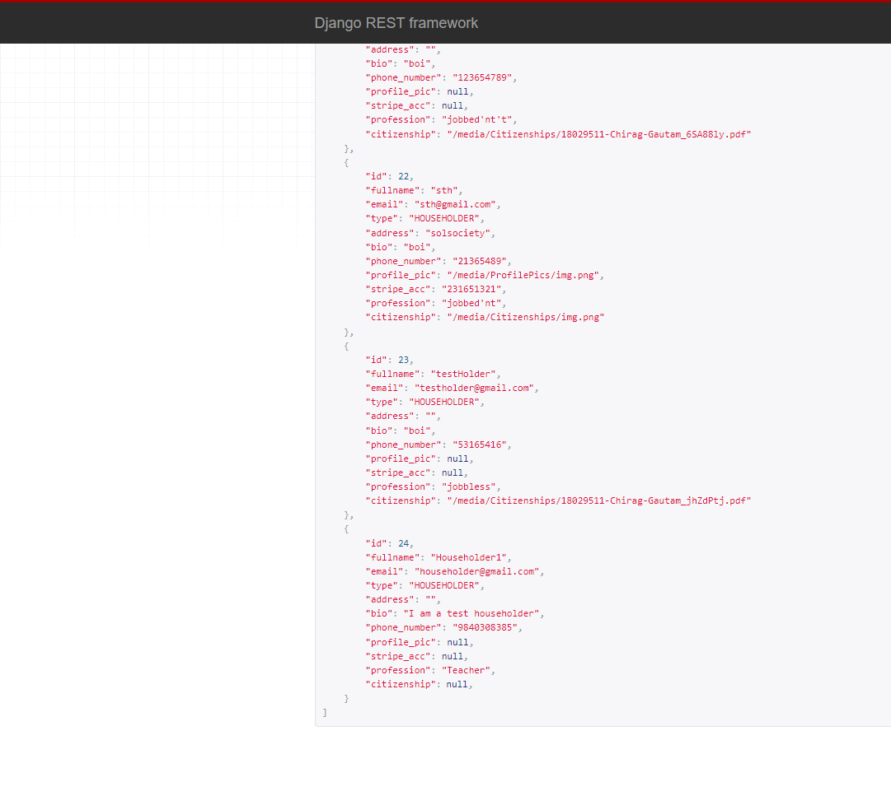

Figure 85: User data in backend

The error was caused since an image could not be uploaded with regular JSON. It had to be attached to a Form Data component.

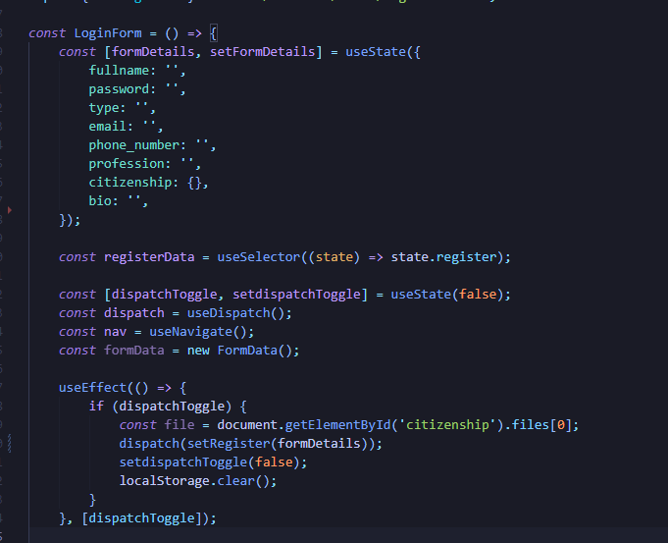

Figure 86: Code causing the issue

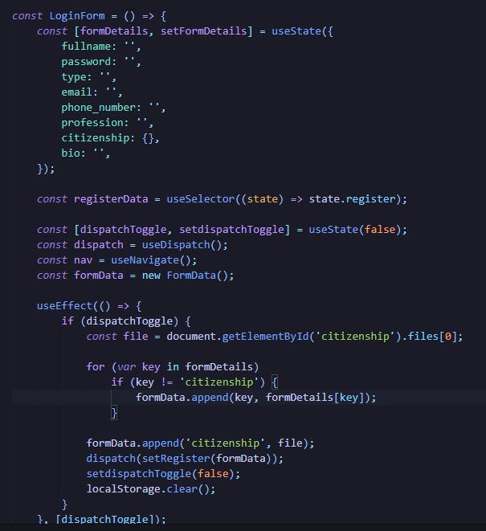

Figure 87: Code resolving the issue

|  |  |
| --- | --- |
| Objective | To check if register feature registers the user |
| Action | Click the Register button after filling all fields. |
| Expected Outcome | The user is registered with provided details. |
| Actual Outcome | The user is registered with all provided details. |
| Conclusion | Test successful. |

Table 23: Unit Test 2

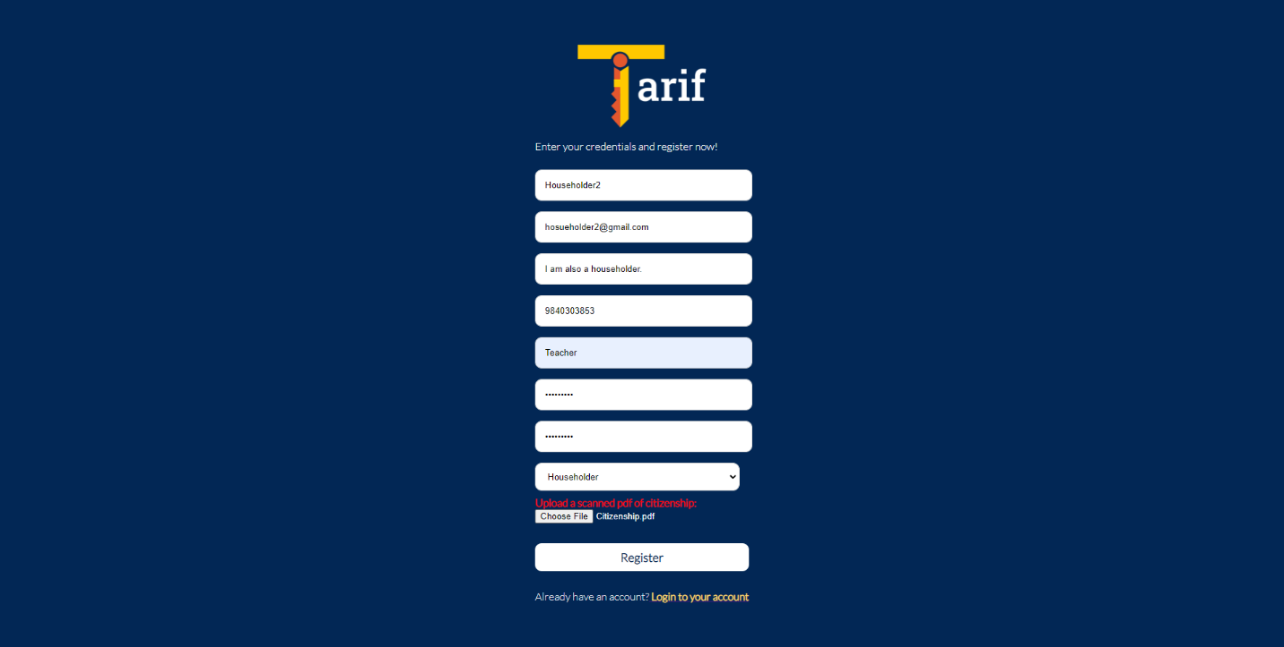

Figure 88: Register form filled

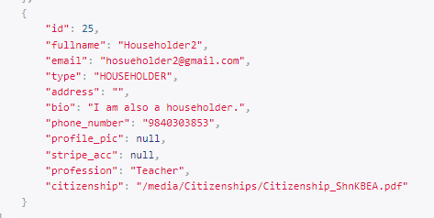

Figure 89: Registered User in the backend

### Testing Login Feature

|  |  |
| --- | --- |
| Objective | To check if login feature registers the user |
| Action | Click the Login button after filling all fields |
| Expected Outcome | The user is logged in. |
| Actual Outcome | The user was logged in. |
| Conclusion | Test unsuccessful |

Table 24: Unit Test 2

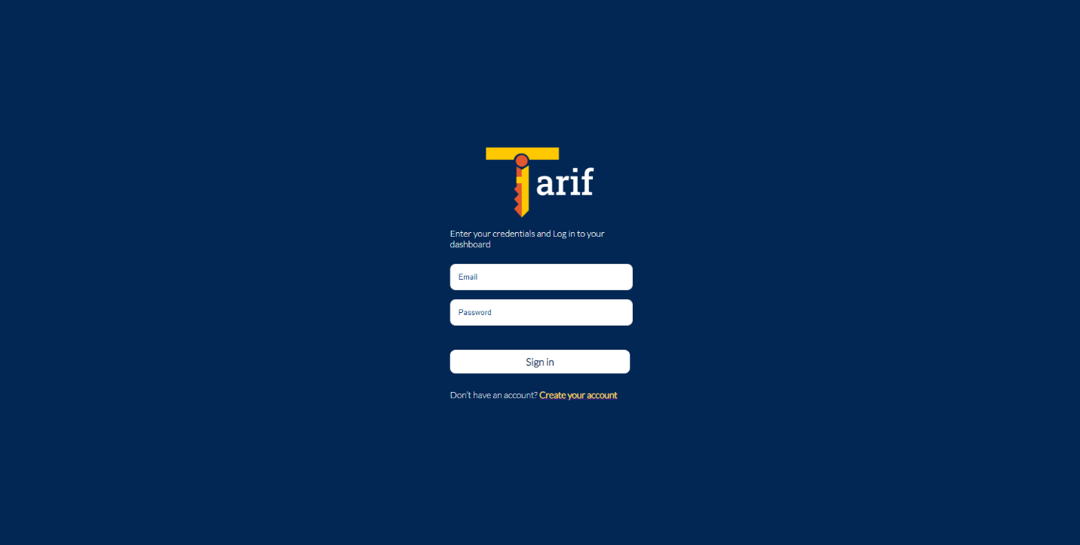

Figure 90: Login form

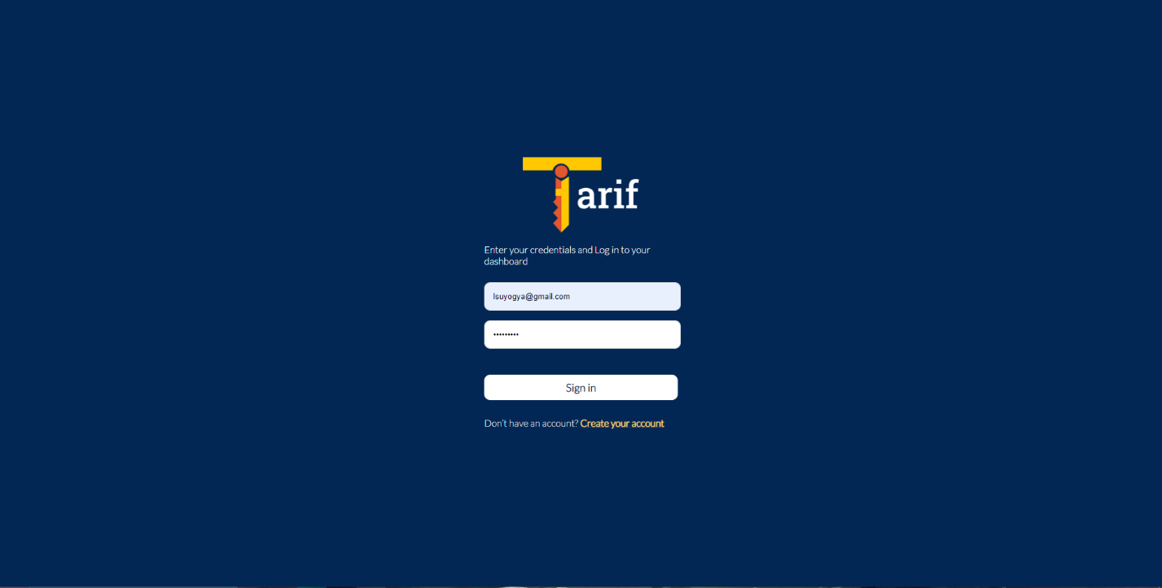

Figure 91: Login form with test data



Figure 92: Auth Token being stored in local storage after login

### Testing Data Visualization / Dashboard Feature

|  |  |
| --- | --- |
| Objective | To check if dashboard displays chart with user data |
| Action | Navigate to dashboard |
| Expected Outcome | The user is displayed chart with their data |
| Actual Outcome | The user was displayed an empty chart |
| Conclusion | Test unsuccessful |

Table 25: Unit Test 3

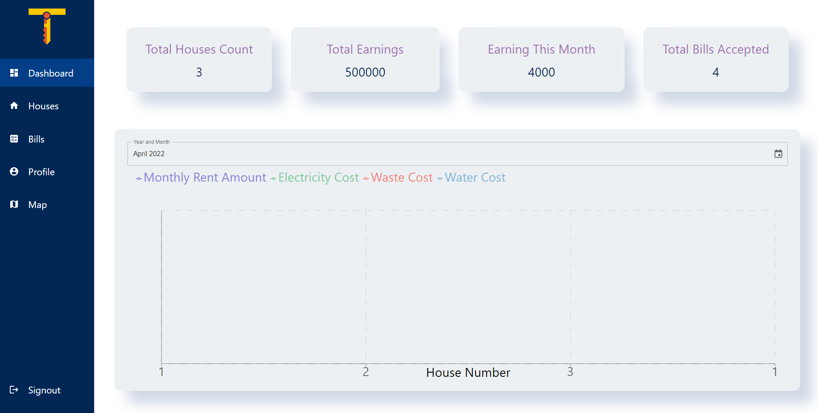

Figure 93: Dashboard display not rendering

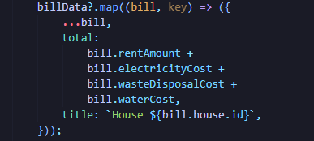

Figure 94: Code causing issue

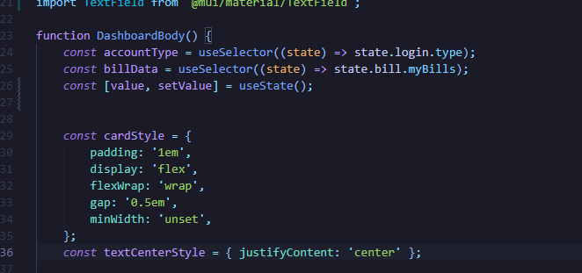

Figure 95: Code after fix

The bill data was not imported from redux store but an api call was directly made which caused the issue.

|  |  |
| --- | --- |
| Objective | To check if dashboard displays chart with user data |
| Action | Navigate to dashboard |
| Expected Outcome | The user is displayed chart with their data |
| Actual Outcome | The user was displayed chart with their data |
| Conclusion | Test successful |

Table 26: Unit Test 3

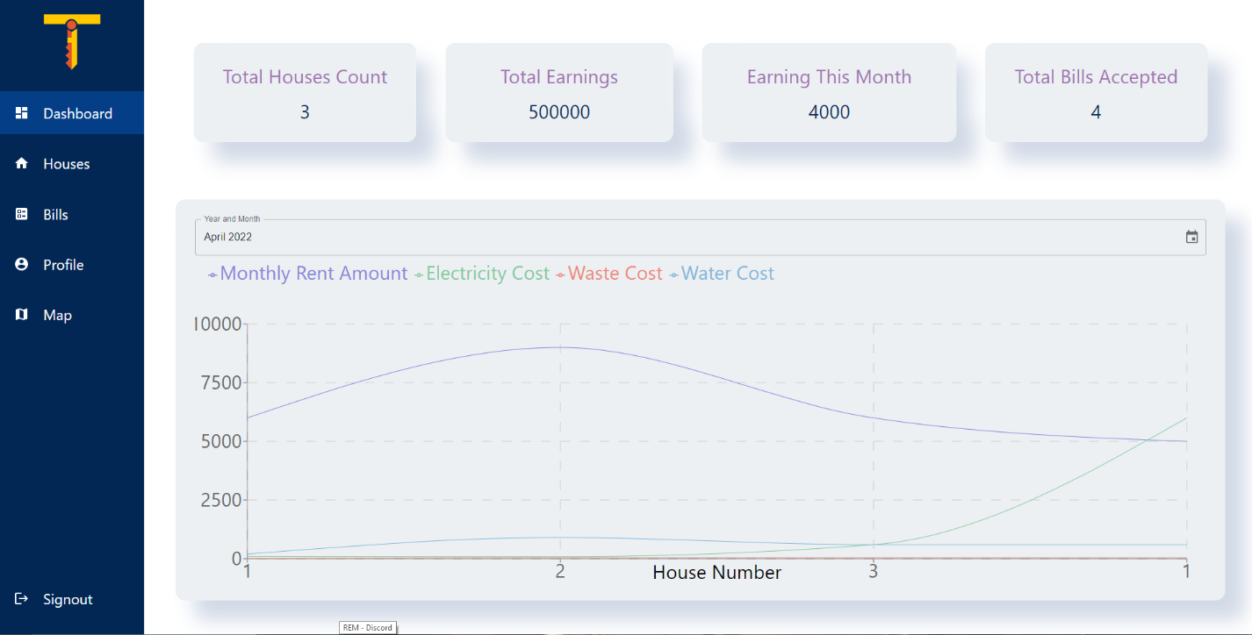

Figure 96: Dashboard with loaded data

### Testing to Add House

|  |  |
| --- | --- |
| Objective | To check if house addition works |
| Action | Click the add house button and add details |
| Expected Outcome | The house is added after the form is filled |
| Actual Outcome | Clicking the map did not update the longitude/latitude fields |
| Conclusion | Test unsuccessful |

Table 27: Unit Test 4

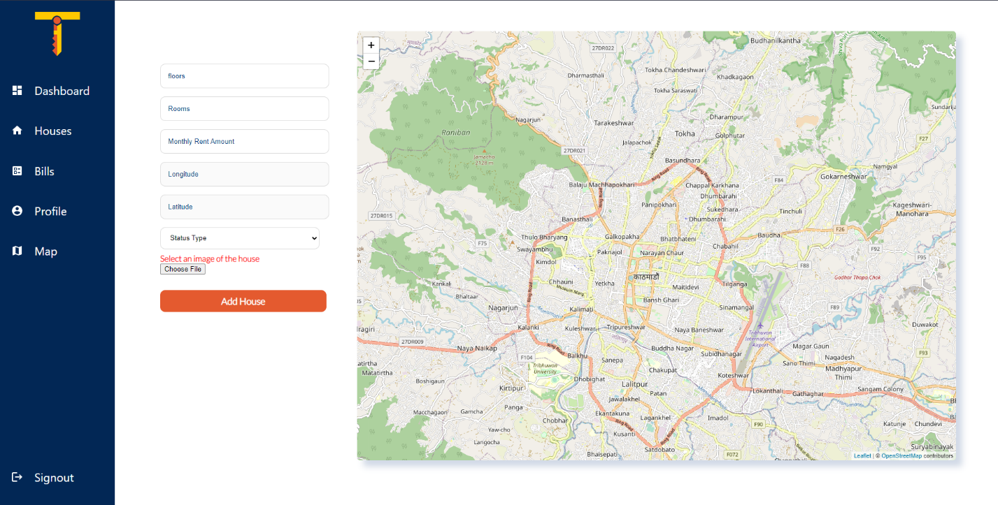

Figure 97: House Addition Form

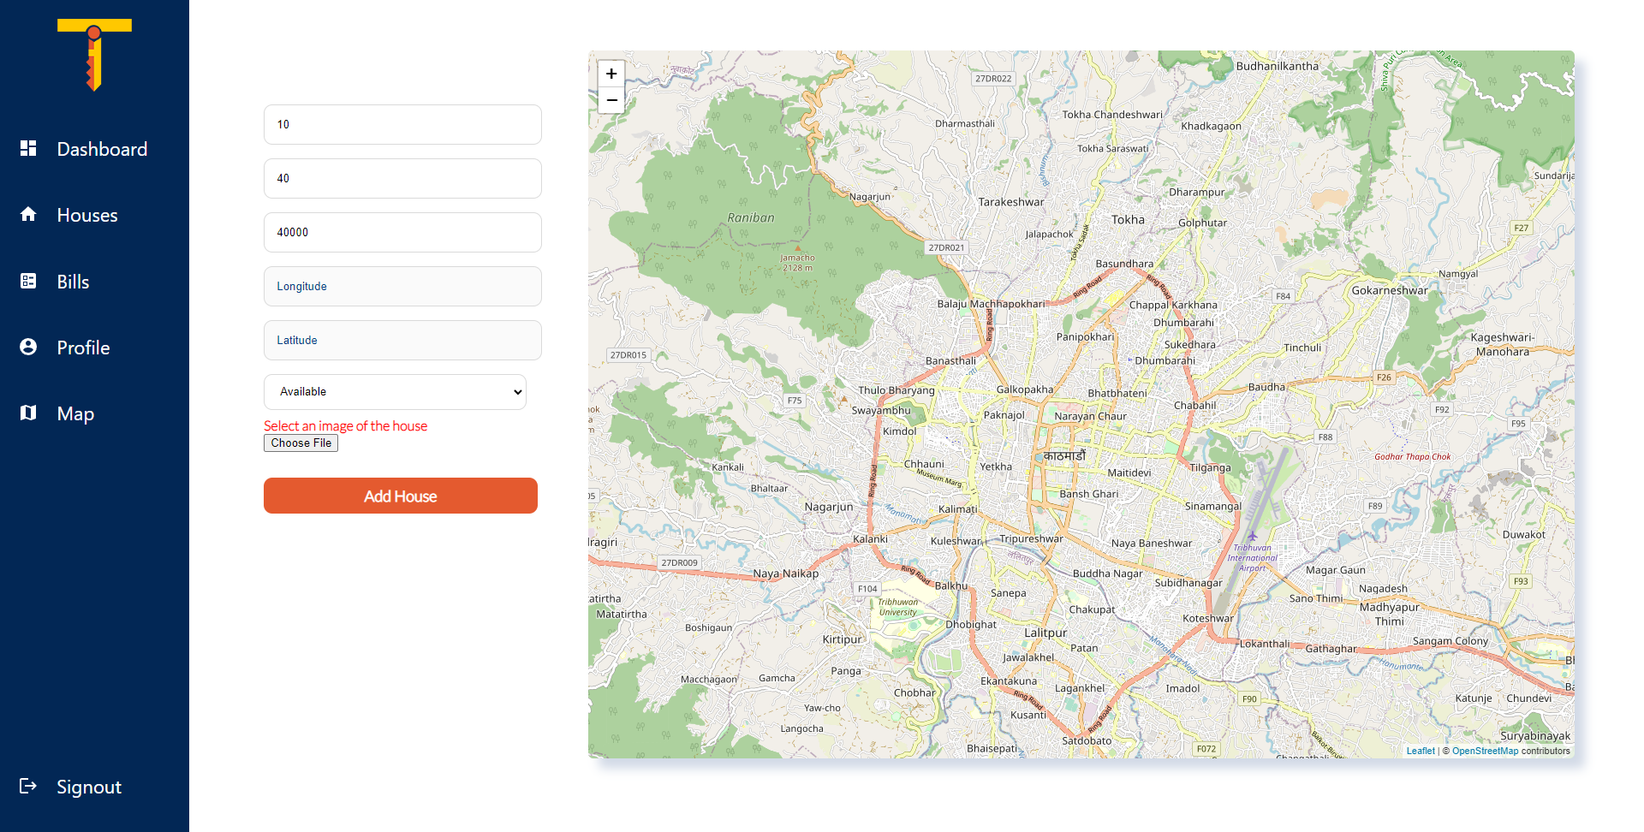

Figure 98: House Addition Form after clicking the map

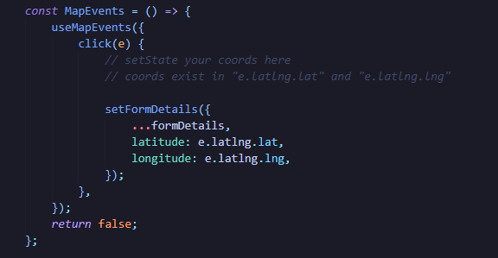

Figure 99: Code causing issue

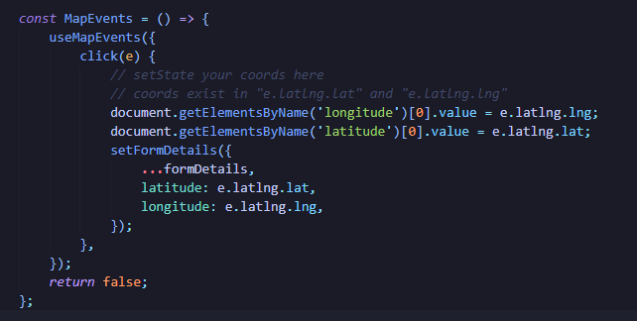

Figure 100: Code after fix

The data was being updated in the state but was not displayed in the text fields.

|  |  |
| --- | --- |
| Objective | To check house addition works |
| Action | Click the add house button and add details |
| Expected Outcome | The house is added after the form is filled |
| Actual Outcome | Clicking the map updated the longitude/latitude fields  Clicking the add button added the house |
| Conclusion | Test successful |

Table 28: Unit Test 4

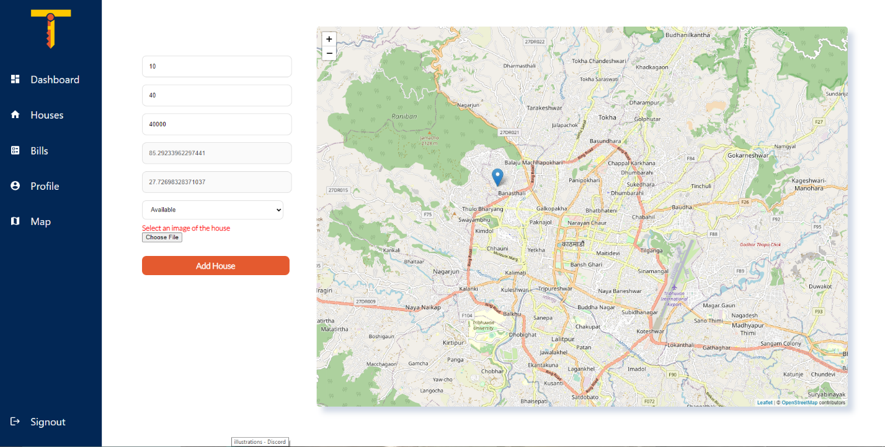

Figure 101: Dashboard with loaded data

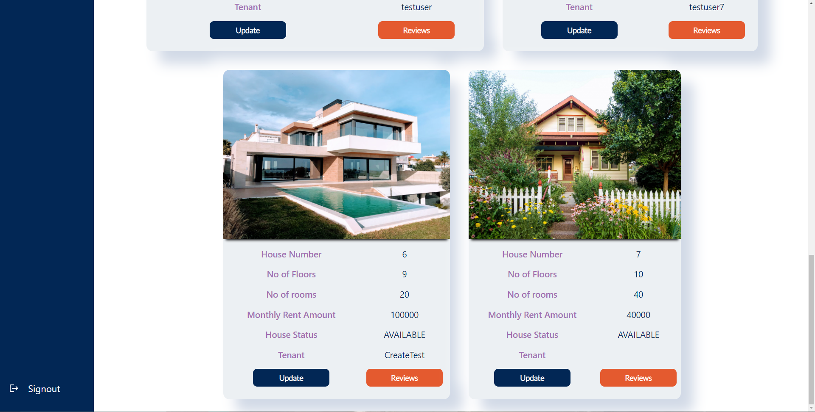

Figure 102: House added

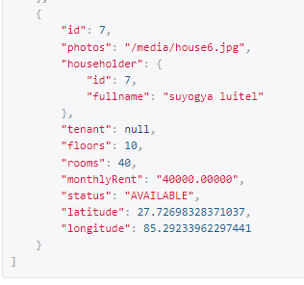

Figure 103: House added in backend

### Testing to Update House

|  |  |
| --- | --- |
| Objective | To check house update works |
| Action | Click the update house button and add details |
| Expected Outcome | The house is updated after the form is filled and the button is pressed |
| Actual Outcome | Updating the house updated all house details |
| Conclusion | Test unsuccessful |

Table 27: Unit Test 5

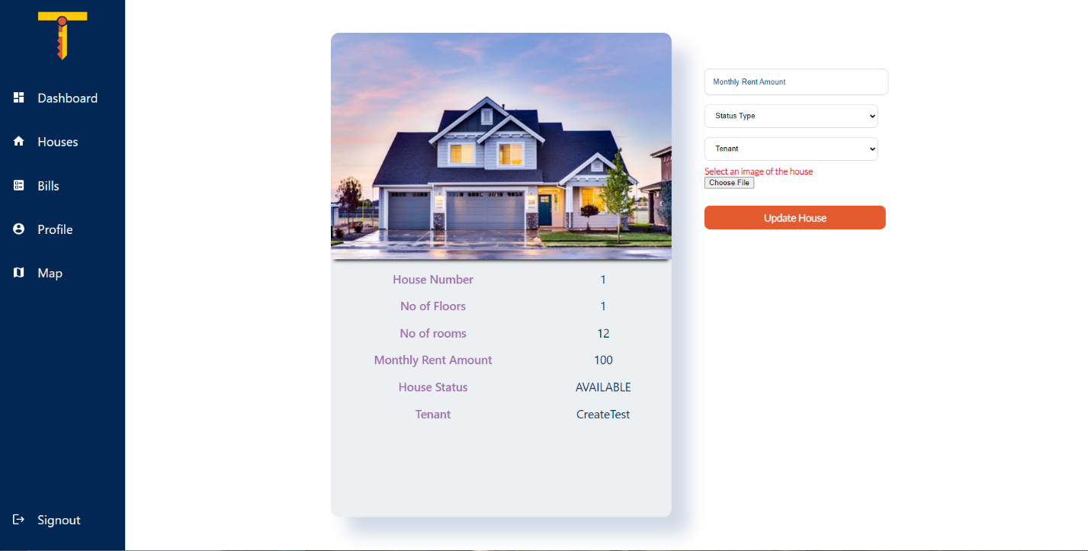

Figure 104: House Update Form

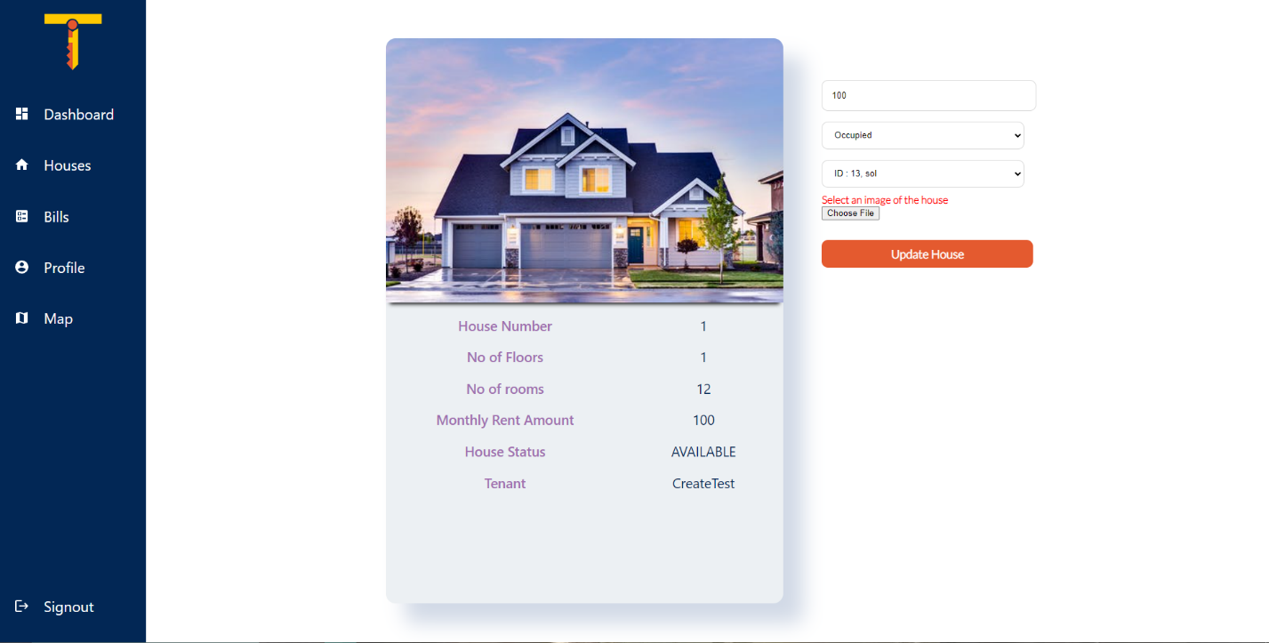

Figure 105: House Update Form with filled data

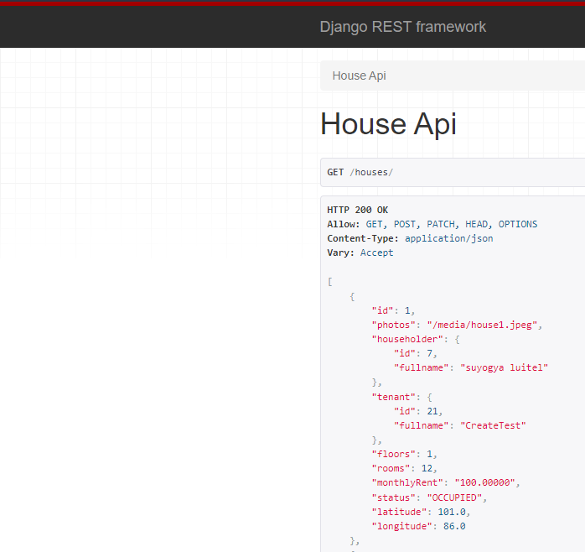

Figure 106: House data from backend

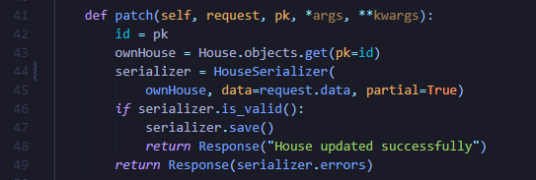

Figure 107: Code causing issue

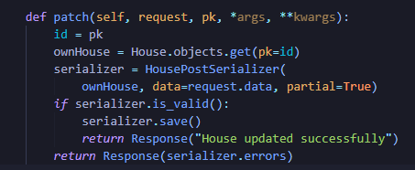

Figure 108: Code after fix

Wrong serializer was used in the patch request. This caused the post method to require a JSON object instead of simply an integer representing tenant id.

|  |  |
| --- | --- |
| Objective | To check house update works |
| Action | Click the update house button and add details |
| Expected Outcome | The house is updated after the form is filled and the button is pressed |
| Actual Outcome | Updating the house updated tenant correctly |
| Conclusion | Test unsuccessful |

Table 30: Unit Test 5

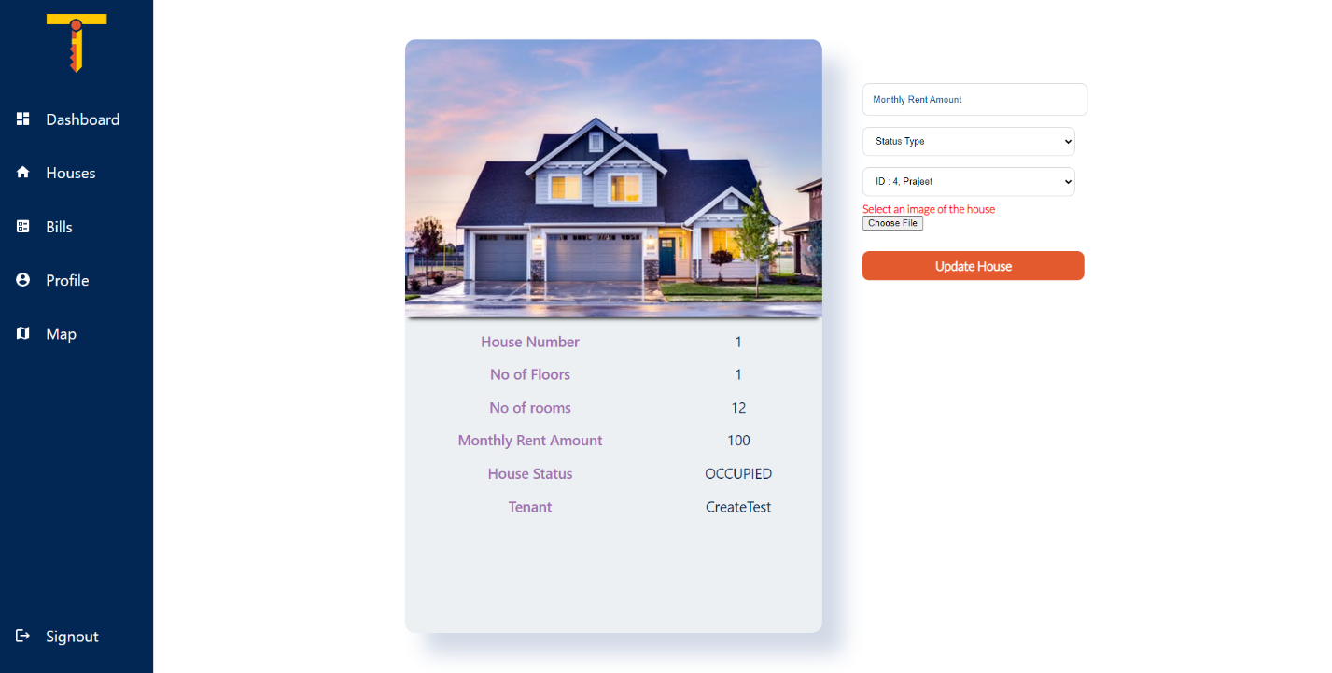

Figure 109: House Update Form with filled data

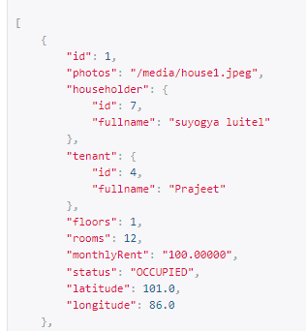

Figure 110: House updated in backend

### Testing to Add Bill

|  |  |
| --- | --- |
| Objective | To check bill addition works |
| Action | Click the add house button and add details |
| Expected Outcome | The bill is added after the form is filled and button is clicked. |
| Actual Outcome | The bill was added after the form was filled and button was clicked. |
| Conclusion | Test successful |

Table 27: Unit Test 6

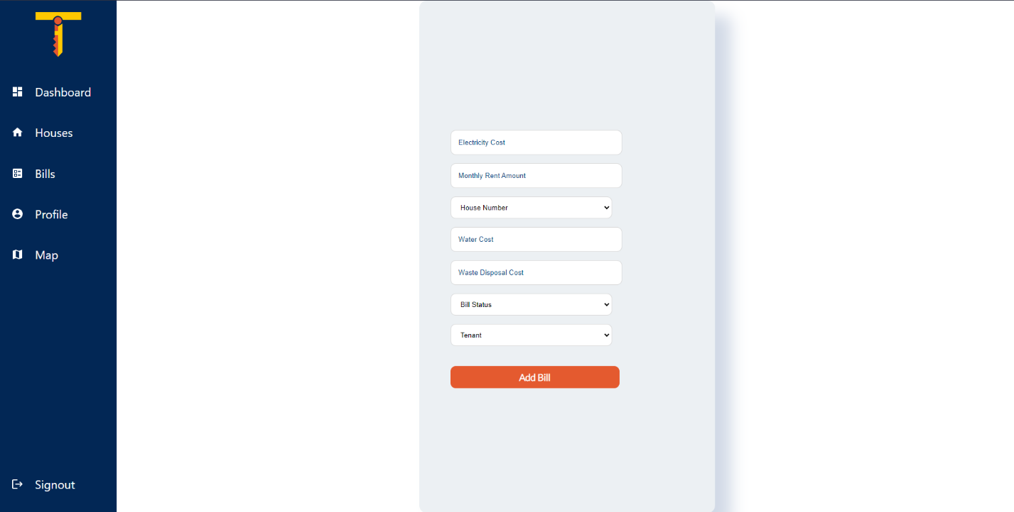

Figure 111: Bill Addition Form

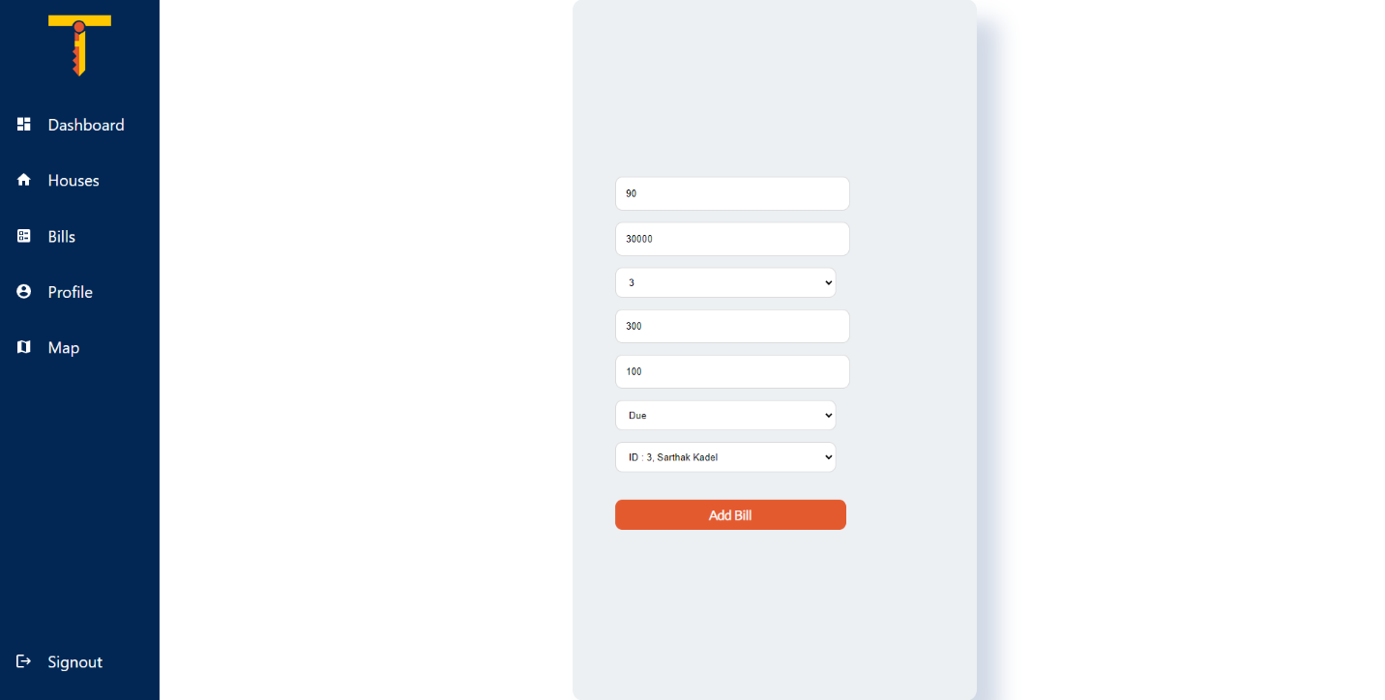

Figure 112: Filled Bill Addition Form

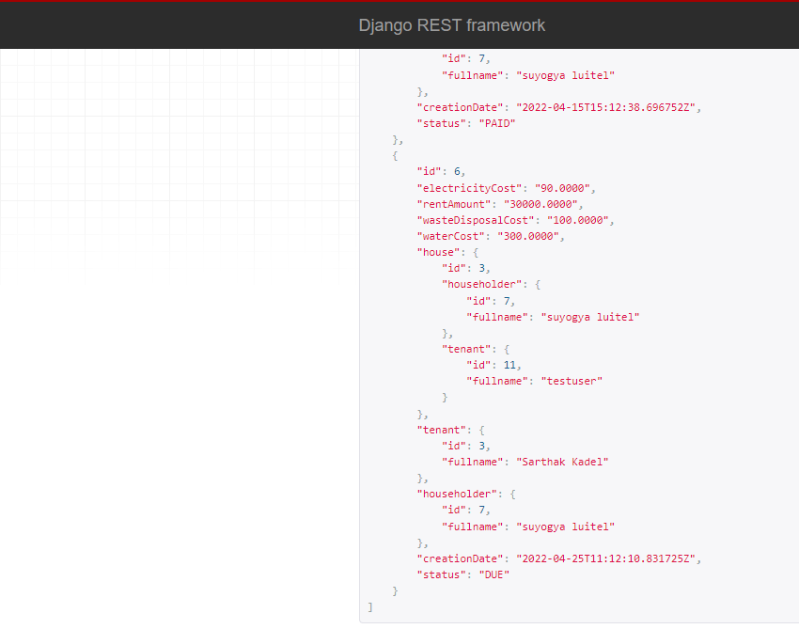

Figure 113: Bill Added

### Testing to Update Bill

|  |  |
| --- | --- |
| Objective | To check if bill update works |
| Action | Click the update button add details and press the update bill button |
| Expected Outcome | The bill is updated after the form is filled and button is clicked. |
| Actual Outcome | The bill was updated after the form was filled and button was clicked. |
| Conclusion | Test successful |

Table 27: Unit Test 7

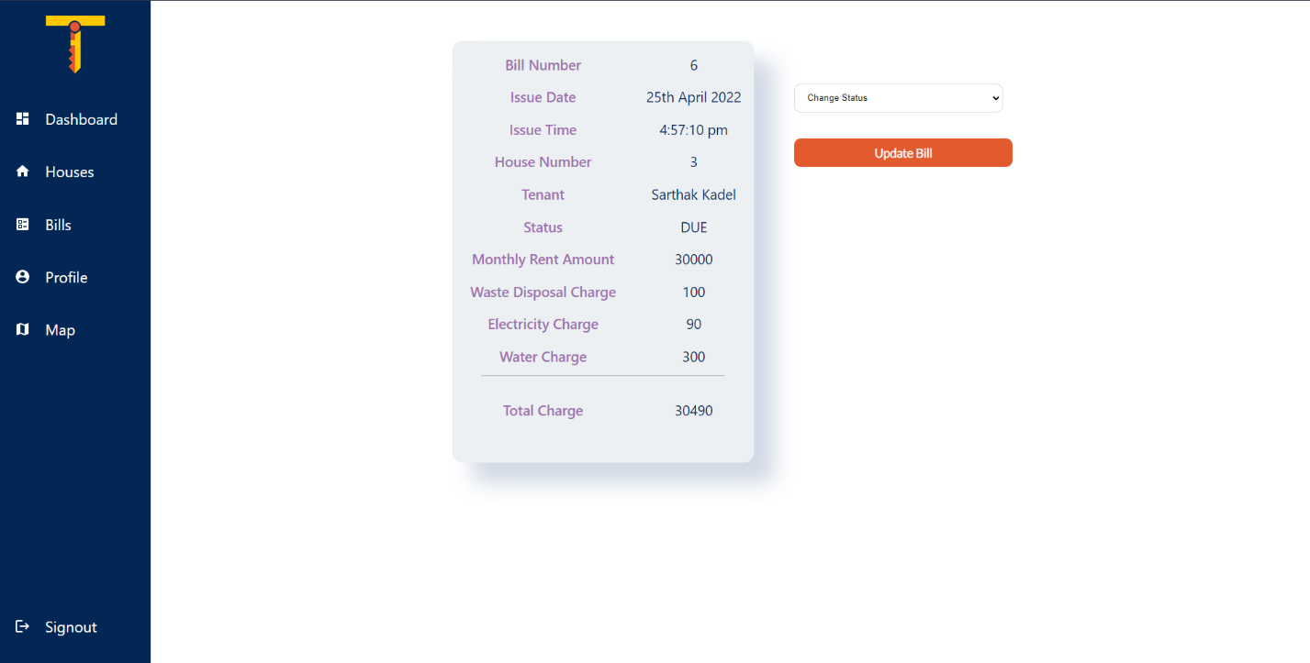

Figure 114: Bill Update Form

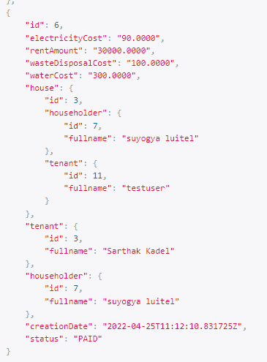

Figure 115: Bill Updated

### Testing Map Feature

|  |  |
| --- | --- |
| Objective | To check if map displays with available houses |
| Action | Navigate to map |
| Expected Outcome | The user is displayed map with their own available houses |
| Actual Outcome | The map displayed was scattered into several parts and not understandable at all |
| Conclusion | Test unsuccessful |

Table 25: Unit Test 8

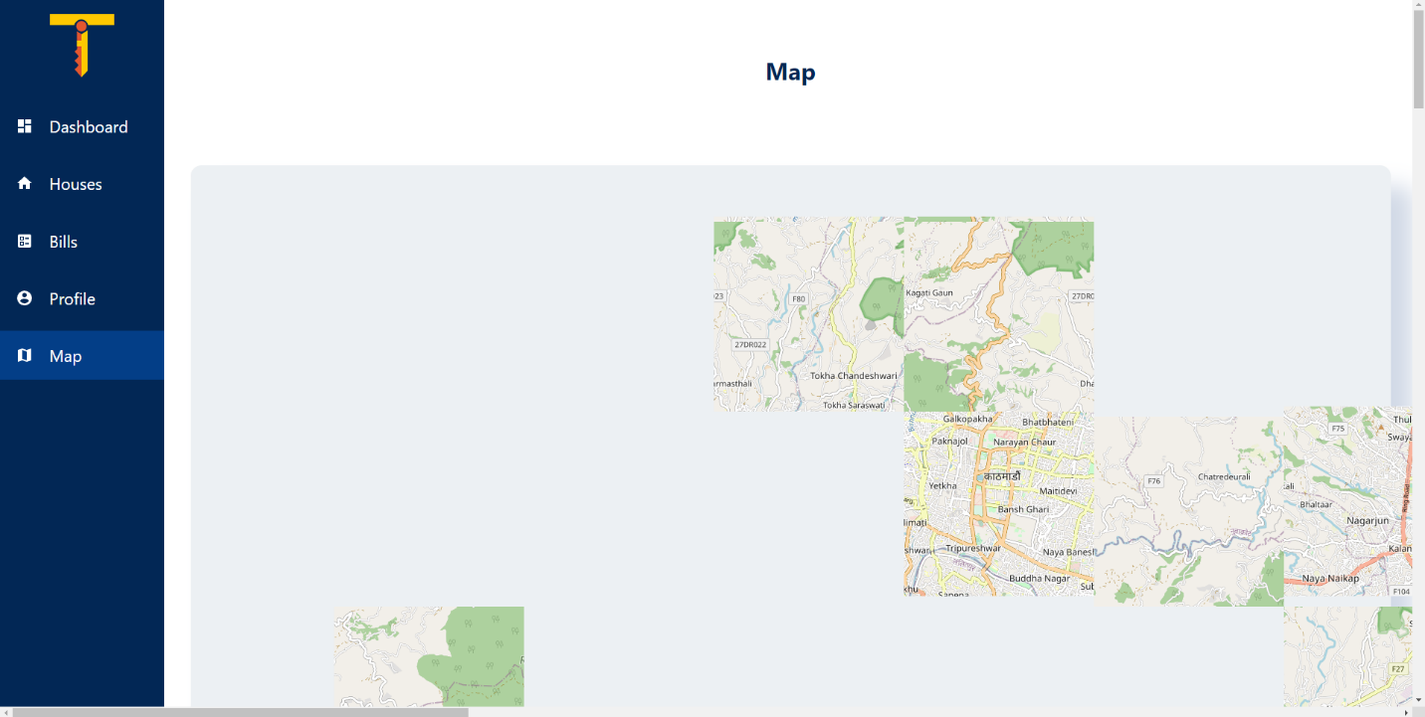

Figure 116: Map improperly rendering

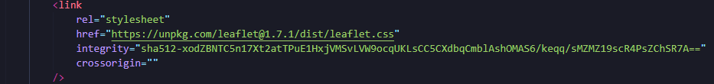

Figure 117: Code after fix

Even after installing the react-leaflet library, its css needed to be explicitly linked into the app’s index html. After linking it, the map worked normally.

|  |  |
| --- | --- |
| Objective | To check if map displays with available houses |
| Action | Navigate to map |
| Expected Outcome | The user is displayed map with their own available houses |
| Actual Outcome | The user is displayed map with their own available houses |
| Conclusion | Test successful |

Table 25: Unit Test 8

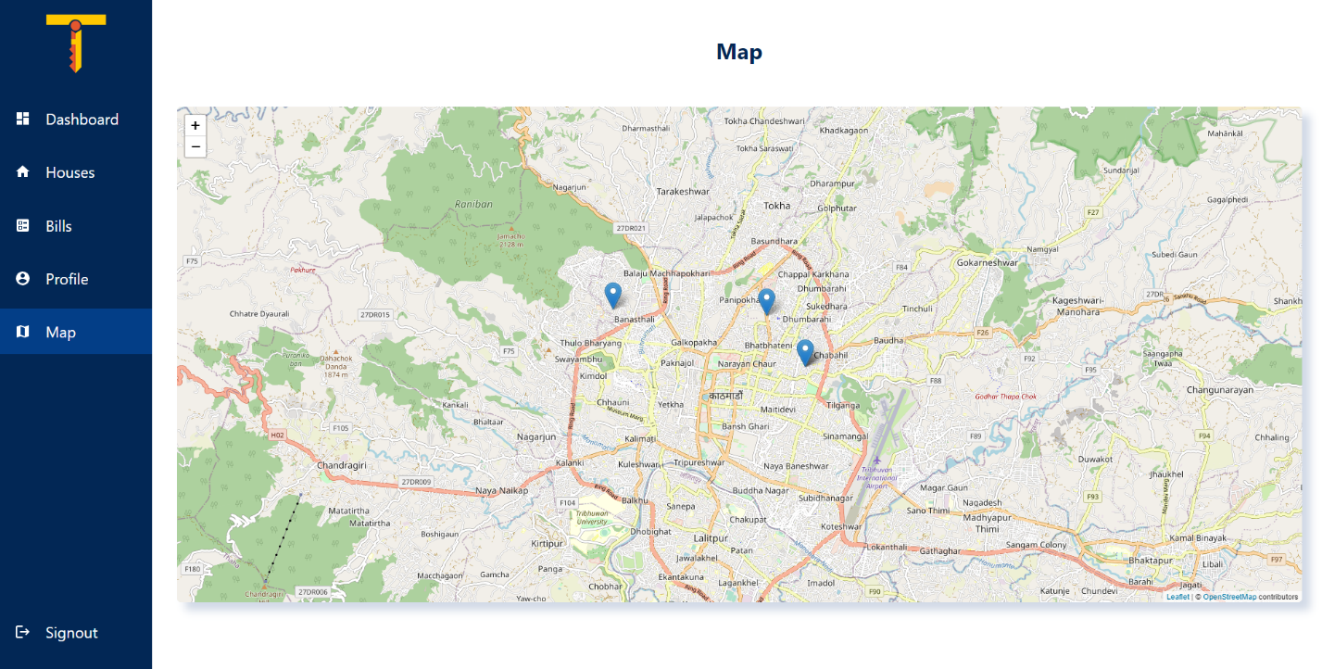

Figure 118: Map with user’s available houses

### Testing to Edit Profile

|  |  |
| --- | --- |
| Objective | To check if update profile works |
| Action | Navigate profile  Change values  Press Update Button |
| Expected Outcome | The user detail is updated and reloaded |
| Actual Outcome | The user details were updated and reloaded |
| Conclusion | Test successful |

Table 25: Unit Test 9

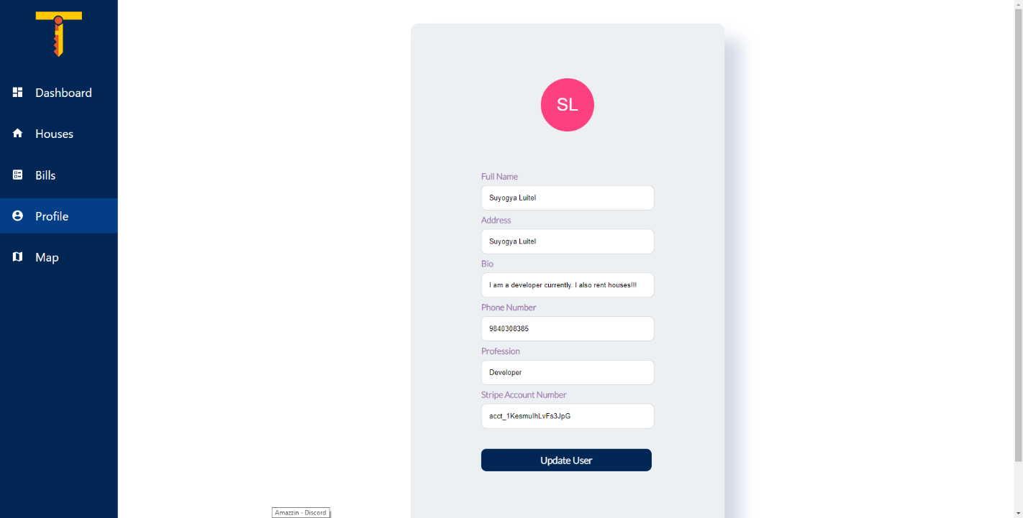

Figure 119: Edit profile form

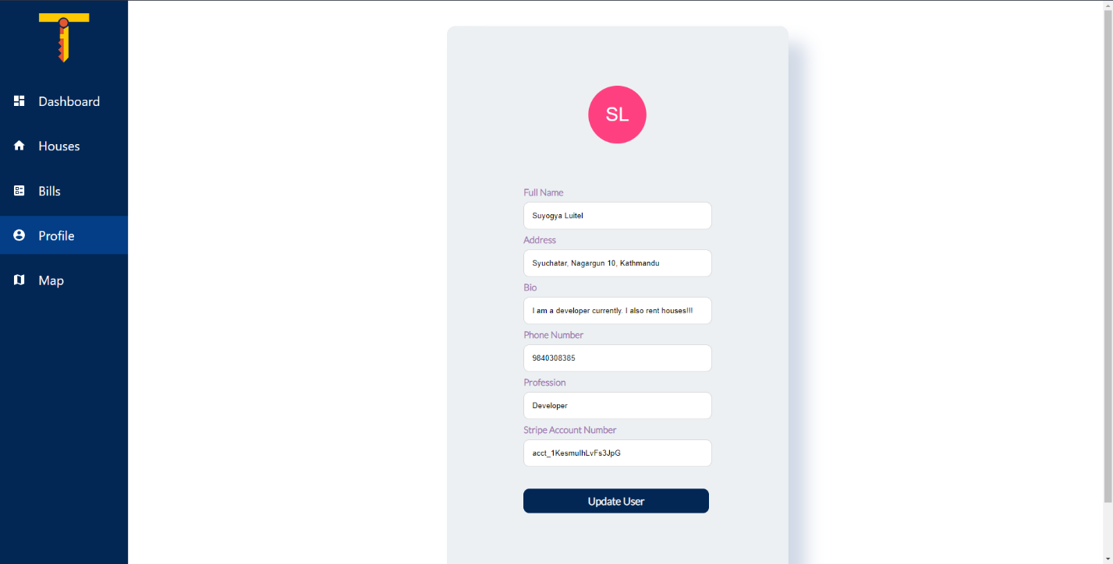

Figure 120: Edit profile form with updated address

### Testing Logout

|  |  |
| --- | --- |
| Objective | To check if logout works |
| Action | Press the logout button |
| Expected Outcome | Auth token is removed from the local storage  User is redirected to login page  A token destroy request was sent to the backend |
| Actual Outcome | User was redirected to login page  A token destroy request was sent to the backend  Auth token was not removed from local storage |
| Conclusion | Test unsuccessful |

Table 25: Unit Test 10

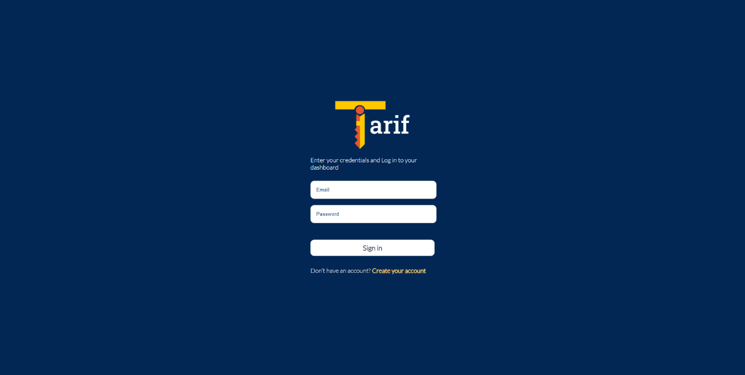

Figure 121: Redirection to login page



Figure 122: Auth Token in local storage even after logout

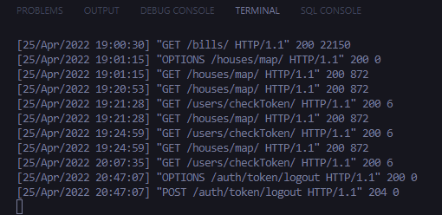

Figure 123: Token Destroy request in backend

The code to clear local storage was written in the button component logic which was being overridden by the redirect action. The code was then moved to the redux action associated with dispatching the token destroy request, which worked.

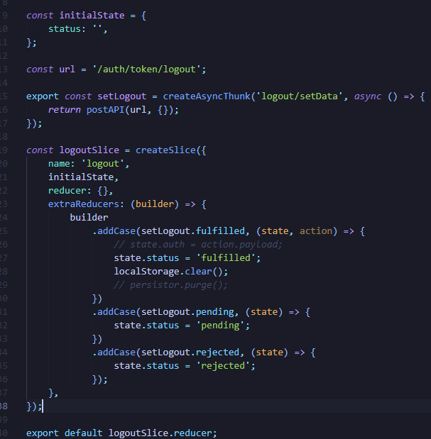

Figure 124: Code after fix

|  |  |
| --- | --- |
| Objective | To check if logout works |
| Action | Press the logout button |
| Expected Outcome | Auth token is removed from the local storage  User is redirected to login page  A token destroy request was sent to the backend |
| Actual Outcome | User was redirected to login page  A token destroy request was sent to the backend  Auth token was not removed from local storage |
| Conclusion | Test successful |

Table 25: Unit Test 10



Figure 125: Redirection to login page



Figure 126: Auth Token in local storage even after logout



Figure 127: Token Destroy request in backend

### Testing Bill Payment

|  |  |
| --- | --- |
| Objective | To check if pay bill feature works |
| Action | Click the Pay button. |
| Expected Outcome | Payment form is opened, and payment is made |
| Actual Outcome | Payment form was opened, and payment was made |
| Conclusion | Test successful |

Table 22: Unit Test 1

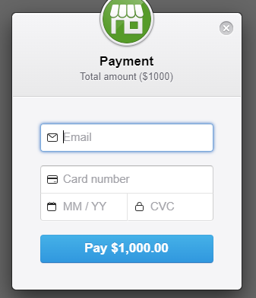

Figure 129: Payment Form

# References

Abler, S. W., 2021. *Feature Driven Development (FDD) and Agile Modeling.* [Online]   
Available at: http://www.agilemodeling.com/essays/fdd.htm  
[Accessed 19 November 2021].

Django, 2022. *Documentation, at a glance.* [Online]   
Available at: https://docs.djangoproject.com/en/4.0/intro/overview/  
[Accessed 26 March 2022].

Fortune Business Insights, 2021. *Property Management Market Size, Share & COVID-19 Impact Analysis, By Component (Software, Services), By Deployment (Cloud, On-Premises), By Application (Residential, Commercial), By End-User (Property Managers, Housing Associations, Real Estate Agents, a,* Pune, Maharastra: Fortune Business Insights.

Lewis, S., 2019. *Prototyping Model.* [Online]   
Available at: https://searchcio.techtarget.com/definition/Prototyping-Model#:~:text=The%20prototyping%20model%20is%20a,or%20product%20can%20be%20developed.  
[Accessed 21 November 2021].

Lucid Content Team, 2021. *Why (and How) You Should Use Feature-Driven Development.* [Online]   
Available at: https://www.lucidchart.com/blog/why-use-feature-driven-development  
[Accessed 21 November 2021].

Lumitex, 2017. *Prototyping Methodology: Steps on How to Use It Correctly.* [Online]   
Available at: lumitex.com/blog/prototyping-methodology  
[Accessed 21 November 2021].

Martin, M., 2021. *Prototyping Model in Software Engineering: Methodology, Process, Approach.* [Online]   
Available at: https://www.guru99.com/software-engineering-prototyping-model.html  
[Accessed 21 November 2021].

PlanView, 2021. *What is FDD in Agile.* [Online]   
Available at: https://www.planview.com/resources/articles/fdd-agile/  
[Accessed 14 November 2021].

Prepinsta, 2020. *Iterative Waterfall Model in SDLC.* [Online]   
Available at: https://prepinsta.com/software-engineering/iterative-waterfall-model/  
[Accessed 20 November 2021].

Project Manager, 2021. *What Is the Waterfall Methodology in Project Management?.* [Online]   
Available at: https://www.projectmanager.com/waterfall-methodology  
[Accessed 20 November 2021].

QA Test Lab, 2018. *Big-Bang Testing Specifics.* [Online]   
Available at: https://qatestlab.com/resources/knowledge-center/big-bang-testing/#:~:text=Big%20Bang%20Integration%20Testing%20is,until%20all%20components%20are%20completed.  
[Accessed 14 April 2022].

React, 2022. *Getting Started.* [Online]   
Available at: https://reactjs.org/docs/getting-started.html  
[Accessed 26 March 2022].

Ruparelia, N., 2010. *Waterfall model with Royces iterative feedback When referring to the waterfall model.* [Online]   
Available at: https://www.researchgate.net/figure/Waterfall-model-with-Royces-iterative-feedback-When-referring-to-the-waterfall-model-in_fig1_220631422  
[Accessed 21 November 2021].

Software Testing Help, 2022. *What Is User Acceptance Testing (UAT): A Complete Guide.* [Online]   
Available at: https://www.softwaretestinghelp.com/what-is-user-acceptance-testing-uat/  
[Accessed 14 April 2022].

SqLite, 2022. *About SqLite.* [Online]   
Available at: https://www.sqlite.org/about.html  
[Accessed 25 March 2022].

Tutorials Point, 2022. *Unit Testing.* [Online]   
Available at: https://www.tutorialspoint.com/software_testing_dictionary/unit_testing.htm  
[Accessed 12 April 2022].

Visual Studio, 2022. *Getting Started.* [Online]   
Available at: https://code.visualstudio.com/docs  
[Accessed 24 March 2022].

# Appendix

## Appendix A (Development)

### Gant Chart

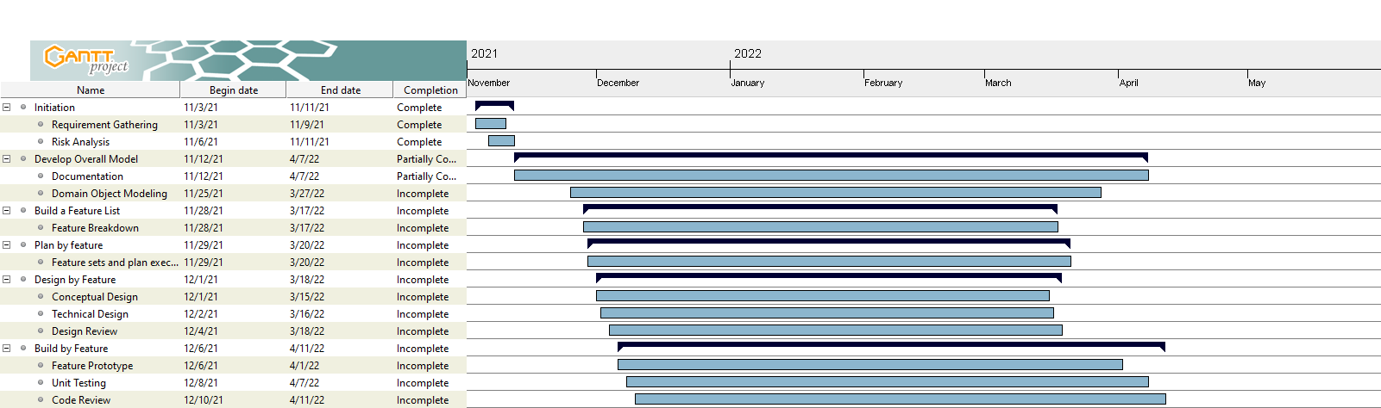

Figure 136: Updated Gantt Chart

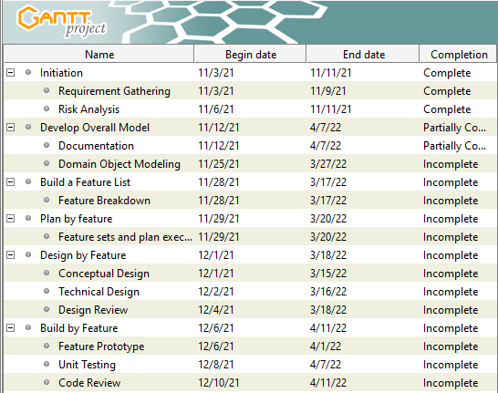

Figure 137: Gantt chart Tasks for Clarity

### Work Breakdown Structure



Figure 138: Work Breakdown Structure

## Appendix B (Development Till Date)

### Code Snippets

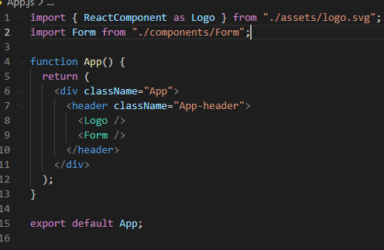

Figure 139: App.js Code

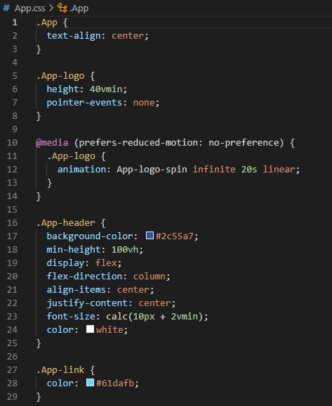

Figure 140: App.css Code

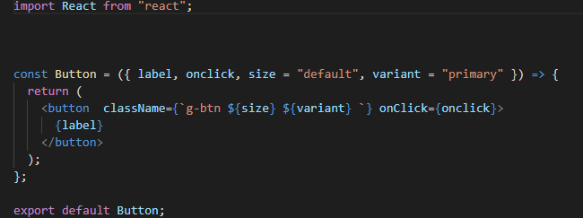

Figure 141: Button Component Code

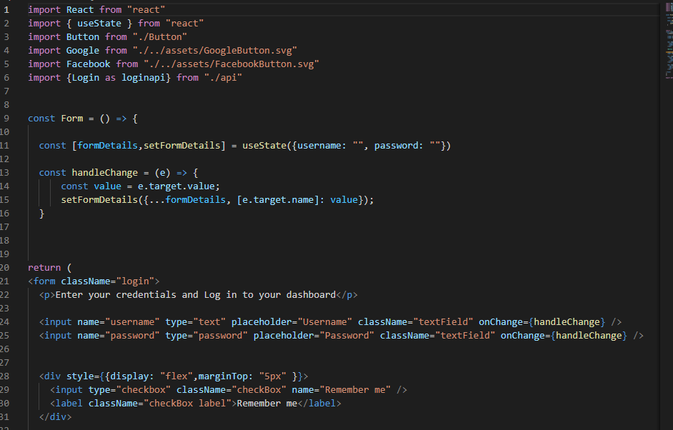

Figure 142: Login form Code

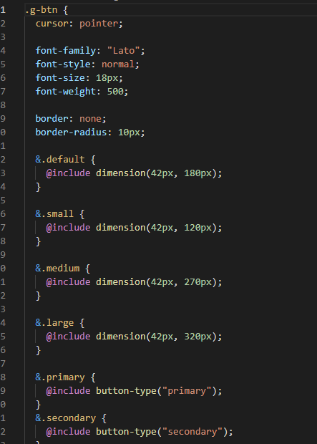

Figure 143: Button style Code

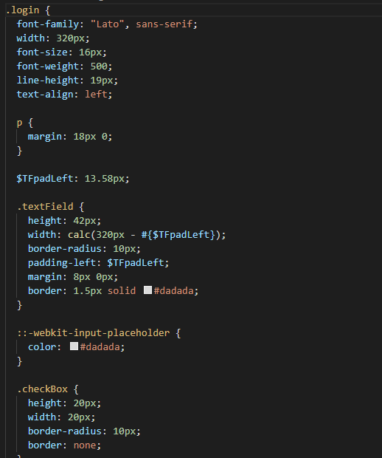

Figure 144: Login Page Code

### Viewable Development

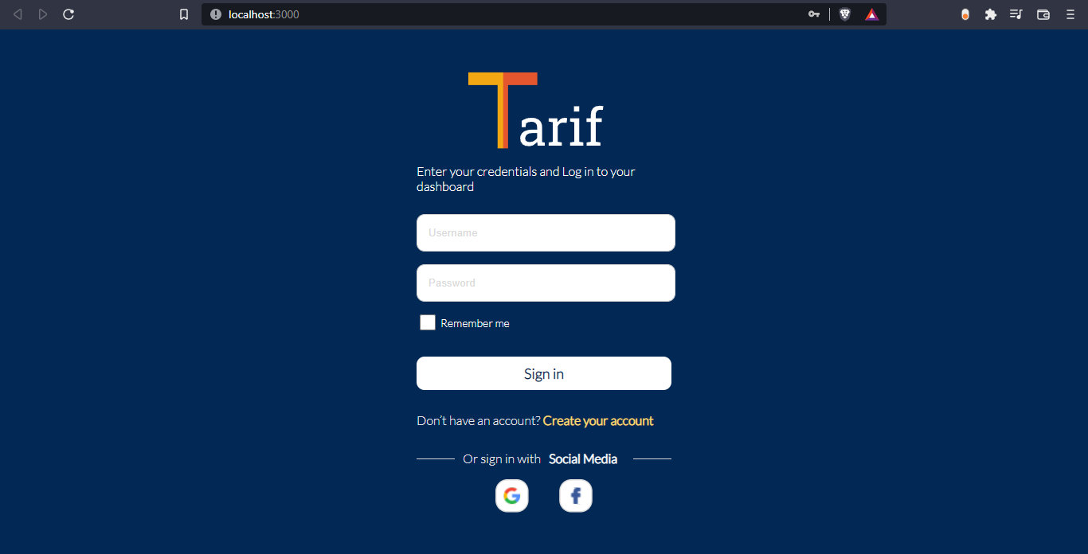

Figure 145: Sign-in page